A Dream Achieved
Jonathan Paul
April 2010

I have always been fascinated with long distance flight, probably related to a long standing interest in Charles Lindbergh going back to age eleven or so when I first read “The Spirit of St. Louis”. I have marveled in the accomplishments of Wiley Post, Howard Hughes, Amelia Earhart, Rutan and Yeager, and Steve Fossett. I toyed with such fantasies as flying to Europe, around the world and to the North Pole. A more practical adventure began to be incubated a year ago which was to fly non-stop from coast to coast, which, in my case specifically meant flying eastbound from the Pacific Ocean to the Atlantic Ocean. I have fantasized and planned for this flight ever since.

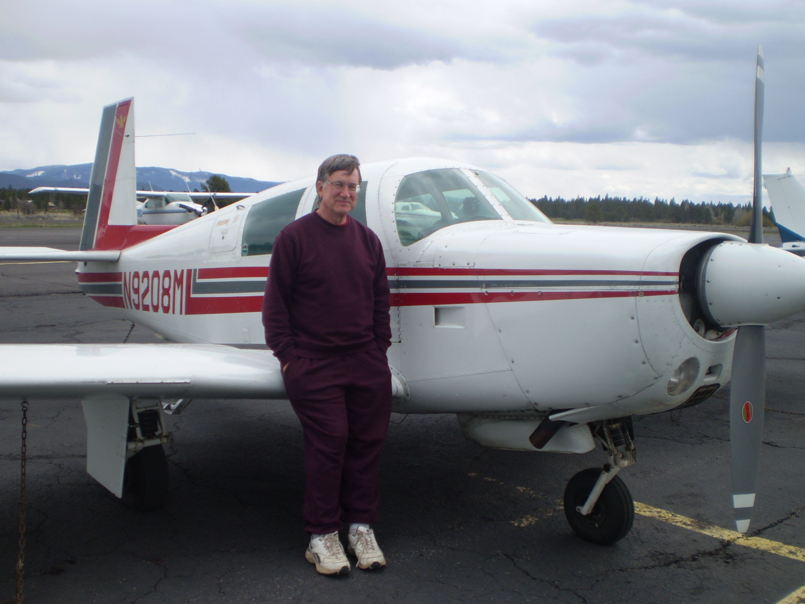
Jonathan and 08M

In general, a non-stop coast-to-coast trip is beyond the capabilities of most light planes, including my Mooney. To succeed in this venture required the adoption of rather extreme flying procedures and the patience to wait for the right winds and weather. I made two attempts at a non-stop flight. The first attempt failed. The second was successful.

Coast to Coast History: The first non-stop continental flight took place in on May 3rd, 1923 piloted by two army pilots, John Macready and Oakley Kelly. They flew a Fokker T-2, a huge single engine monoplane from New York to San Diego. The T-2 had a 400 horsepower Liberty engine and a fuel capacity of 725 gallons. It took three attempts over a 9 month period before they succeeded. The east to west direction was necessitated by the fact that fully loaded the aircraft could barely climb to 2,000 feet and could not climb above the continental divide until considerable fuel had been used. The successful flight took 27 hours and averaged 90 statute miles per hour (78 knots). This flight was heralded as a major accomplishment. Considering the primitive state of aviation (less than 20 years after the Wright brother first flew at Kitty Hawk), it was. But aviation has progressed a lot since then, and a good example is the airplane I fly.

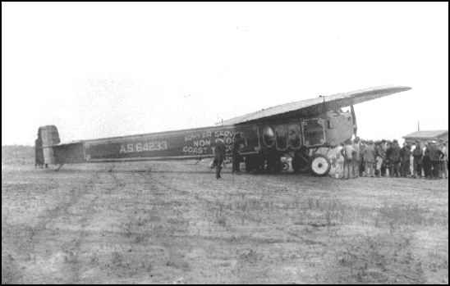
Fokker T2 Aircraft 1923

N9208M: My airplane is a 1966 Mooney E-Model. The Mooney design has always been considered fast and efficient. What is not generally appreciated is that a Mooney’s efficiency can also yield exceptional range. Although my 45-year old Mooney does not have all the speed modifications of the later “201” models or the power of the current long-body models, it is shorter and lighter and is considered the fastest of the early Mooneys. It is completely stock with the exception of long-range tanks. With these, it has an in-the-wing fuel capacity of 90 gallons as opposed to the standard 52 gallons.

I had done considerable test flying to explore the long-range flying potential of this aircraft. In general, to achieve long range, one has to fly high, use very low power settings, slow propeller speed, and lean the mixture to the maximum extent possible. The following are some data points for various flying configurations in my airplane:

Mode | Altitude | RPM | MP | Fuel Flow  (GPH) | TAS (knots) | MPG  (nm/gal) | No Reserve  Range (nm)
Normal Cruise | 7500’ | 2500 | 23” | 10.5 | 150 | 14.2 | 1,221
Long Range | 13,000 | 2000 | 17” | 6.0 | 123 | 20.0 | 1,763
Very Long Range | 13,000 | 1950 | 15” | 5.2 | 115 | 23.1 | 1,901

The practical range is significantly lower than the numbers above because one has to allow for taxi fuel, fuel used in the climb and reserve fuel of at least an hour.

Coast to Coast Distance: The shortest distance between the Pacific and Atlantic Oceans is between San Diego, California and Savannah, Georgia. This is a direct distance of 1811 nautical and an airway distance of 1,860 nautical miles. Departing from my home base of Salinas adds 160 miles and an hour and one half to the trip and is not a practical starting point for that reason. So my flight has to launch from San Diego.

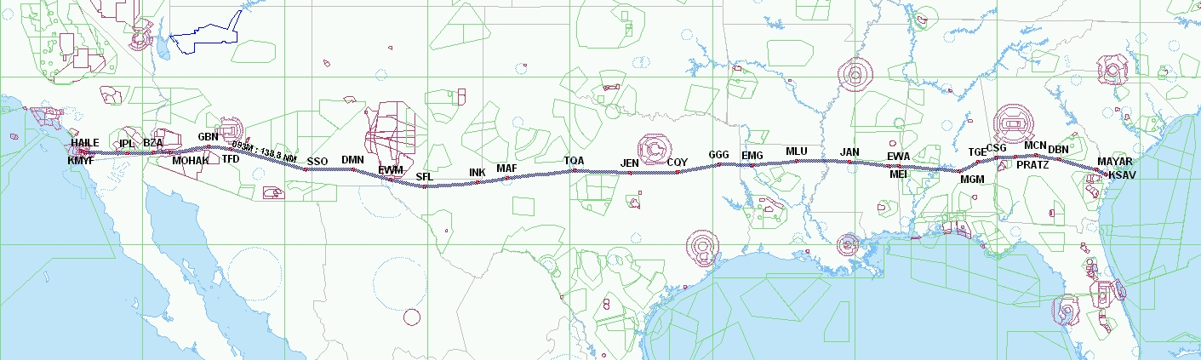
Flight Plan route via airways.

Tailwinds: To be at all possible, the non-stop coast-to-coast flight must proceed eastward to take advantage of prevailing westerly winds. In fact a good tailwind is essential to success. To provide enough reserve, using the 6.0 gph Long Range power settings, I estimated that it was necessary to have an average 35 knot tail wind to make the trip. However, as experience has revealed, favorable winds are an elusive entity. They generally occur during the winter months (November-April). Further, really big winds are often associated with horrible weather. Finally, it is not that common to see good low-level winds across the entire southern tier of the US. When they are strong in the west, they are often light and variable or contrary in the east, or visa versa.

Weather: In our small airplanes, with normal general aviation equipment, we generally don’t plan for trips that cross 1800+ miles. Lining up favorable winds with no serious en route weather (icing, or convective weather), is not that easy. The wind and weather forecasts from sites like AWC (Aviation Weather Center) are generally excellent, and allow for four-day planning for wind, and two-day planning for surface weather, and 24 hour forecasts for icing. But these excellent sources are subject to the vagaries of nature and can forecast weather that is quite different from what actually occurs.

First Attempt: I had been following the weather for several months during the winter and juggling personal and employment activities trying to find a window of suitable weather and winds that coincided with my availability. This cross country trip would require about a week to complete including the preparation, the actual flight, and the return trip. Nothing worked out. Having retired from my job on April 1st, I felt I could be a little less picky about conditions and could make an attempt with less than optimal conditions. Easter Sunday, April 4th, in retrospect, would have been near perfect, but the forecasts leading up to that date weren’t encouraging and I had not made the decision to launch in time. But the wind forecasts for Tuesday April 6th looked pretty good with strong westerly winds in the West, veering into south west winds over Texas and petering out over the Southeast. I thought that the winds in the west, 60 knot tail, could make up for lesser winds in the East. So I planned to takeoff on Tuesday morning. The fuel budget for the trip was as follows:

Taxi and pre-takeoff fuel: 1 gallon
Extra Fuel for climb to 13,000 feet: 5 gallons
Reserve (1 hour at cruise): 6 gallons
En route Fuel: 74 gallons (12 hours, 20 minutes at 6.0 gph))

The flight plan I ran off on Monday afternoon using forecasted winds showed 12 hours 47 minutes en route using my long range cruise mode. (13,000 feet at 6 gph). The estimated flight duration was not very favorable as it cut unacceptably into the reserve. But, it was worth a try, I thought.

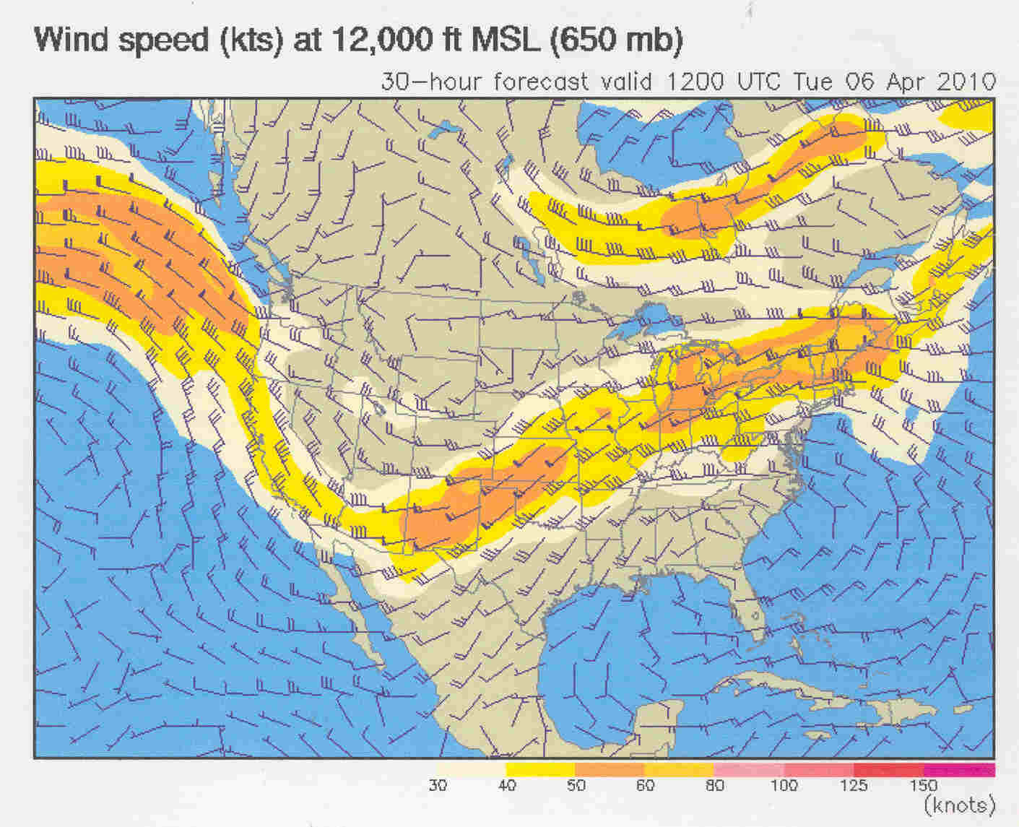

Launching: The departure from San Diego meant flying down in the afternoon of April 5th, spending the night in a hotel, and launching early the following morning. There is a good Sheraton Hotel outside Montgomery Field (just north of San Diego) so I decided to launch from there. On Monday, I changed the oil in the plane since my oil consumption always seems much better on brand new oil (1 quart every 10 hours), packed an overnight bag, filled up my two oxygen bottles, and packed a bag of in-flight snacks. I had decided that a before-dawn departure at 5am would allow me to arrive at Savannah just at the end official twilight. I did not want to be groping around Georgia in the nighttime in a possible low fuel situation.

Flight to San Diego: But first I had to get to San Diego. The briefer was not encouraging about flying to San Diego. It had been raining all morning in Central California and the same cold front was now situated over southern California with winds at Montgomery of 20 knots, gusting to 35 with occasional ceilings of 600 feet overcast 1 ½ miles in rain. I noted, with some satisfaction that the winds were directly out of the west and filed my flight plan to San Diego. Contrary to the forecast, the flight down was beautiful. I used it to re-confirm the long range cruise configuration and to practice my engine leaning during climb procedure. Except for a few clouds during the approach into Montgomery, the flight was in perfect VFR conditions. The plane performed beautifully. On landing, I oversaw the fueling of the plane like a mother hen. I wanted every drop of fuel that could fit to be in the tanks.

Flight Plan: I filed my flight plan before going to bed. The briefer was quite interested in a Mooney flying 1800 plus miles and asked me all sorts of interesting questions. I slept soundly until the alarm went off at 3:30am

Launch: I had planned a 5am departure. But there was a lot to do between the alarm and lift off. I brewed a thermos of coffee in the room, packed my bags, and checked the weather. The forecasted winds were the same. There were clear skies both in San Diego and in Savannah, and so far as I could tell, no weather whatsoever on my route of flight. It could be an easy flight, I was thinking. I drove my rental car back to the airport and loaded the plane using the headlights of the car. A suspicious security guard drove over and wondered if I had paid my parking fee (I hadn’t). While fueling the prior evening, I had bought two extra gallons of Avgas in a separate gas can, which I now used to top off the tanks. Gas from the extended tanks slowly fills up the airspace at the top of the main tanks so, a top off can nurse another few gallons into the tanks. The evening was chilly and moist causing dew to condense on everything, especially the plane windows. I tried to keep the windows clear but it was something of a losing battle. The moon was a week past full and the setting quarter moon offered scant illumination. I had several flashlights at the ready. Finally, I strapped myself in the cabin, arranged all my charts and other in-flight equipment and entered the first 10 waypoints of my flight plan into the Garmin 430. Finally, I started the engine. The moisture on the windows pretty much obscured whatever view there might have been.

As the Montgomery tower was closed at this hour, I called SOCAL approach and received my IFR clearance which was the same as filed the night before. The taxi to the active runway was a slow and tentative process because of my poor visibility and unfamiliarity with the airport. My Garmin 695, however with its “Safe Taxi” feature provided a detained taxi diagram with a little plane moving along the taxiways toward the active runway. I should mention that I rarely fly at night having suffered in 40 years of flying two in-flight engine failures. Such problems in the dark have a special terror to all pilots and I am no exception. Nonetheless, the beauty and solitude of night flight has a special allure to which I am not immune.

Takeoff: I called for my release which came almost immediately and at 5:12 (only a few minutes later than planned), I poured on the coal and ascended into the night sky with San Diego lights like a sparkling blanket below me. The first waypoint was Mission Bay VORTAC right on the coast followed by a course reversal to join V66 which was to take me all the way to Gila Bend, Arizona. Almost immediately, after liftoff, I throttled back into my climb configuration which is basically normal cruise power, about 70 % horsepower. This allowed me to also lean the engine in climb, something I normally don’t do. But I was mindful that each extra gallon used in climb reduced my range by 20 nautical miles. As it turned out, my gradual climb out of San Diego used less fuel than I had planned. When I reached 13,000 feet after 25 minutes of flight, the fuel totalizer showed only 5.6 gallons used. That included my taxi fuel, and I was 45 nm along on V66.

Sunrise: I have a wonderful piece of aviation technology in my cockpit which is the Garmin 695 portable GPS mounted on the pilot’s-side yoke. It has a huge moving map showing the aircraft’s current position and a complete database of aeronautical information including current weather downloaded from a satellite. However the first thing I noticed as I took off was that the 685 was much too bright. I had never flown with it at night before and I did not know how to turn down the brightness (I do now). But it was obscuring the other instruments and the view outside. So as an interim solution, I covered it with my approach plate book and I could then see outside comfortably. I noticed a vague horizon to the east which was the first indication of the coming sunrise.

I also noted that the autopilot was holding an almost 30 degree cut to the left (North) of the course for V66. Strange, I thought, maybe the gyro compass (HSI) was not set correctly on takeoff. I also was somewhat displeased to see that the huge westerly winds forecasted had not yet boosted our speed in the climb much beyond 100 knots. Hmmm…. Let’s see what happens when we are settled in cruise.

Over the Imperial Valley, the sun burst over the horizon causing me to scramble to put on my sunglasses. Beautiful, but we have a long way to go and it will be night again when we get there.

Cruise: About 50 miles east of San Diego I reached 13,000 feet and I further leaned the mixture until the engine was burning 6 gallons per hour. The GPS ground speed barely got above 140 knots. Oh dear. We need 150 knots average ground speed all the way to Georgia, and here is where I expected 175 knots or a 50 knot tailwind. It doesn’t look good. I wonder what happened. Well, let’s see how it goes as we head further east.

Over Bard VOR (BZA), which is 137 nm from Montgomery and 1:10 into the flight, I did a serious reality check. My fuel totalizer showed the endurance of the airplane at current fuel burn: 12 hours and 37 minutes. The Garmin GPS showed time to destination: 12 hours 38 minutes. Oops…. And I should at this point be making ground speed well in excess of the trip average. What is happening? It became obvious to me (as confirmed later) that the strong westerly winds had shifted into strong north westerly winds. A small meteorological detail, but of huge importance to my progress eastward. So this is why the autopilot was making a 30 degree correction to the North. Ugh. It didn’t look good.

Change of Plans: I flew on for another hour until I was abeam of Phoenix before I finally decided what I wanted to do. I was very loath to admit failure but I realized that landing in Alabama had little appeal. Traveling a “long distance” is not the same accomplishment as doing something that has a familiar scale, like flying “coast to coast”. So the choice was either to make an unexpected visit to my brother-in-law in Texas or throw in the towel and return home to Salinas. It took about an additional minute to make that decision. I called the controller:

“Albuquerque Center, N9208M cancelling IFR. We wish to stay with you for flight following VFR to Salinas California”.

“N9208M, Cancellation received. What is the identifier for Salinas?”

It was probably the first time any aircraft has diverted to Salinas while en route to Savannah.

A Long Slog Home: The trip home to Salinas from Phoenix at normal cruise power took four more hours at 110 knots ground speed as the northwest wind that did little to help me get to Savannah, was a full in-the-face headwind while traveling back to my home base.

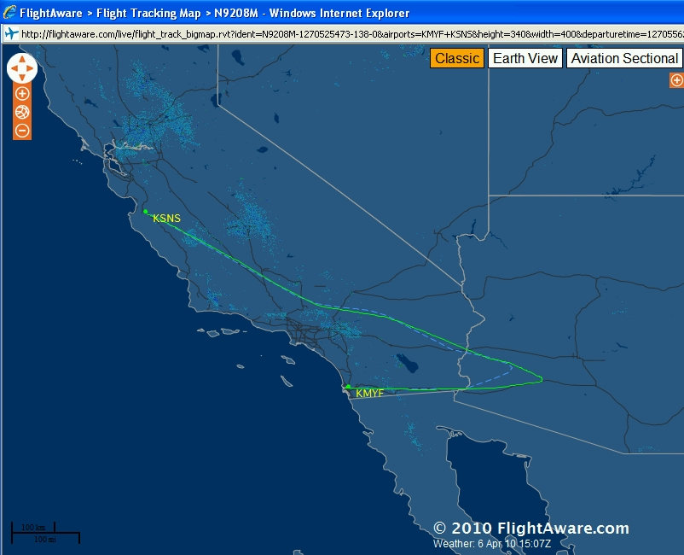
The aborted first attempt at a non-stop cross country flight

Undeterred: I was disappointed but not discouraged. I was hopeful that there would be some more days of strong “winter’ winds before the summer weather established itself. I also felt that I could improve on my chances of success by making some minor changes to my flight strategy:

First, I intended to fly at lower power setting to improve efficiency and increase miles per gallon. On my first attempt I was using a cruise settings burning 6.0 gallons per hour and thereby limiting myself to 12 hours of flight. If I could burn 5.0 gallons per hour, I reasoned, I could remain aloft in cruise for 15 hours. I would go slower (115 knots vs. 123 knots) but I would be getting better miles per gallon (23 vs. 20 mpg). But more importantly, if the winds were reasonable strong, that extra time aloft would translate into greater range. So I determined to set power to burn 5.0 gph.

Secondly, I was determined to fly at 15,000 feet rather than 13,000. Presumably the winds would be stronger at the higher level. The extra altitude would, by default, lower the power produced by the engine, and thereby reduce the fuel flow to the desired 5.0 gph.

Third, I decided that it was unnecessary to get up early for a 5am takeoff, and that a daylight departure would make the morning preparations and takeoff easier. I had some difficulty staying awake on the aborted first flight and I figured that a full and restful night’s sleep would be helpful. This later schedule, however, would mean I would be landing after sunset in Savannah.

Waiting for the Weather: Unfortunately, most of April was characterized by sluggish winds and by generally bad weather along the southern tier of the US. It wasn’t until the very end of the month that I could see evidence of the high-level jet stream moving south which is also associated with favorable low level winds. On Sunday April 26th, I participated in the 21-mile power walk associated with the Big Sur Marathon and on Monday I was an ambulatory basket case. But in response, it seemed, the 3 and 4-day forecasts were showing favorable winds, similar to those on my earlier attempt, only better. There were strong 50-60 knot west winds in the far West, shifting to moderate south west winds over Texas and then steady 10-30 knot westerly winds over the South Eastern states. It looked good for a Thursday, April 29th, departure.

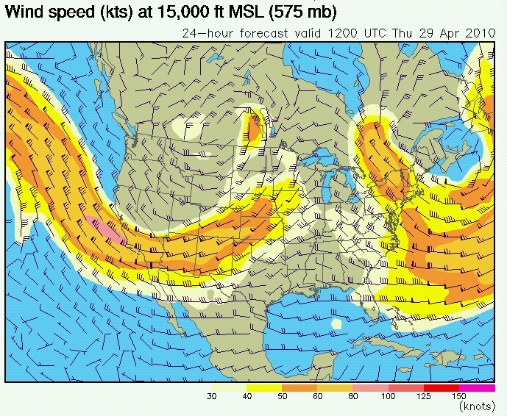
Preparing Again: I went through the preparation drill as before. I poured over my 4 page check list making sure I had everything in order. I filled my oxygen bottles and changed the oil even though there had been only had 18 hours of operation since the last oil change. I packed my small overnight valise. I updated the database on the Garmin 430W. By Wednesday afternoon, all was in readiness and I flew down to Montgomery Field, just north of San Diego and checked into my hotel.

Dual Flight Plans: I had prepared two different flight plans: The first light plan was the same as before, essentially a straight shot across the southern US via El Paso. The alternate flight plan was slightly longer and was designed to take advantage of the northern shift in the strong winds over Texas. By taking a slightly more northern route via Albuquerque, the flight path would be in the stronger winds for a longer time. As I prepared to retire, I ran both routes through the flight planner at duats.com. The original flight path was only minutes slower than the alternate, so I decided to stick with the shorter and more direct routing. I filed my IFR flight plan and went to bed quite relaxed when compared with my first attempt.

Departure: The drill in the morning was much the same as on the previous attempt except it was daylight when I arrived at the airport. This made loading up and doing my preflight much easier. Actually, there wasn’t much to do since the previous evening I had fueled the airplane, topped off the oil, and organized the cockpit. As before, I coaxed an additional 2 gallons of fuel into the extended tanks, making for an actual fuel load of 90 gallons. I never planned the flight for 90 gallons, but rather for the official 86 gallons. But I knew it was there if I needed it in a pinch. If I was tight on fuel at the end of the flight, I planned to run one tank dry and therefore know that all my usable fuel was in a known tank. But from past experience, I was aware that a restart at altitude after running a tank dry seems to take forever, and doing that in the dark over unfamiliar Georgia did not have much appeal. If I was really tight on fuel, I would land short.

I called for my clearance which came back simply as:

“Cleared to Savannah airport, after takeoff fly 270 degrees, radar vectors to Mission Bay (VORTAC), join Victor 66 Gila Bend as filed, climb to and maintain three thousand feet, expect fifteen thousand in 5 minutes, squawk 7214, frequency 119.6”.

Then I was on my way. After two minutes going westbound after takeoff, the controllers turned me to my on course heading and joined V66 and headed east. My climb was slow as I was throttled back to normal cruising power and leaned out to 10 gph (and less as I got higher). I was gratified that my ground speed showed 120 knots while I was indicating 90. This was a good initial sign. San Diego was covered by a thick overcast of cumulus clouds and from about 4,000 feet until 8,000 feet I was in bumpy wet clouds. At 8,000 I broke out into the bright sunshine. The sun sat just above the horizon straight ahead.

Cruising over the South West: The wind was really tearing along at 50-60 knots directly on my tail. It was relatively smooth, but I soon became aware in my climb that there were strong up and down drafts. One moment I’d be climbing at 1500 feet per minute and the next unable to maintain altitude in my climb. I eventually reached my planned cruising altitude of 15,000 feet helped by a strong updraft and set up the engine to my planned cruising settings: 1950 RPM, maximum, manifold pressure (16 “), and mixture leaned to 5.0 gallons per hour. It because quite obvious that the engine was not happy with these settings. It was running rough and occasionally missing. I found I had to richen it out to 5.2 gph to be reasonably smooth and at 5.3 gph it was purring like a well-fed pussy cat.

The second unintended situation was that the plane could not maintain a reasonable airspeed at this power setting at 15,000 feet. I would set it up at an indicated airspeed of 95 knots and then the airspeed would start to decay and the deck angle would get steeper and steeper, finally mushing along at an indicated airspeed of 70 knots as the autopilot tried to hold altitude. This was not good planning. I had never actually test flown the airplane in this configuration at 15,000 feet which turned out to be a careless error, but not a fatal one. Eventually I descended to 13,000 feet and flew most of the flight at this altitude burning 5.2 gph and truing out at 115 knots.

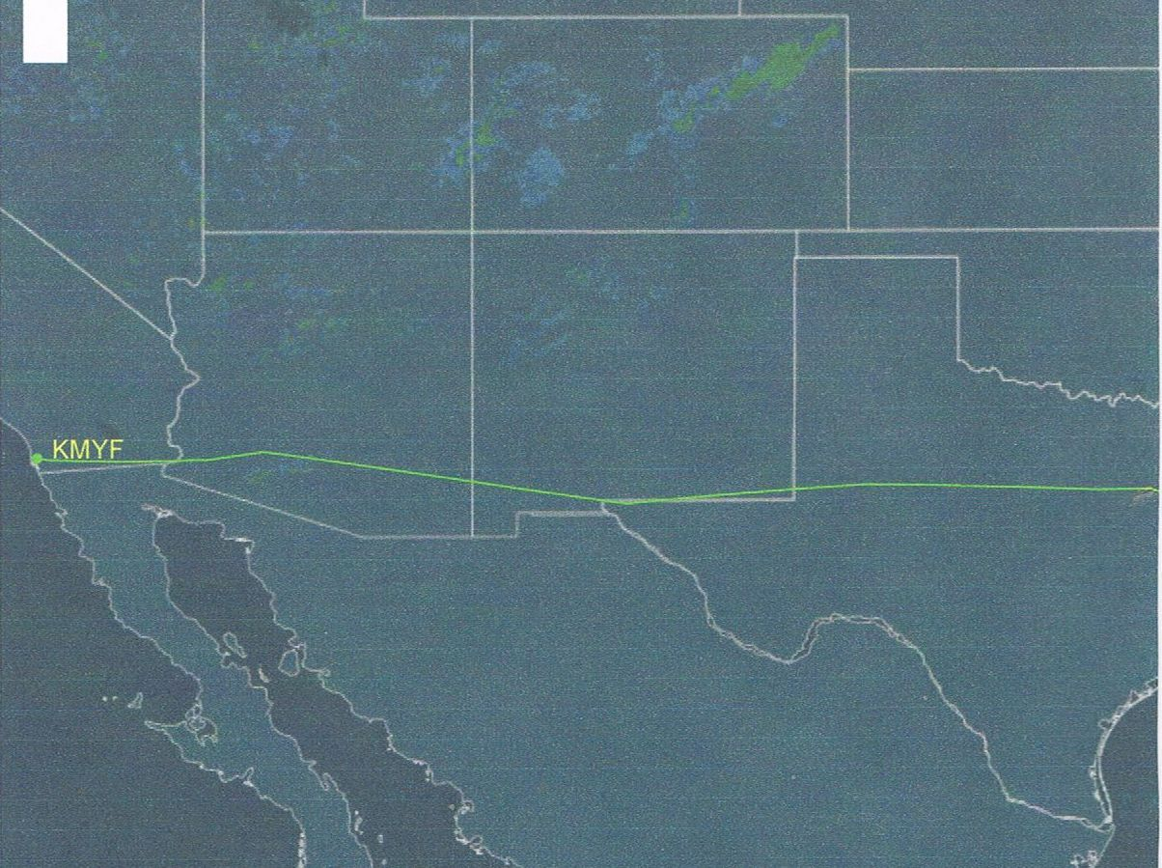
The first half of the flight

Mountain Waves: The ride over southern California, Arizona, and New Mexico was as fast as I could have hoped for. But the strong winds were creating mountain waves characterized by long-period strong alternating updrafts and down drafts. Setting the autopilot up for a stable cruise was completely impossible After some thought, I asked Center for a clearance for a block altitude of 13,000-15,000. Since there wasn’t much traffic and none in the mid teens, this was immediately granted. So for the next four hours as I tore over Arizona and New Mexico, I turned off my altitude hold on the autopilot and manually held an average indicated airspeed of about 95 knots. We rose and fell as the waves dictated but it was relatively smooth. Following the recommendations of my soaring friends, I tended to slow down in the updrafts and speed up in the down drafts. I think this had a beneficial effect. But hand flying the airplane was not very restful. Occasionally, I experienced a longer than average down draft had to temporarily increase power to avoid sinking below 13,000 feet. In some of the up drafts, I saw a ground speed in excess of 200 knots. On the average, I had a ground speed of around 180 knots, a tail wind of 65 knots. Below is a screen shot of the GPS showing one of the good moments with a ground speed of 213 knots as we passed over the Imperial Valley. It also showed an optimistic time en route to Savannah of just over 8 hours based on the current airspeed.

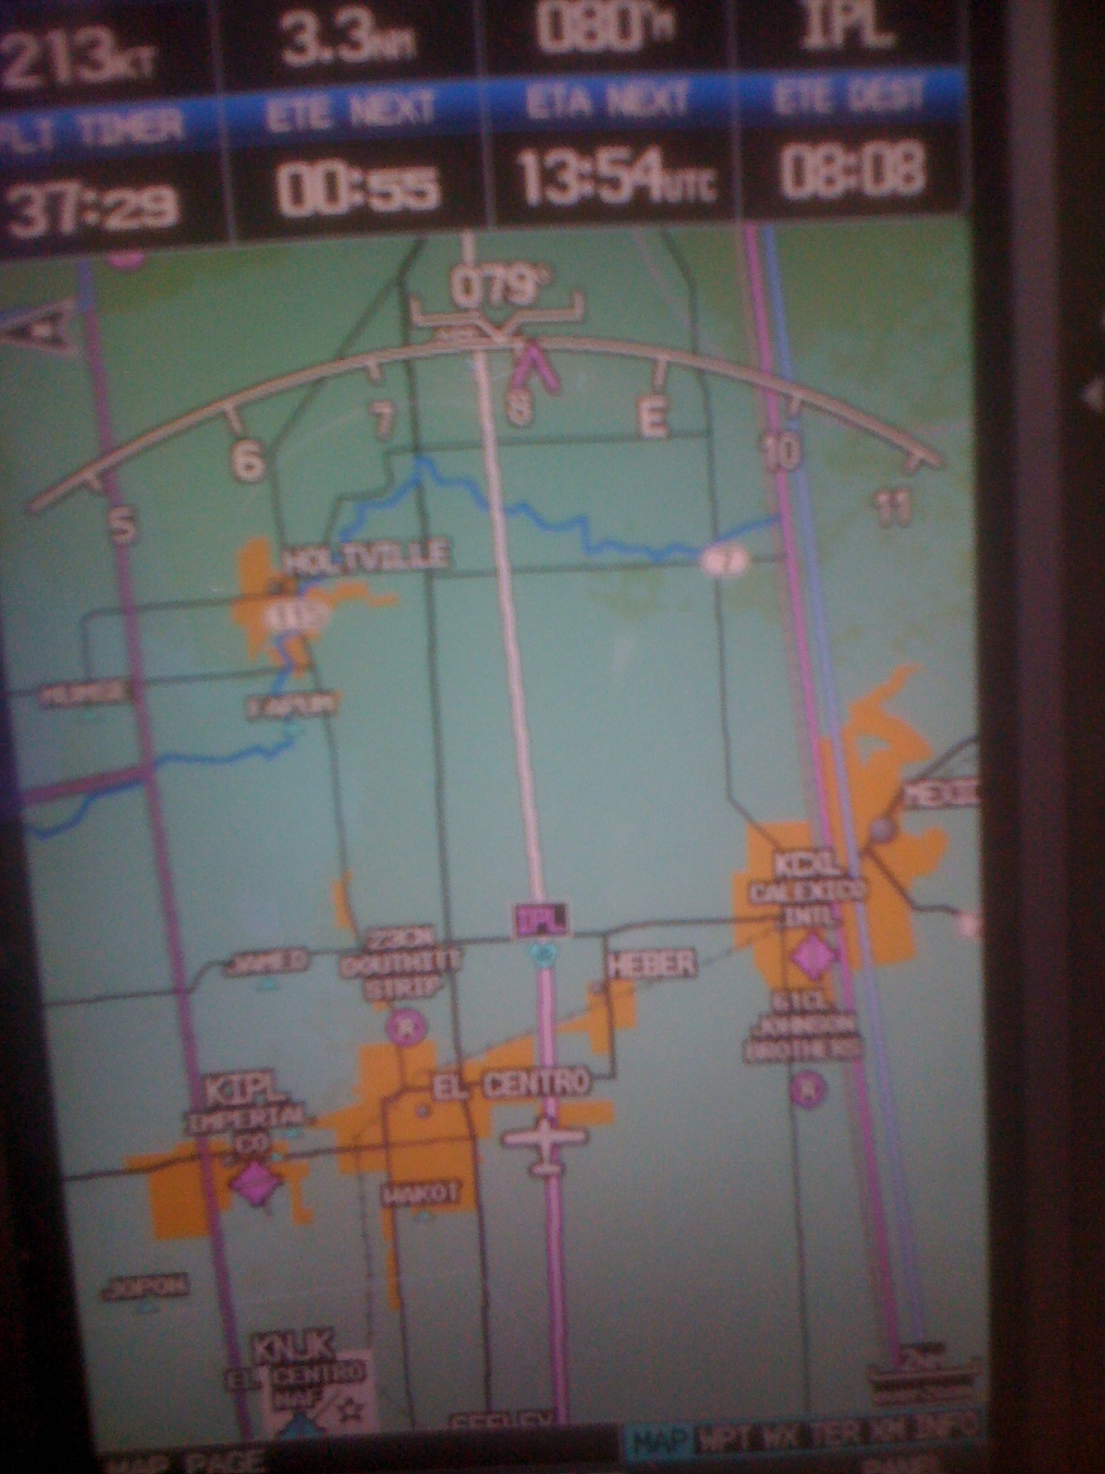
213 knots groundspeed over the
Imperial Valley, California

By the time we reached Midland, Texas, the mountain waves had disappeared and I settled in at a smooth cruise altitude of 13,000 feet. I held this altitude for the rest of the flight. And I could count on the autopilot to do most of the flying while I did other chores and monitored the airplane.

Equipment: This coast-to-coast flight relied on installed equipment that I would classify as essential to achieving long distance flight in a safe and comfortable manner:

- Long range tanks – Absolutely essential to achieve the range for a coast-to coast flight. These tanks added 36 gallons (actually 38 gallons) to the standard fuel capacity of the aircraft.

- Autopilot with altitude hold – This allowed me to relax and concentrate on monitoring the flight.

- Totalizer - The JPI 450, the second absolutely essential item, allowed me to optimally lean the engine (along with my engine analyzer) and to know exactly how much fuel I had in each wing.

- GPS coupled to the autopilot - The Garmin 430W allowed me to enter the entire flight route in and to fly direct to any waypoint. It and the Garmin 695 provided me with perfect situation awareness which was a big help and comfort. Further, the unit would support low IFR approaches should those be necessary.

- In-Cockpit Weather - The Garmin 695 with XM weather allowed me to monitor the clouds and convective weather ahead (thankfully, there wasn’t any) and to get real-time updates of the forecasted winds. The battery powered 695 was also my backup navigation should the 430W and my VFH navigation radio (King KX-155) fail.

- Oxygen – Also essential for flying at altitudes where the winds were strongest and for reducing fatigue and maintaining adequate O2 blood levels for coherent decision making. I was on oxygen for the entire flight and used one D-size medical oxygen tank for the 13 hours I was in the air. An oxygen saturation level monitor confirmed that I was actually receiving sufficient oxygen.

- Active Noise Reduction Headset - The E-Model is a noisy airplane even at 1950 RPM . The near total silence created by the Bose 10 headsets is a major fatigue reducer.

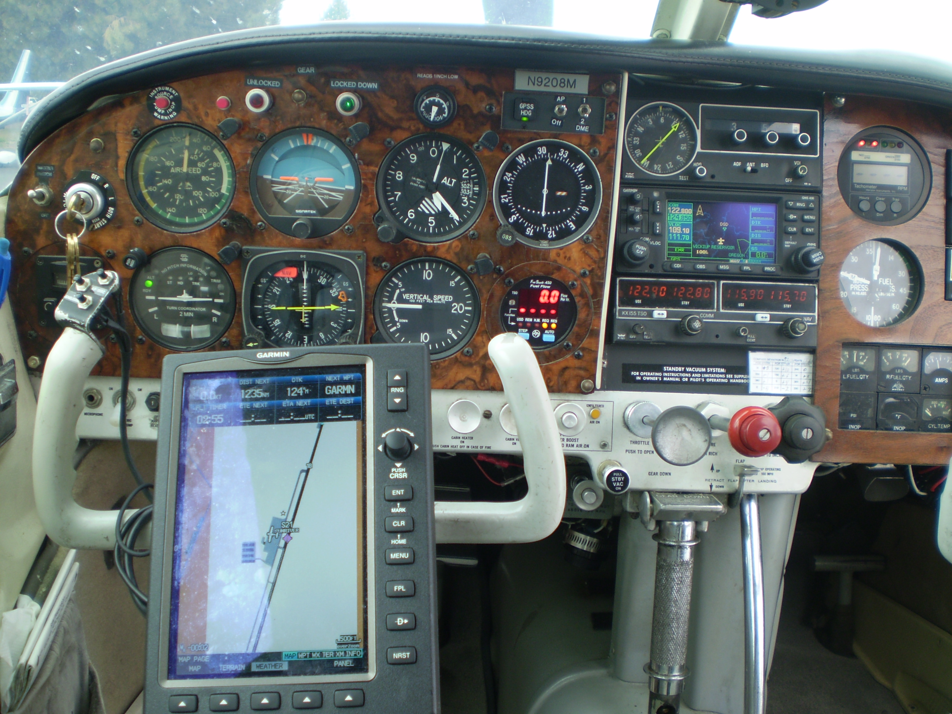
Dual Garmin GPSs (430W and 695), JPI Fuel totalizer on the lower right,
STEC-30 Autopilot, King HSI.
My Front Office: The cockpit was a cozy and friendly place. I had everything close at hand. I used a strap-on knee board to record clearances and to make notes about flight conditions. The ashtray to my left held a supply of pens and pencils. The O2 tank was strapped to the passenger’s seat to my right with the capacity and fuel flow gauges easily visible. The O2 delivery tube was suspended from one of the overhead panel spot lights to support the weight of the tube. My IFR chart atlas from Aircharts was on the seat next to me, but really served only as a backup to the GPS. On the seat behind me within easy reach (remember this is the short body E-Model) was my flight bag full of aviation gadgets and charts. The rear seat also held my lunch bag, two quart bottles of water, handheld VHF radio, and spare headset. In a wall pocket to my left was my oxygen level sensor that I from time to time strapped onto one index finger to confirm that I really was feeling as well as I felt. The same pocket held two LED flashlights.

On this flight, I dressed for comfort, wearing draw string sweat pants and sweat top over a T shirt. My first act on reaching cruising altitude was to shed my shoes, move the seat back a notch or two, and do my best to feel relaxed in spite of the inherent excitement of the task at hand.

I felt I must look somewhat ridicules. My head was covered by my Mooney baseball cap, eyes obscured by dark sunglasses, the Bose headset hid everything recognizable as human from the side, and the rubber mustache that is part of the Oximizer cannulus makes one look like a plastic walrus.

Fuel Management: One of my most critical tasks was to switch fuel tanks so as to maintain an even fuel load between the left and right wings. The fuel gauges in my airplane are ancient and highly inaccurate. But the JPI fuel totalizer kept track of fuel use and fuel remaining as well as calculating endurance and current miles per gallon (it is connected to the GPS). But it did not tell me how much of the total fuel remaining is in each tank. To handle this task I kept a detailed log of fuel used at each switching of tanks. During the flight, I switched tanks 7 times. After initially using 6.2 gallons from the right tank (in the climb), I switched tanks every 2 hours (about every 10-11 gallons). In general, there was never much more than a 5 gallon difference between the left and right sides. Below is the fuel log from the trip for those who might be interested in such details. Note that the time to destination is significantly affected by the current ground speed at the time I switched tanks.

Leg Start (UCT) | Tank  Used | Fuel Used | Fuel On Board * | Leg Fuel Used | Left Tank | Right Tank | Endur-  ance | Time to Dest | Fuel Flow
13:15 | R | 0.0 | 86.0 | 6.2 | 43 | 43 | - | - | 13.2
13:47 | L | 6.2 | 78.8 | 11.0 | 43 | 36.8 | 13:13 | 9:03 | 5.9
15:37 | R | 17.2 | 68.8 | 10.5 | 32.0 | 36.8 | 12:58 | 7:42 | 5.3
17:30 | L | 27.7 | 58.3 | 10.4 | 32.0 | 26.3 | 11:05 | 7:47 | 5.2
19:30 | R | 38.1 | 47.9 | 10.8 | 21.6 | 26.3 | 9:09 | 5:21 | 5.3
21:30 | L | 48.9 | 37.1 | 10.5 | 21.6 | 15.5 | 7:00 | 4:37 | 5.3
23:30 | R | 59.4 | 26.6 | 10.6 | 11.1 | 15.5 | 4:59 | 2:34 | 5.3
01:30 | L | 70.8 | 16.0 | 4.0 | 11.1 | 4.4 | 2:58 | 0:34 | 8.0
02:10 | - | 74.0 | 12.0 | - | 7.1 | 4.4 | - | 0:00
* Actual fuel at start was 90 gallons, at end 16 gallons

Direct Routing: The filed flight plan route followed the airways and was relatively straight from San Diego to Savannah. Over Southern New Mexico I asked for a direct routing that would cut a few miles of the leg between San Simon (SSO) and El Paso (EWM). I was disappointed when they said they were unable to give that clearance. After a pause of perhaps 30 seconds, they came back with the following:

“After El Paso direct Meridian (Mississippi)”

I was pretty pleased. This bypassed 10 intermediate waypoints and shortened the route somewhat by eliminating an equal number of twists and turns.

As I approached the Dallas/Fort Worth class B airspace, center gave me a revised routing that would take me around the Class B area to the south. They explained, somewhat apologetically that if I were VFR, I could fly directly over the area. But being IFR, I had to go around. “Go figure!” the controller added.

I had one more direct clearance, after Meridian, I was given direct Macon (Georgia). This too was slightly amended later to avoid a hot MOA near Montgomery.

Shifting Winds: As expected, by the time I had reached central Texas, the winds had quieted down and shifted to the northeast. South of Dallas/Fort Worth and before Shreveport, LA, I observed my slowest ground speed of the trip, 124 or a tail wind of only 9 knots. I expected from the forecast for the winds to pick up slightly over Mississippi and Alabama. Over Shreveport, I had an endurance of 7:00 hours (37 gallons remaining) and only 638 miles to go. Even if the winds quit altogether, I could make it to Savannah in five hours and thirty minutes. This was the first time in the trip that I felt confident that I was going to succeed in this venture. As it turned out, I reached Savannah four hours and forty minutes later.

Crossing The Southeast: Abeam of Longview Texas, I wondered if Don Maxwell, owner of the local Mooney Service center and a frequent follower of Flight Aware, was noting my presence in his airspace. What I didn’t know was that he and dozens of other friends, Mooney colleagues, and total strangers were following my flight with feelings of good wishes and bemused amazement. I learned later that Don was indeed watching and called Longview approach control asking that they pass on the greetings from the Mooney “List”. Unfortunately, these good wished did not arrive before I was switched to the next sector.

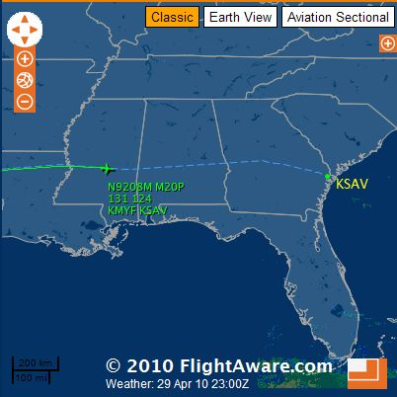
124 Knots over Mississippi at 13,000 feet

As I progressed eastward, the sun, low on the horizon behind me, began to strike the instrument panel over my left shoulder. The flight conditions were absolutely smooth. The autopilot was doing its usual perfect job. It seemed incredibly peaceful and quiet in the cockpit. This was how I had hoped and imagined any long flight would be, a time to wonder at the marvel of flight and to be at peace with one’s self. Forgotten were the up and down drafts over the Southwest.

Over eastern Mississippi, I could see that the tailwind was picking up again. The ground speed nudged 136 knots, a tail wind of over 20 miles and hour. That’s good, I was thinking, and it added to my sense of contentment.

An Arrival Dilemma: Over Montgomery, Alabama, I consulted the AOPA database on the Garmin 695 to see about FBOs at Savannah International. It turned out that all FBOs closed at 5pm local except for Signature Aviation which closed at 10 pm. I did a quick time zone analysis and discovered that I would arrive in Savannah at 10 minutes after 10 pm. I checked my cell phone but the battery had run down by trying to find cell station or Wifi signals since leaving San Diego. I had visions of standing alone on a dark and abandoned ramp, cell-phone out of juice, locked into the confines of airport for the night. Hmmm. What can I do? I couldn’t call Signature from the air. I decided I’d try to contact flight service to see if they could help. So I called Anniston Radio while approaching Montgomery and told them of my problem and asked if they would call Signature requesting them to remain open for a few extra minutes to handle my arrival. I explained the unusual nature of my flight and the FSS person was most helpful. A few minutes later, he called back with the message that Signature would remain open but it would cost me $75 dollars in overtime fees. Was that OK? I responded in the affirmative, I didn’t see that I had any choice, but I was a bit disgruntled with Signature. On the other hand, I was very appreciative with the help the FSS guy was giving me.

With the tail wind increasing and with the substantial reduction of my fuel load, I consider making some reduction in power and airspeed. This would have the effect of increasing my MPG as well as my reserves at the end of the flight. On the other hand, I was approaching the end of the flight with little more than two hours to go. My reserves were ample. The totalizer showed an endurance of 4 hours and 23 minutes. I could afford to increase speed and get to Savannah somewhat sooner. But I was reluctant to change anything since everything was working so perfectly. I had used these same settings since El Paso so why change them now? So I just left the power settings as they were. .

Night Falls: Somewhere east of Montgomery, night gradually overtook me. I turned on the navigation lights, the strobe light, and the panel lights to full. I arranged my flash lights close at hand, and turned down the illumination of the Garmin 695. I could look over my left shoulder and see a thin strip of red glow on the western horizon. Outside there were few lights on the ground. It was very quiet and peaceful. The engine hummed away with its comforting drone. My only connections with the ground were the infrequent communications with Memphis Center and Montgomery approach control.

I considered emergency alternates should anything start to go sour: Columbus, Macon, Dublin, Metter. I jotted down some frequencies for each just to be prepared. In the dark, an emergency landing would not be fun. I checked the weather for Savannah on the 695. Perfect! Winds from 180 degrees at six, clear skies, visibility better than 10 miles. I consulted the airport diagram on the 695. It looked like the landing would be on runway one eight.

Montgomery turned me over to Atlanta Center.

“Good evening, November 9208M, Columbus altimeter two niner eight six. Bill Rabek and a bunch of guys on the ground send their regards for a safe trip”.

Whoa…. I am suddenly re-connected to the rest of the world. Bill Rabek is an Atlanta-based air traffic controller, flight lead for the Mooney Caravan to Oshkosh, and a good friend. He must have made an arrangement to have the on-duty controller send some sort of greeting. I was grinning from ear to ear. I returned a startled acknowledgement to the controller and we spoke briefly about the trip. Now that was really nice, I thought and wondered who he meant when he mentioned a “bunch of guys”.

Descent: I passed over Macon at 0110 UCT (9:10 pm Local time, 6:10 pm California time). I had less than an hour and 126 miles to go. My ground speed was steady at 137, a 22 knot tail wind. The lights below spoke of a bustling community but the area further east was totally dark and somewhat foreboding. I couldn’t yet see the lights of Savannah. I also noticed a strange obloid smudge at my one o’clock position. I looked at it with increased concentration as it transformed itself into a bright red semi circle on the horizon. The Moon! It had been a full yesterday and would be the same tonight. How beautiful and wonderful. It rose with amazing rapidity slightly to the right of my heading. Before long, I could actually see features on the ground below in its cold illumination. Not that I needed it with the autopilot working so steadily, but I now had a perfect horizon for hand flying if necessary.

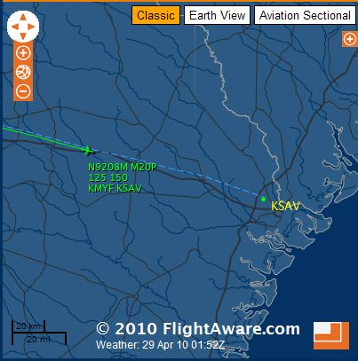
Descending into Savannah Georgia

About 50 miles out of Savannah, I received my first request to descend, a modest two thousand feet to eleven thousand feet. I disconnect the altitude hold and pushed forward on the yoke. It was my first change in altitude in 1300 miles. The control pressure was heavy and stiff. I got the plane going down at about 300-400 feet per minute but did not reduce the power. A few hiccups at 11,000 feet reminded me to feed in a slightly richer mixture. The fuel rate rose to 7.5 gallons per hour. I was seeing 120 knots on the airspeed and 150 ground speed. Before long, I got a further descent at pilot’s discretion to 5,000 feet. I was in no hurry to get down and to sacrifice the safety of altitude by a headlong descent. I descended at a leisurely 500 feet per minute. I listened to the ATIS (airport terminal information service) which confirmed the good weather. Atlanta Center turned me over to Savannah Approach and I was told to expect a visual approach to runway 18 (as expected) and given further descent. The Garmin 695 obligingly depicted the extended center lines of the runways. At 3,000 feet, I turned eastward to make a right base to the active runway. I could not recognize an airport down there and I did not see a rotating beacon (it must be there somewhere) but the GPS assures me that somewhere in the jumble of ground lights, was my intended airport and the ending of this miraculous flight. I turned a five mile final at 2,000 feet and there ahead was the welcome sight of flashing threshold lights and the VASI. Two miles out, I lowered the gear, did a GUMPS check with more care than usual, and flipped on the landing light. As the threshold passed under me, I murmured a small prayer for a smooth and uneventful landing. Chirp , chirp, one of my better landings. I had arrived.

Arrival: I turned off the active runway onto the parallel taxiway and requested directions to Signature Aviation. Shortly afterwards a golf cart came careening out to my taxiway with the obvious message, “Follow Me” which I compliantly did, grateful to have someone else worry about the navigation for awhile. We reached a parking place and I shut down the engine. I was in Savannah Georgia, twelve hours and fifty five minutes, 74.0 gallons of fuel, and 1810 nautical miles from San Diego, California.

Afterwards: Much to my delight, the night manager at Signature told me that they had received several calls of congratulations to be delivered to me. Figuring that I might be some sort of VIP, they waived the $75 dollar overtime charge, which also pleased me. I was directed to a nearby hotel and personally delivered there by the now off-duty line manager. Wide awake (after all it is only 7 pm California time) I first called my wife who was greatly relieved. I then checked my e-mail and found about fifty e-mails of congratulations and general discussion concerning the flight. Most of the senders had followed my flight on Flight Aware hour by hour. I was very content, not only because the flight succeeded without a single problem, but that my friends and acquaintances were able to share and appreciate the experience.

More Details: For the detail-minded among the readers, follows my navigation log from the flight. No attempt was made to clean up the entries. This was exactly as created.

Leg Start (UCT) | Location | FL | IAS | GS | Dist  to Dest | Time to Dest | Endur-ance | Flight Conditions
13:15 | San Diego (KMYF) |  |  |  | 1845 |  |  | Overcast
13:55 | Imperial (IMP) | 130-150 | 102 | 200 | 1763 | 8:40 | 13:15 | Light chop, up and down drafts
14:10 | Bard (BZA) | 130-150 | 110 | 201 | 1717 | 8:34 | 14:45 | 5.4 gph, 35.6 mpg, up and down drafts
14:20 | MOHAK Intersection | 130-150 | 102 | 179 | 1685 | 9:25 | 13:35 | 5.7 gph, VFR clear
14:42 | Gila Bend (GBN) | 130-150 | 106 | 180 | 1619 | 8:56 | 13:41 | 20 degrees left deflection. Light chop
14:54 | Stanfield (TFD) | 130-150 | 90 | 175 | 1580 | 8:36 | 13:27 | Undercast, parachute jumping at Eloy
15:55 | Abeam San Simon (SSO) | 130-150 | 102 | 173 | 1441 | 8:11 | 12:21 | Severe Mountain Wave, Full power.
16:20 | Abeam Deming (DMN) | 130-150 | 80-110 | Var 150 | 1357 | 9:10 | 12:09 | Severe Mountain Wave
16:51 | Newman (EWM) (Abeam El Paso) | 130-150 | 105 | 164 | 1287 | 7:16 | 11:43 | Direct Meridian MS
17:11 | Abeam Salt Flats (SSO) | 130-150 | 100 | 158 | 1225 | 7:36 | 11:19 | Above Guadalupe Mountain Range
17:48 | Abeam Wink (INK) | 130-150 | 85 | 149 | 1131 | 7:33 | 10:48 | Smooth
18:32 | Abeam Snyder TX (KSNK) | 130 | 97 | 151 |  | 6:11 | 10:08 | New routing to avoid DFW
19:03 | Abeam Tuscola (TQA) | 130 | 100 | 149 |  | 5:48 | 9:36 | Abilene TX
19:46 | Glen Rose (JEN) | 130 | 97 | 149 | 773 | 5:03 | 8:52 | At this point, I know we will make it, 46 gallons left
19:52 | CELTIC Intersection | 130 | 96 | 144 |  | 5:22 | 8:41
20:19 | Cedar Creek (CQY) | 130 | 96 | 129 | 744 | 5:45 | 8:18 | Light chop, Direct Macon, GA
20:58 | Abeam Longview TX (KGGG) | 130 | 97 | 128 | 690 | 5:34 | 7:38 | Discussion with FTW controller. Smooth, few clouds at 10K
21:25 | Abeam Shreveport LA (SHV) | 130 | 95 | 126 | 633 | 5:05 | 7:09 | Smooth, getting colder
22:00 | Monroe LA (MLU) | 130 | 96 | 130 | 553 | 4:21 | 6:35 | Sun lower, smooth, freq quiet, still FTW
22:20 | Mississippi River | 130 | 97 | 135 | 506 | 3;46 | 6:11 | Revised routing, MEI Direct MCN
22:42 | Jackson MS | 130 | 100 | 131 | 466 | 3:37 | 5:48
23:14 | Meridian MS (MEI) | 130 | 99 | 132 | 396 | 3:03 | 5:16 | Direct MCN
00:07 | Abeam Montgomery AL (MGM) | 130 | 97 | 136 | 270 | 1:57 | 3:51 | Shadows longer, called Signature via FSS
00:39 | Abeam Columbus GA | 130 | 96 | 132 | 199 | 1:27 | 3:51 | Night
01:10 | Macon GA (MCM) | 130 | 98 | 137 | 129 | 0:56 | 3:18 | Night
01:28 | Dublin GA | 130 | 98 | 138 | 86 | 0:38 | 3:04 | Starting Down
02:05 | Savannah GA (SAV) | 130 | - | - | 0 |  |  | Totalizer = 12.0 gallons plus 4 = 16 gallons remaining

