Belize Honeymoon

By Jonathan Paul, MAPA #5549

The Honeymoon

This story is about our honeymoon trip in our Mooney to the Central American country Belize. Well, it wasn’t exactly our honeymoon. That distinction belonged to our young friends and Mooney owners Monika and Morten Boyd. What is interesting is that Monika and Morten (who I will henceforth abbreviate as M&M) invited us, a couple 25 years their senior, to share this special time with them. This is, in itself, a testimony to that special bond that can grow up between flyers.

I met M&M at a Mooney fly-in at Mulegé, Baja Sur, Mexico, in the Spring of 2004. They are a professional couple from Los Angeles who fly a well-equipped 1970 F model, N9344V. Both M &M are of European descent. Monika is Swiss and Morten is Norwegian/Irish. They are charming, fun to be with, and exuding affection for each other.

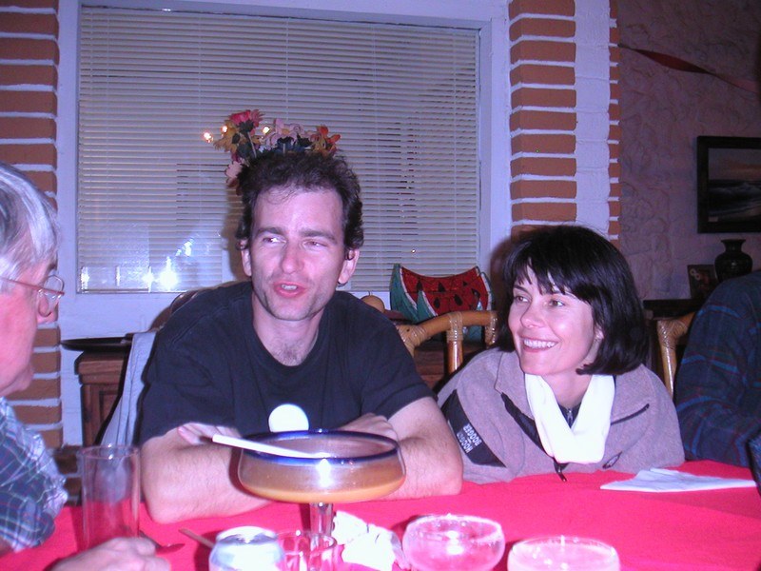
Meeting Monika and Morten at Serenidad Hotel, Baja Sur, February 2004

Later in the year they joined the Mooney Caravan to Oshkosh and we spent some quality time drinking California wine in the warmth of the Wisconsin evening. It was there that Gayle and I were invited to their wedding. This was very flattering, but not more than when, after the wedding ceremony, Morten said “We were thinking of taking our Honeymoon trip over Christmas to Belize. Would you like to join us?” The answer was, of course, “Why, yes!”

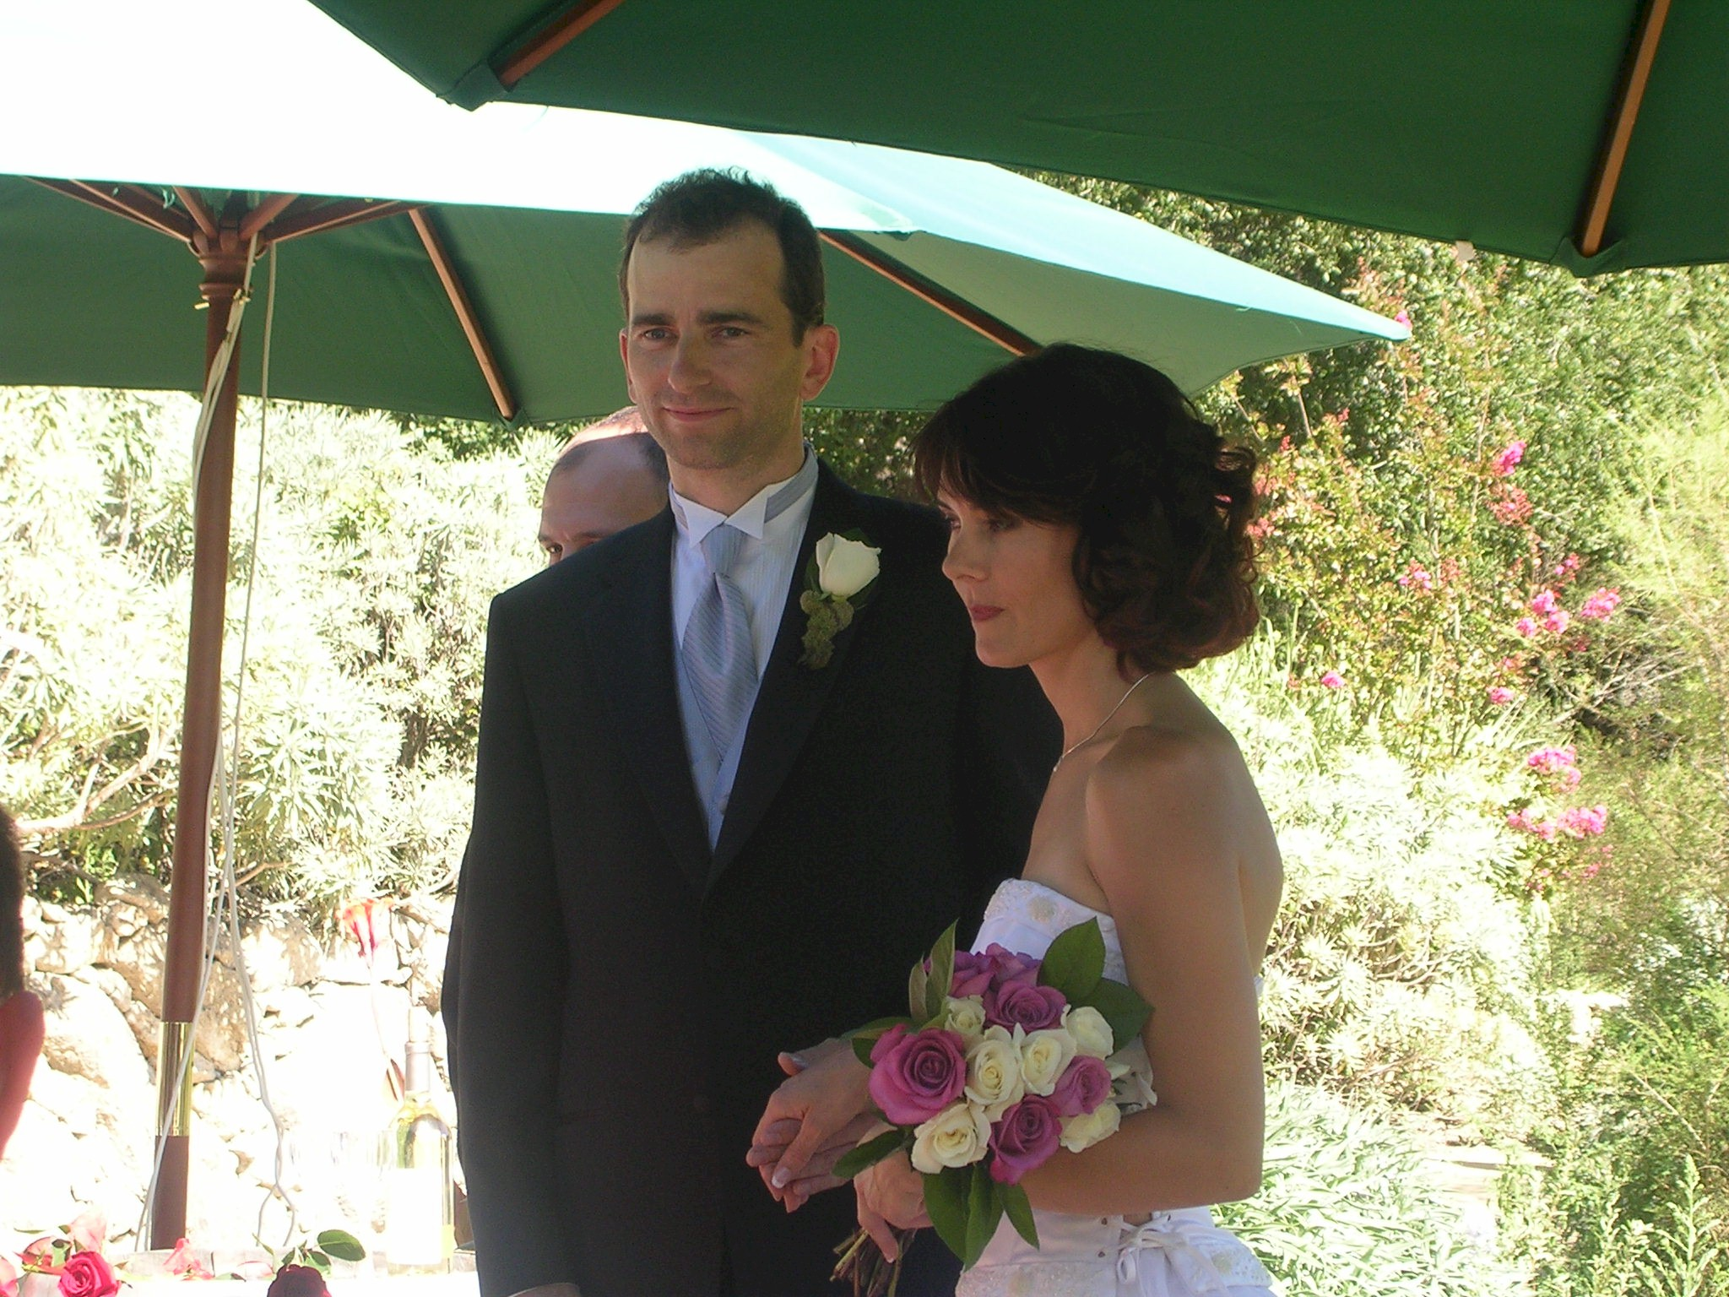
Monika and Morten at their wedding

M&M are avid scuba divers and Belize, with it’s fantastic reef, was a logical place for them to vacation. I am sure, however, that the notion of flying to Central America was somewhat daunting especially for relatively new Mooney owners with only one short trip to Mexico under their belts. The idea of doing the trip with another plane represented much less of a stretch. In retrospect, we both felt a great comfort in the fact that we were planning and executing the trip together. The flying part of the trip was without anxiety and did not differ materially from a long cross country in the United States. For pilots considering a south of the border trip, traveling with another plane or with a group not only adds a significant measure of safety but also provides companions with whom one can share the experience.

Planning

Having decided in early September to make the trip, we had over three months for planning. We had agreed on Belize as a final destination, but the rest of the trip was a blank page. Belize lies on the eastern flank of the Yucatan Peninsula, so an obvious side trip would be to visit some Mayan ruins. At this point, both Morten and I used the Internet to gather information about stopover points, accommodations and other arrangements. In Belize much of the tourist area is centered on Ambergris Caye, a narrow sandbar about a half mile from the world’s second longest reef. Accepting recommendations from a guidebook, we made week-long reservations at the Caribbean Villas, a combination beach front hotel and bird sanctuary. As for intermediate stops, we selected Tikal in Guatemala as our destination to see Mayan ruins based on the itinerary of a group trip organized by the Baja Bush Pilots (BBP). I suggested seeing a bit of colorful Southern Mexico, so we scheduled a two-day stopover in the mountain city Oaxaca (pronounced waa-haaca). Finally on our final leg northbound, we planned to spend New Year’s Eve in Alamos, a colonial town, where the principle hotel has planned a gala dinner and dance.

With these fixed stopover points, we decided to fly south on the eastern Gulf coast of Mexico and northbound on the Pacific coast. Our itinerary looked like this:
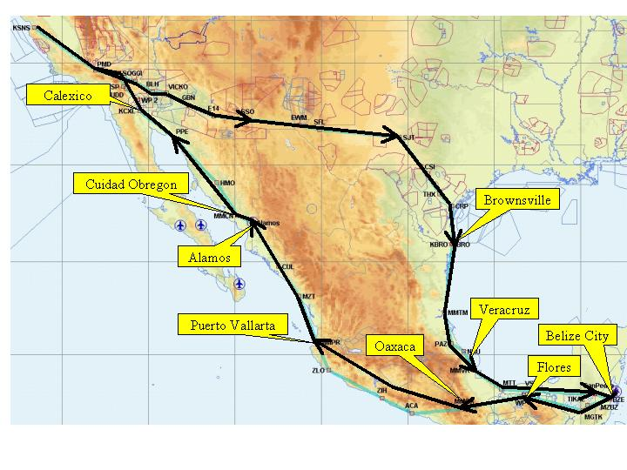
Our point of departure from the United States was to be Brownsville Texas where we would meet up with M&M. Thus, for the outbound trip, at least, we would actually cover more miles over the United States than over foreign territory. The northbound half of the trip would cross the mountains in Southern Mexico and then basically follow the Pacific Coast reentering the states in Calexico, California.

Now that the trip is done, I cannot emphasize the importance and helpfulness of the Internet is making arrangements and assisting with our planning. Secondly, I would never make such a trip without a Jeppesen trip kit with all necessary IFR charts and airport diagrams. Even if the trip is strictly VFR, the wealth of information in the trip kit and especially the approach charts is most helpful. The role of Baja Bush Pilots was minor and, in fact, their Airports of Mexico book is disappointing and possibly out of date.

Both Morton and I were very organized about all the necessary documents. We each had a dedicated packet containing everything we needed. These included the following:

Passports and visas
Pilot’s license
Current medical
Radio-telephone permit
Aircraft registration
Aircraft airworthiness certificate
Aircraft insurance policy confirming liability coverage in countries to be visited
Permission letter if aircraft corporate owned.
Permission letters from countries that require them (Guatemala)

Monika being a Swiss citizen required a visa to visit Belize. Otherwise, a passport was sufficient identification.

Emergency Preparations

I carried an emergency kit that was left over from a prior trip to Alaska consisting of flares, food, water, a medical kit, and various warm and protective clothing items. To combat common mechanical problems I carried a battery charger, tire pump, fuel siphon, a tool kit (lots of duct tape) and an empty 5 gallon fuel container. I had considered getting training on how to change spark plugs and clean injectors but ran out of time.

I figured the most likely mechanical problem would be with my on-board avionics or the electrical system that powers them. Therefore I also brought my King 99 handheld transceiver and a used Garmin 195 portable GPS that I picked up on e-bay for $100 (what a deal). This latter unit proved so superior to my panel mounted VFR GPS that it became my principle means of navigation. Thirty two double-A batteries were close at hand if required (which they weren’t).

Morton said he was satisfied bringing a spare airplane (mine) and, so far as I know, he made no special provisions for an emergency.

The Weather Outlook

December is not always the most benign time of the year in the Southwest. But as the departure date approached our trip across the Southern USA looked favorable. On the other hand, the Mexican Gulf coast looked marginal. Satellite images and surface analysis charts showed a persistent low with frontal activity hanging over that part of our route. We discussed a contingency plan to fly south down the Pacific coast of Mexico. However by the Friday preceding our departure, the messy stuff had moved offshore into the Gulf. From California to Texas, a high-pressure area was building and ceilings and visibility were unlimited. As it turned out, we had nearly perfect weather for our entire trip while, in our absence, California endured almost two weeks of torrential rains, snow in the higher elevations, and icing levels below well below 5,000 feet. In short we were fortunate with weather. Although by all accounts, December is one of the nicest months of the year in the tropics and usually is spared the monsoon weather of the summer months.

Across The United States

Gayle is an elementary school principal and her school closed for Christmas break a week before Christmas. So on Saturday morning, December 18th, we took off from our home base in Salinas for our first en route overnight stop, Tucson Arizona. N9208M is a manual-gear 1966 E-model that I have owned since 1984 (along with a 201 and a 231 at various times). It is reliable and simple and with 250 hours on the factory overhaul, would be expected to be trouble free. The airplane, has been carefully packed during the preceding week and had the oil newly changed and all equipment working well.

With only 52 gallons, 08M does not have exceptional range. An unusual 25 knot headwind reduced our ground speed to 120 knots and the fuel computer was predicting 4 gallons reserve at landing in Tucson. So we made a fuel stop in Blythe and landed in Tucson after five hours total flight time. If anyone needs a recommendation for a restaurant in Tucson, the Poco Cosa Restaurant, serving regional Mexican food, served up the best meal on a trip that was characterized by exceptional cuisine. This restaurant, a favorite of ours, was the main reason we planned our stop in Tucson and it did not disappoint.

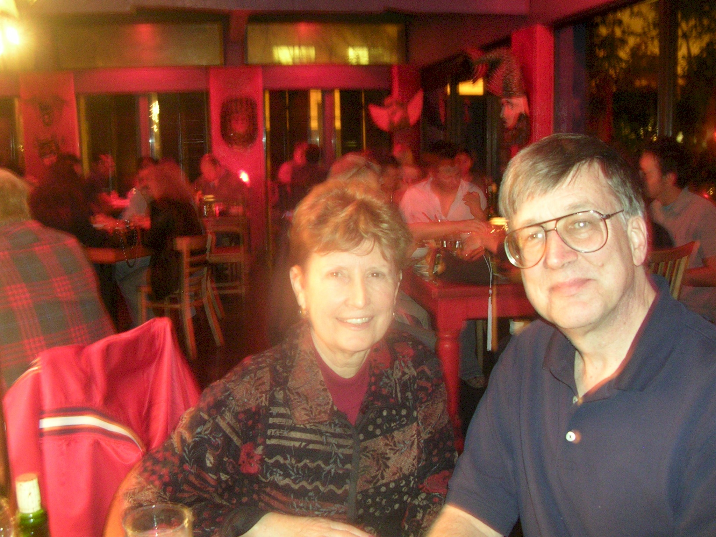
Poco Cosa Restaurant in Tucson

We departed Tucson early the next morning to avoid the afternoon turbulence and landed after an uneventful 4 hour flight at our second overnight stop, San Angelo Texas where we spent the night with Gayle’s relatives.

On Monday morning we were up early for an 8am departure for Brownsville where we had planned for an 11am rendezvous with Monika and Morten. Once again, the SE winds and the restricted military areas conspired to delay our arrival at Brownsville by some 30 minutes. But just before noon, we were united with our trip partners who, being young and energetic, had flown nearly all the way from Santa Monica the previous day.

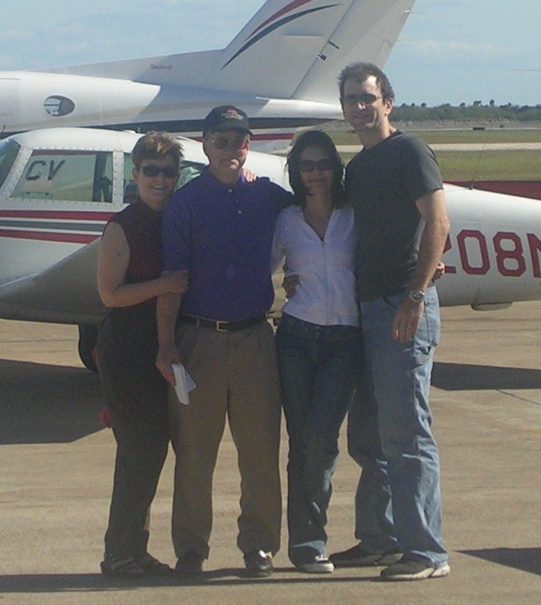
Our Rendezvous at Brownsville Texas

Brownsville to Vera Cruz

At about 1pm, we took off from Brownsville and opened and closed our DVFR with Brownsville approach control. The airport is about 2 minutes from the border so one call did it all. We then called Matamoros Tower and informed them that we would be transiting their traffic management area en route to Vera Cruz at 7,500 feet. As is normal, they requested that we report in 10 miles to the south as we left their area. We formed up in a loose formation about 500 to 1,000 feet apart and headed south.

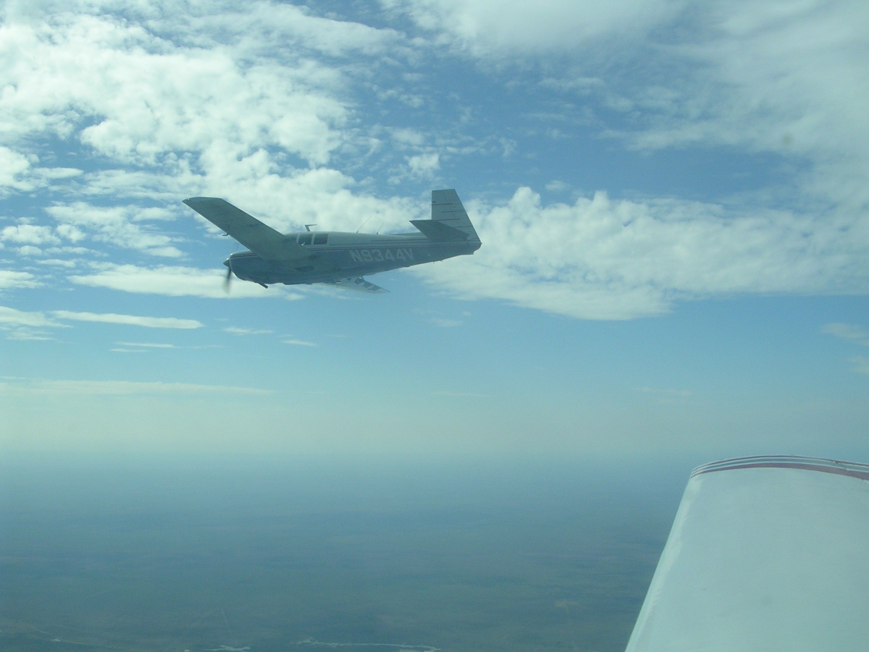
N4344V over the Mexican Gulf Coast en route to Vera Cruz

The coast is very flat with sand bars, algae green estuaries, and little signs of habitation (at least from our altitude).

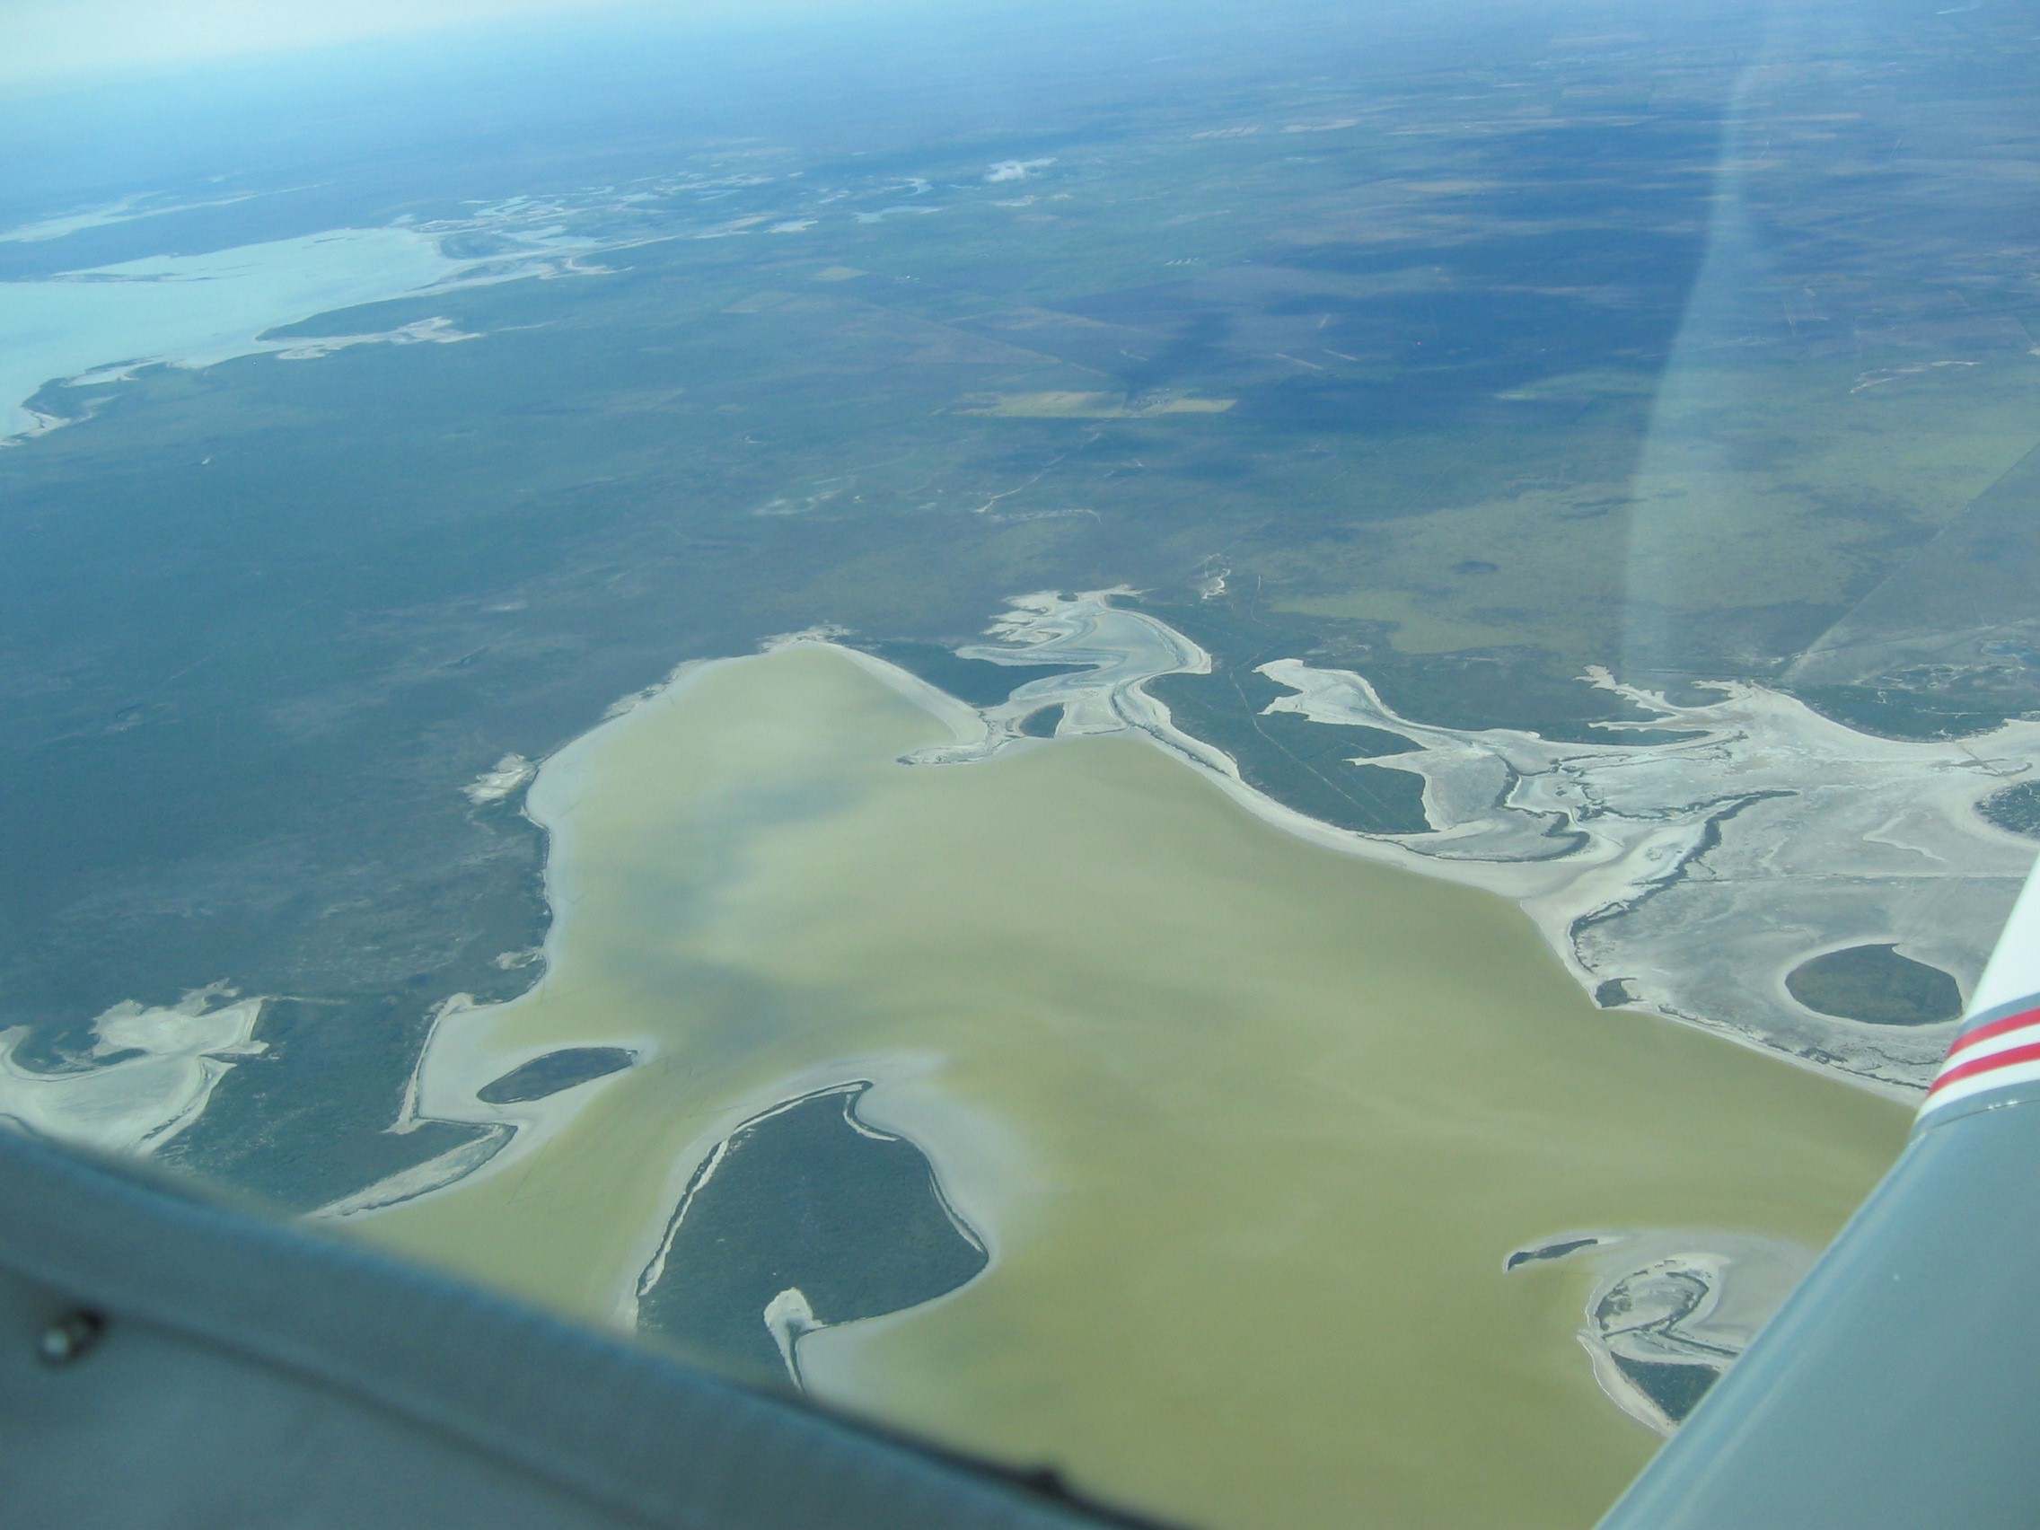
Over the Mexican Gulf Coast

Our flight proceeded southbound without much excitement. We chatted continuously on the radiowhich made for a friendly, connected feeling. After four hours we approached the industrial city of Vera Cruz, our planned overnight stop. 50 miles out we announced our penetration of their large TMA. The English proficiency of all the controllers was excellent (not always the case in Mexico) and we had no problems with any communication except for the occasional request to repeat some instruction.

Vera Cruz has a modern looking airport and terminal with several commercial passenger jets parked at the gates. We were ushered into the customs area where we were informed that there was a special charge of $110.00 for planes arriving between 3pm and 5 pm on Mondays. This had us outraged, but there was little we could do with our Spanish limited to the words “baño” and “margarita”. We felt taken advantage of. In fairness, this was the only time during the whole trip that we were ripped off, although it was done with exceptional politeness. As we write this, Baja Bush Pilots is investigating the incident on our behalf, but we expect little relief. Monika summed it up by observing that we (as residents of the States) have so much and the so many Mexicans have so little. It was perhaps only a small measure of wealth redistribution that we could easily afford.

In the “excitement” of our discussions with customs, we neglected to go through some of the other necessary steps related to arriving at our Mexican airport of entry. This was no problem, but it meant extra work on our departure the next morning.

We boarded a taxi for our drive to our downtown hotel. The driver must have thought he was trying out for the Daytona 500 because we had the taxi ride from hell all the way to the hotel, running red lights, passing into oncoming traffic, honking and playing chicken with pedestrians. Gayle, always the teacher, said she wanted to spank the driver. The downtown hotel, affiliated with Howard Johnson’s, was pleasant and colonial. We slept well.

Vera Cruz to Belize City

The next day, we arrived at the airport at about 9am to get an “early start”. However it took nearly two hours to get all our paperwork straightened out. This included obtaining a multi-entry general declaration ($50), filing a flight plan ($10), paying for overnight parking ($10) and buying fuel ($4.00/gal). This set a pattern for most of our airport arrival/departures. Morten and I ran around filling out paperwork and paying out money while our wives sat around the airport guarding the baggage and being bored. We departed at about 11am and followed the shoreline south.

South of Vera Cruz there are some substantial mountains that come almost to the shoreline. They were very picturesque and very green. We kept generally offshore until the city of Minititlan where we picked up a nearly direct easterly heading for Belize City across the Yucatan Peninsula. I was somewhat disappointed with the “jungle”. I expected to see an unbroken canopy with dangerous looking vines rising up to snare the unsuspecting aviator. Except for the last 100 miles or so, there was considerable cultivation and villages. We crossed several rivers that looked swollen and brown.

About an hour out of Belize City, the scattered clouds below us (we were again at 7,500 feet) closed up to form a pretty solid undercast. We were not flying so close as on the previous day since that was somewhat tiring and it was more relaxing to more alone. We occasionally saw the sun glint off 4344V about 2 miles ahead. Morten caught the Belize City ATIS which was reporting 2500 foot overcast in light rain showers. It this point, we had to make a decision. Get down through one of the infrequent breaks in the overcast or continue on to Belize City and try to get a pop-up approach into the airport. We really did not know if the latter was possible or considered good form outside the U.S. As was typical on our flight, I chose to descend and Morten chose to continue at altitude (secretly hoping for an instrument approach). We came across a nice hole about 75 miles west of Belize City and descended to 2500 feet. This altitude was well above any of the small hills in the area and I was perhaps 500 feet below the cloud layer. There was occasional drizzle and the visibility was relatively good at 7-10 miles. I reported to Morten the conditions and he too found a hole (a virtual hole he admitted later) about 25 miles out of Belize City. Several airliners were shooting the VOR approach into the airport.

Our route to Belize City was not exactly direct as we had to make a slight dogleg to the north to avoid Guatemalan airspace. On this trip, Guatemala was the one country that required prior permission to fly in their airspace. When we received our faxed authorization, it was very clear that it applied only to certain days and that at all other times we were forbidden to fly into their country. Our authorizations did not become valid for a week, so we made a point of not antagonizing the Guatemalan authorities. I doubt if they would have scrambled F-16s to intercept us. In fact, I doubt if they even knew we were nearby. But better to be safe than sorry. So our GPS units kept us five mile or so north of the Guatemalan border.

Our arrival into Belize City differed from those at Mexican airports in two respects: 1) we had to get the approval of at least a ten governmental functionaries and 2) we were greeted by “helpers” who were to see us through the formalities. My helper was a tall and gentlemanly fellow named Javier who whispered that he would only charge us $50 dollars for his services ($25 on arrival and $25 on departure). Considering the number of rubber stamps that we had to obtain and forms we had to fill out, this was a bargain. He earned his $25. Once again, Gayle and Monika waited patiently as Morten and I scurried around hither and yon getting approvals and paying out money.

We decided not to get fuel as it was getting late in the day, about 4:00 pm and we still had to fly to our end destination, San Pedro, on Ambergris Caye before dark. So we filed a flight plan and received a “briefing” for the 26 mile flight across the bay. The briefing was kind of silly because one could figure out all the information such as departure and Unicom frequencies from the maps. But it was required and we listened patiently.

We took off, Morton ahead, and headed directly to San Pedro and its 4,000-foot paved strip. The flight was totally over water. It turns out that a fleet of Cessna Caravans fly almost constantly between Belize City and San Pedro ferrying tourists to the popular resorts on the Caye. We saw several coming and going on our short flight. We landed behind one who seemed a bit wary of these wayward Mooneys flitting around their private territory.

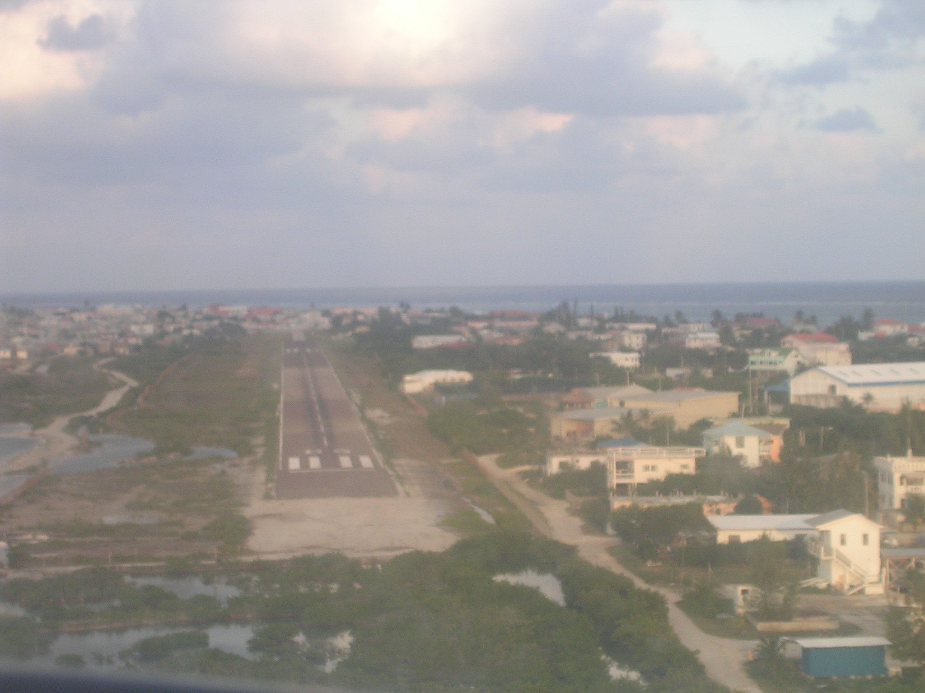
Short Final at San Pedro

San Pedro Airport is a bit odd. It is adjacent to the town. At the northern end of the single runway is a taxiway that carries on for another 1,000 feet to a ramp area that is right in the heart of the business section. In fact, the terminal building looks just like another storefront on the main street. We were advised to avoid that ramp area and parked off to the right of the runway on a grassy patch. Waiting for us was the representative of Caribbean Villas with a super sized gold cart.

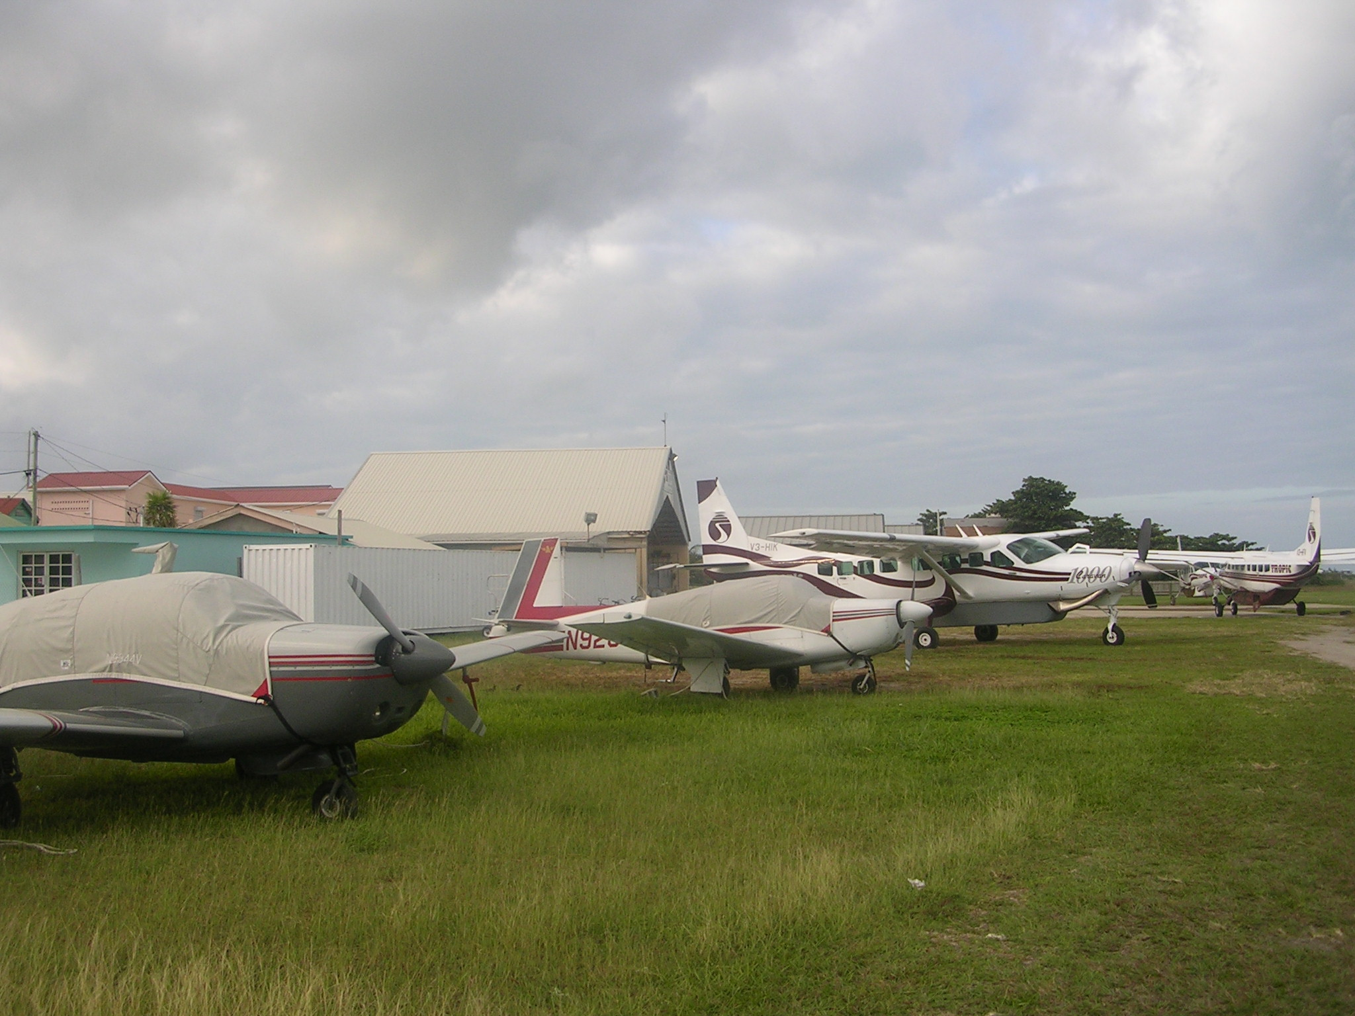
Tied down at San Pedro Airstrip

A Week on Ambergris Caye

We had made a 6-night reservation at the Caribbean Villas in October. We took what was available which was a suite with kitchen and a conventional room. M&M, being on their honeymoon opted for the suite but Morten advised us to come down at any time to cook dinner if we were so inclined. Gayle, the consummate chef, somehow managed to keep us supplied with restaurant reservations throughout our stay

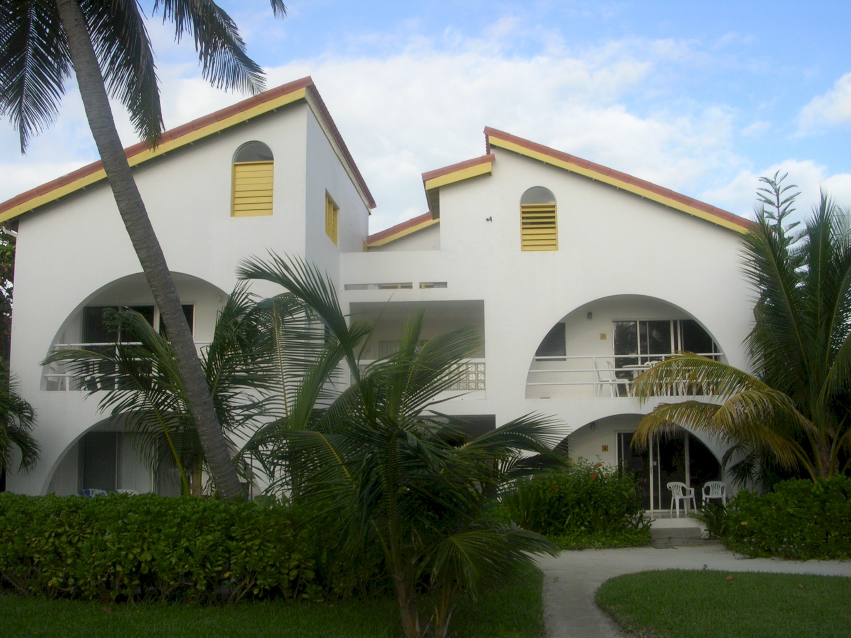
Caribbean Villas

In terms of amenities, the Caribbean Villas were somewhere between the very upscale resorts and some rather plain hotels in town. It sported its own bird sanctuary with observing tower and unlike many of the other resorts with manicured gardens had preserved the dense jungle-like vegetation that must have covered the entire Caye in earlier times. The resort itself consisted of two 2-story building with about 6 rooms each.

Our 2nd story room faced the beach which was about 100 yards away through a grove of palm trees. The beaches are beautiful white sand although the water just off shore is very shallow and somewhat muddy. A much more pleasant way of swimming was to walk to the end of the hotel pier, perhaps 2-300 feet long, and swim off the end in deeper water. The pier was also used as an embarkation point for the many fishing and snorkeling boats that catered to the tourists. The water was warm and clear. About a half mile off shore we could see the waves breaking on the reef, reputed to be the 2nd longest in the world after the Great Barrier Reef in Queensland, Australia.

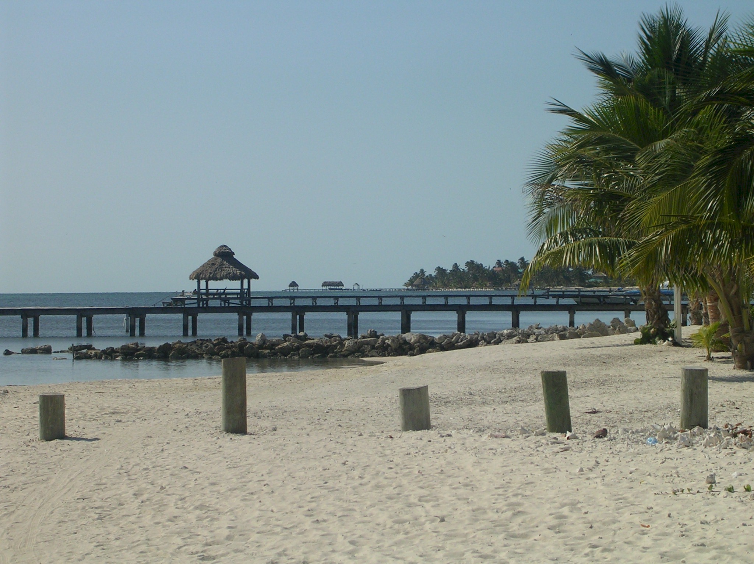
The beach in front of our hotel

From our second floor balcony, we had a beautiful view of the ocean and faced easterly and the rising sun. We had beautiful weather while in San Pedro. It was warm but not so hot that we never thought to turn on the air conditioning in our room. I can’t recall that it ever rained during our stay although a few times I noticed that there were quite a lot of cloud cover (as on our arrival).

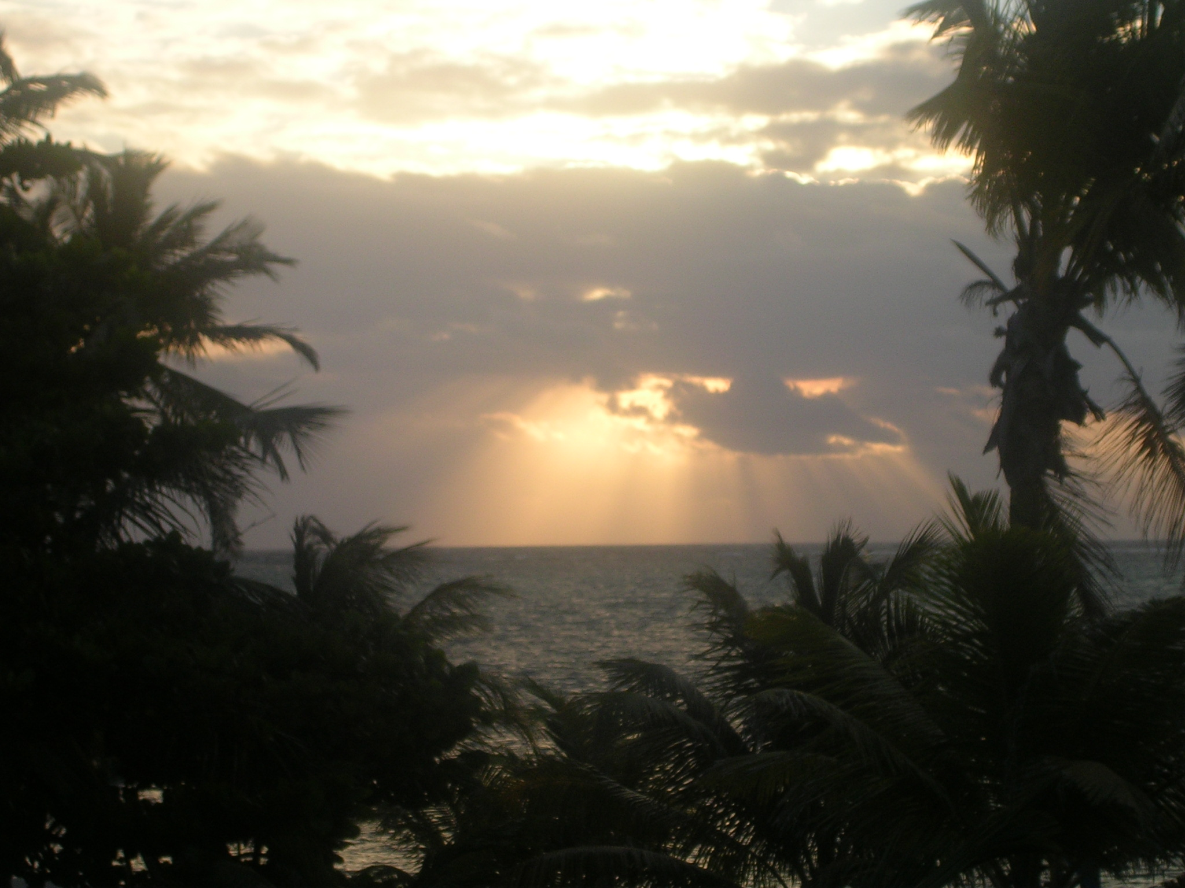
A Belize sunrise

The Golf Cart

It turned out that the principal means of transportation in San Pedro, for the tourists at least, is the gold cart. So we rented one for the week for about $50 per day. It really wasn’t necessary and more walking would have probably allowed us to work off the good food we ate in abundance. On the other hand, we could get from one place to another faster with the Gold cart. We all took turns driving, however my tenure as driver was much maligned by the others because I seemed to hit all the speed bumps at the top speed of 20 miles per hour.

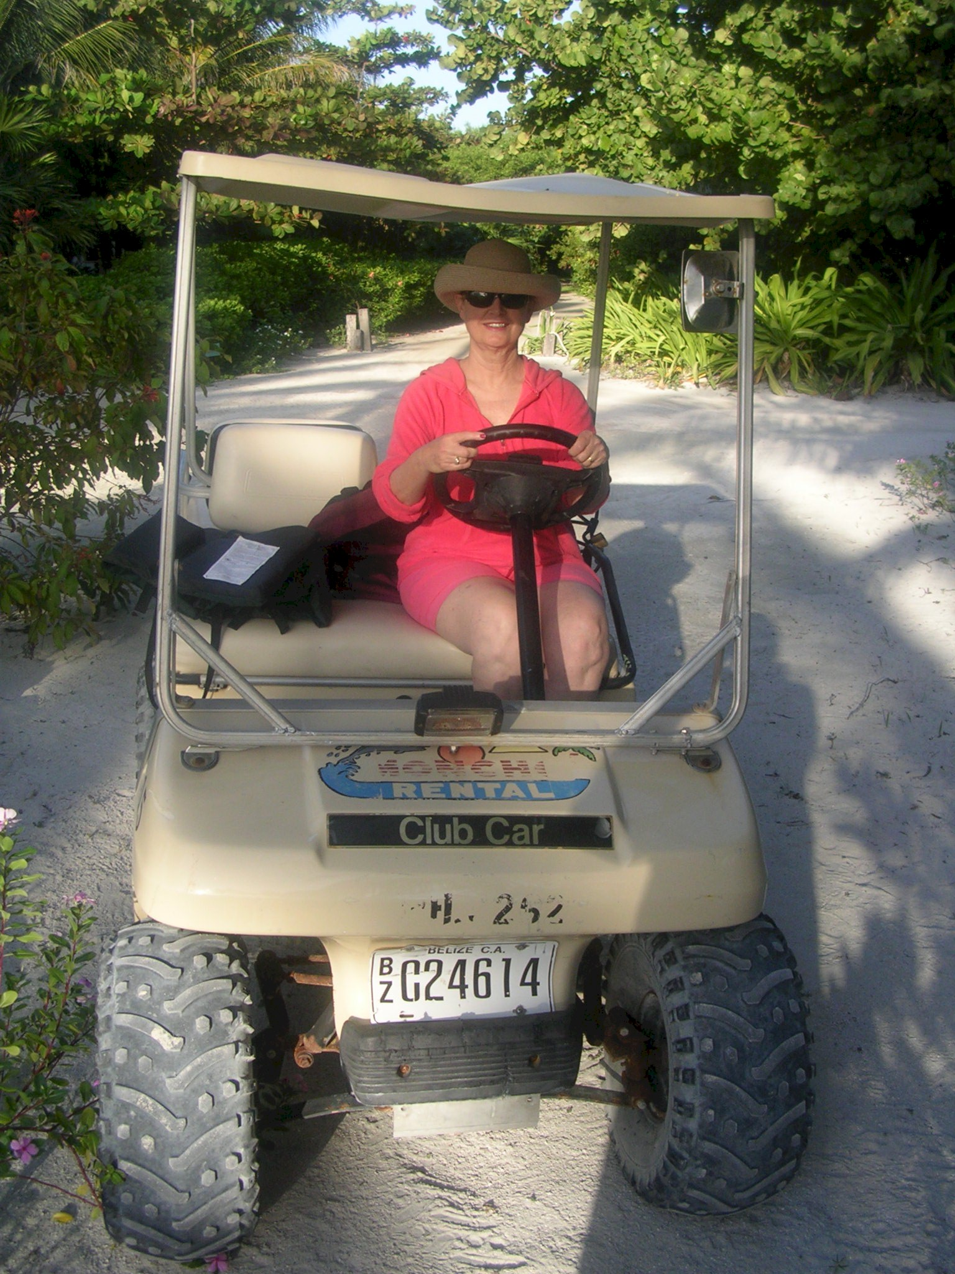
Our Trusty Gold Cart

San Pedro Town

San Pedro is a nice tidy tourist-oriented town with three north-south main streets lined with colorful shops, restaurants, hotels and the businesses catering to gringos. It’s really quite small, perhaps a half mile from the southern where our hotel was to the northern end which is separated from the rest of the Caye by an inlet to the interior bay.

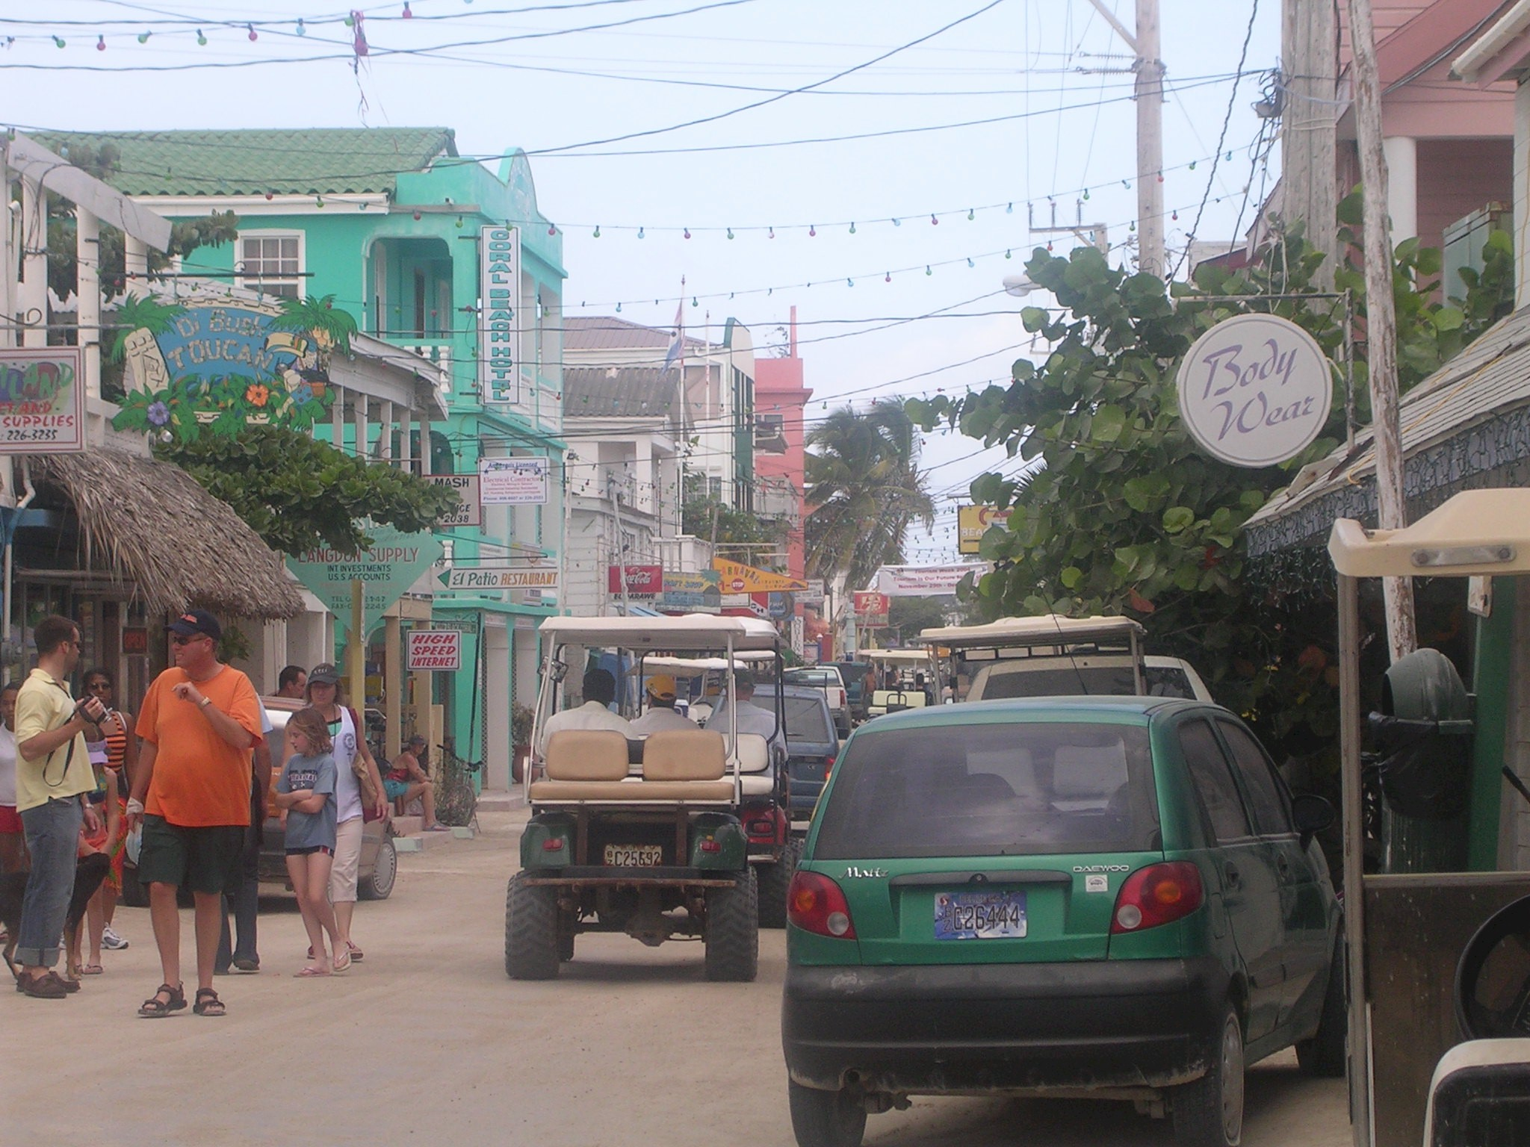
The Main Street in San Pedro

Excellent Dining

The restaurants in San Pedro were excellent. They came in all shapes and sizes and cuisines. We had excellent food throughout our stay and never had a bad meal except for one marginal affair which I will describe later.. It was not inexpensive, however, and prices seemed to be comparable to good restaurants in Los Angeles, especially if one ordered good wine and the tasty appetizers. Did I mention that Monika and Morten are wine connoisseurs? Unlike Mexico where tequila is king, rum is the native drink in Belize. And the local beer is quite nice and apparently a monopoly since we saw no other brands but the ubiquitous Belikin. Somehow, a case of the stuff was delivered to our room and about half of that amount made it back to Salinas where it serves as an occasional; reminder of our vacation.

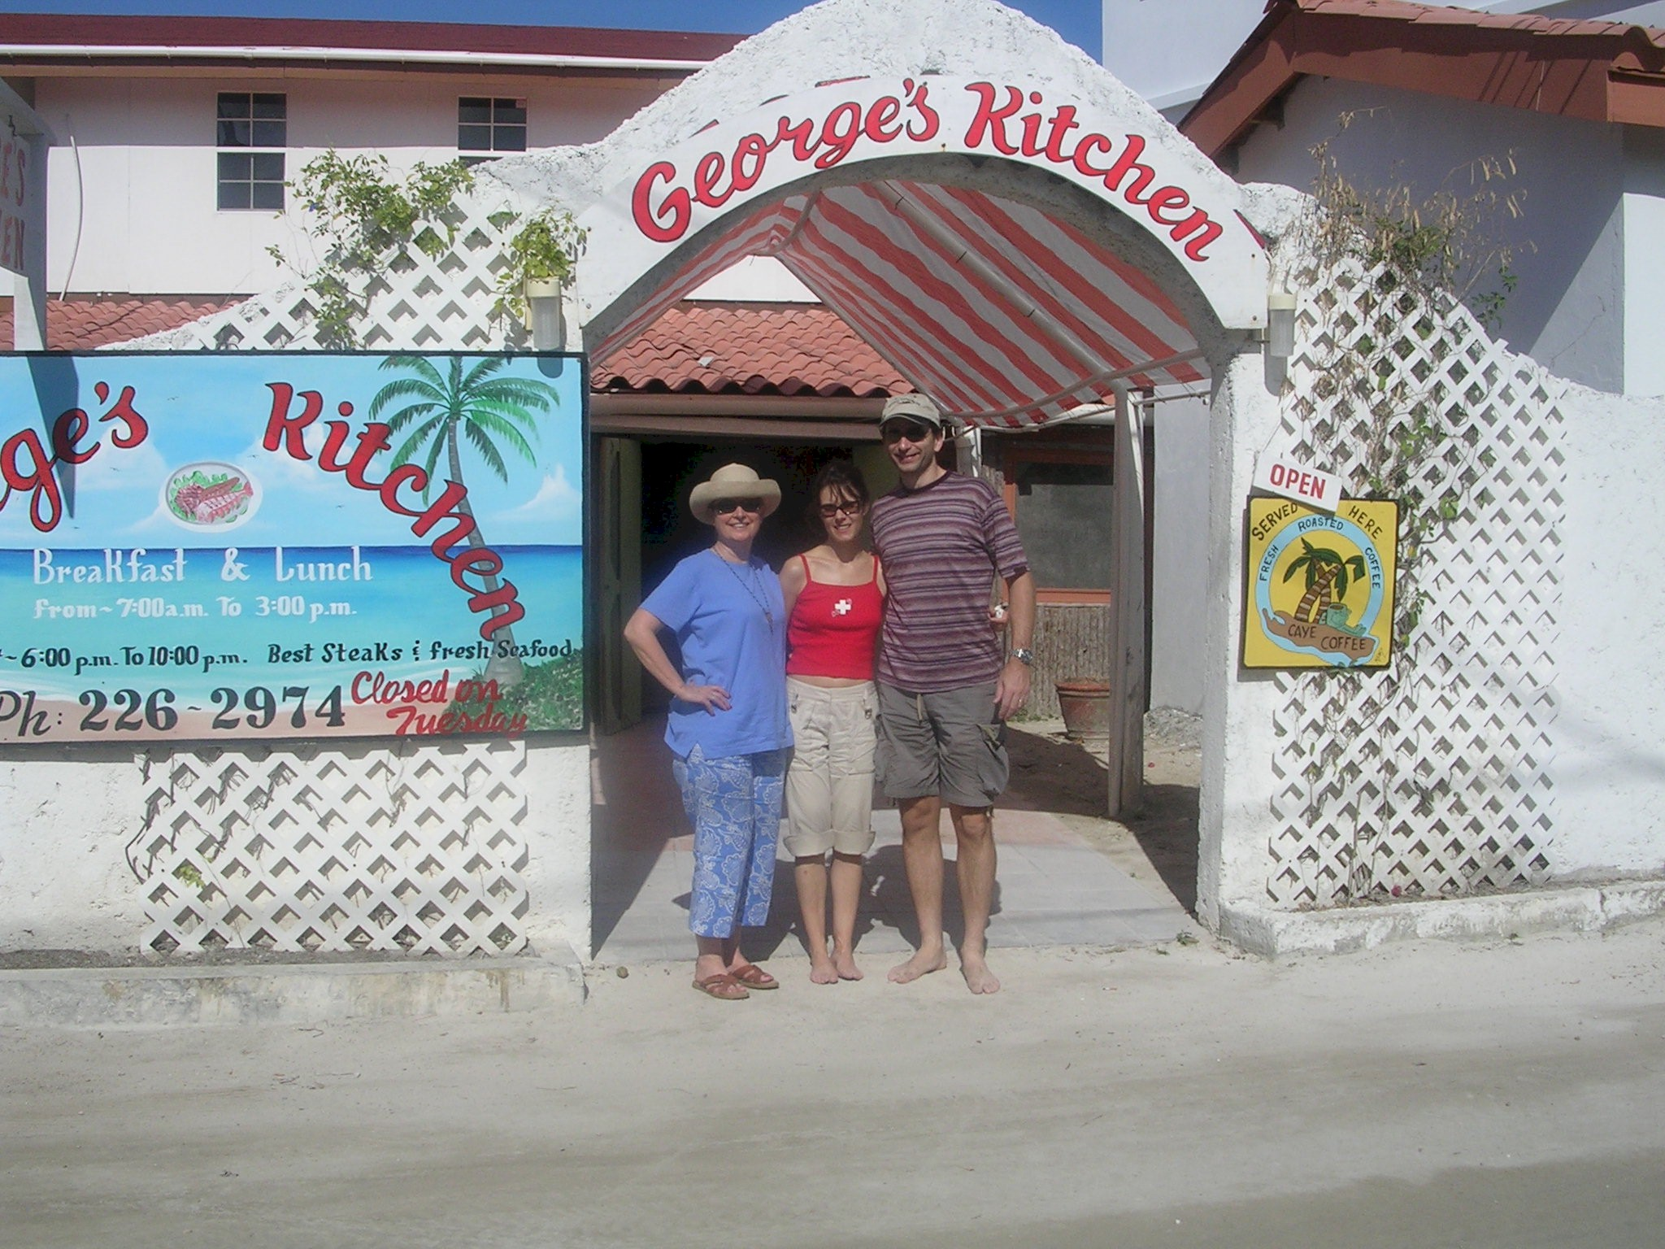
We never went hungry

The Moonlight Cruise

Our vacation included both the Christmas and New Year’s holidays. Shortly after our arrival we say an advertisement for a Christmas Eve moonlight cruise including a gourmet dinner and dancing in a 90 foot catamaran named the Calypso. Although not cheap, the occasion seemed to warrant special treatment and the prospect of a lobster dinner seemed quite appealing. So we signed up.

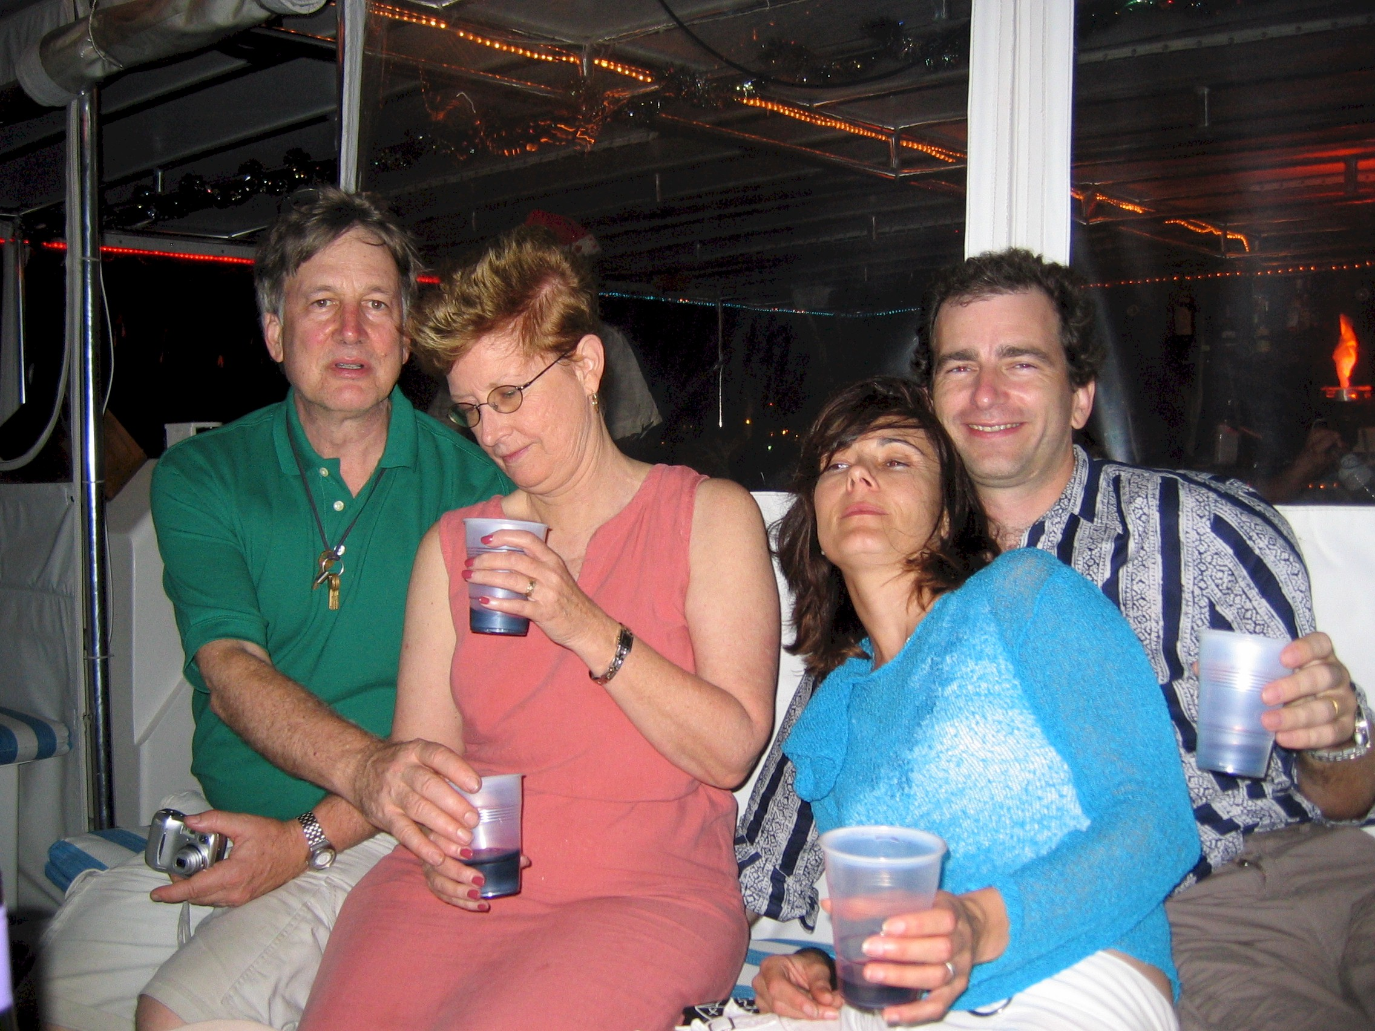
Christmas Eve on the Dinner Cruise

And we had a lovely time. The moon was full. The ship was stable and well-captained, The weather was warm and tropical. But the food was laughable and the bartender was a Zonker look-alike who knew less about mixing drinks than Mother Theresa. Our gourmet dinner was served on paper plates and emerged course by course from Styrofoam coolers in increasingly lukewarm condition. To avoid the crush at the bar, we ordered a few bottles of wind and made our own party. A memorable event was the first sighting of me on the dance floor in the current millennium.

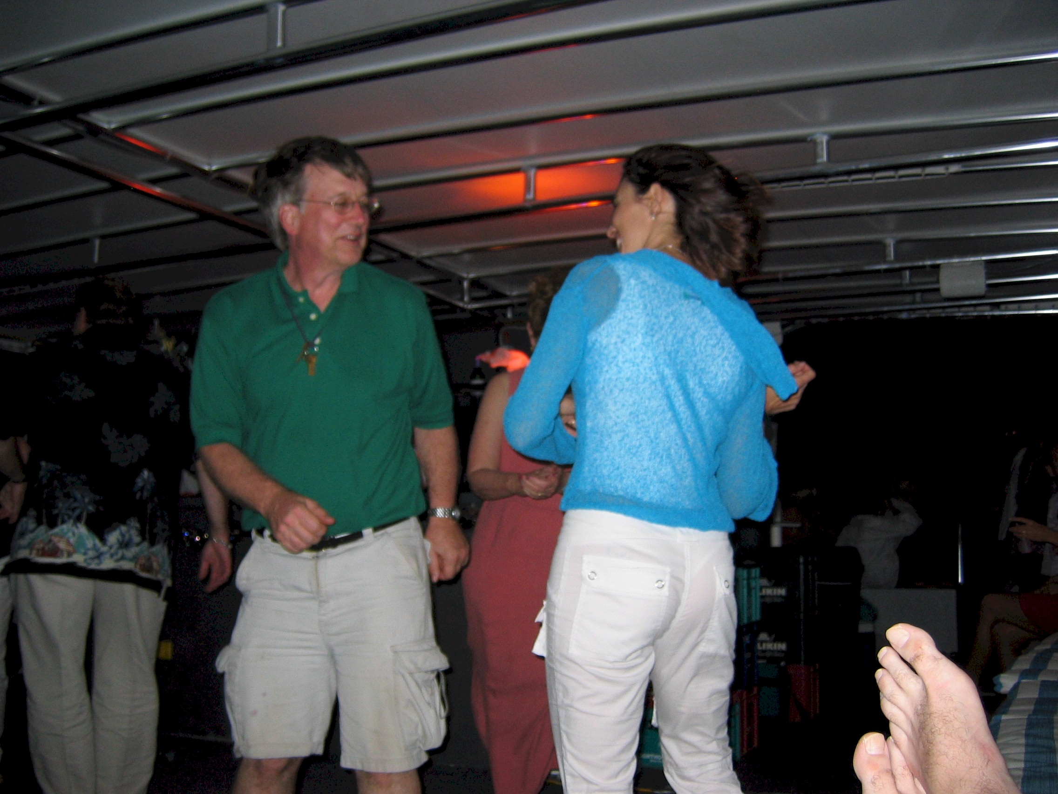
Dancing ? The feet belong to our intrepid photographer, Morten

Snorkeling on The Reef

Probably the Belize high point for Gayle and I was our day spent snorkeling on the reef. The fish were in amazing profusion as the following photograph shows. Morten took the following picture with his underwater camera.

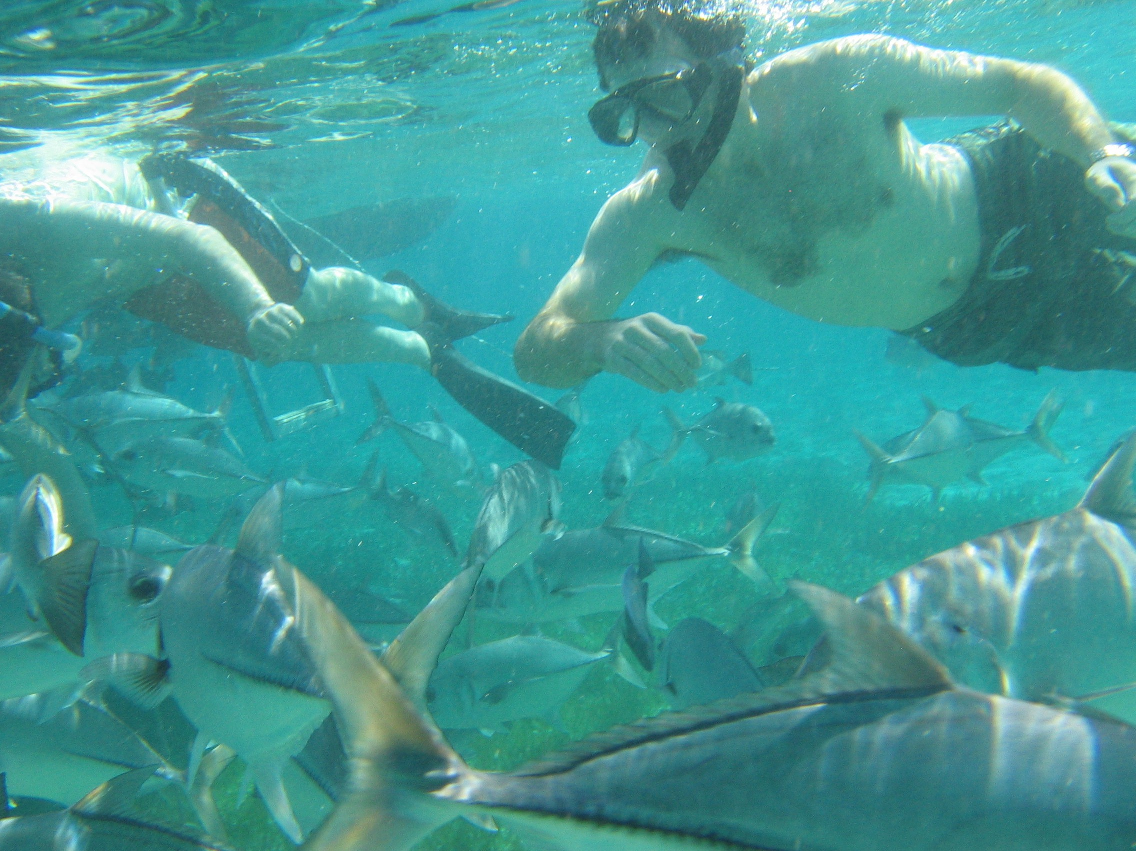
Jonathan and fish, snorkeling on the reef
Gayle is not a strong swimmer and had immediate difficulty getting the hang of her snorkel. The guide, who must be trained to watch for such things, gave her a life preserver ring and literally towed her around the reef for the better part of an hour while he pointed out the sights. He was working hard (and received a good tip for his troubles) The water was never more than 20 feet deep and the plant life fish life, and coral formations were amazing.

The Blue Hole

On Christmas day Monika and Morton went scuba diving to one of the premier spots in the world, the Blue Hole. It is a submarine cave whose roof has partially collapsed forming a dark circular opening in the otherwise relatively shallow ocean bottom. I can’t remember how deep the hole goes, but according to M&M it is far lower than the limits for recreational diving. Their main dive was down into the gloomy depths of the hole to the 120 foot level where they are often under the overhang. Dangerous stuff.

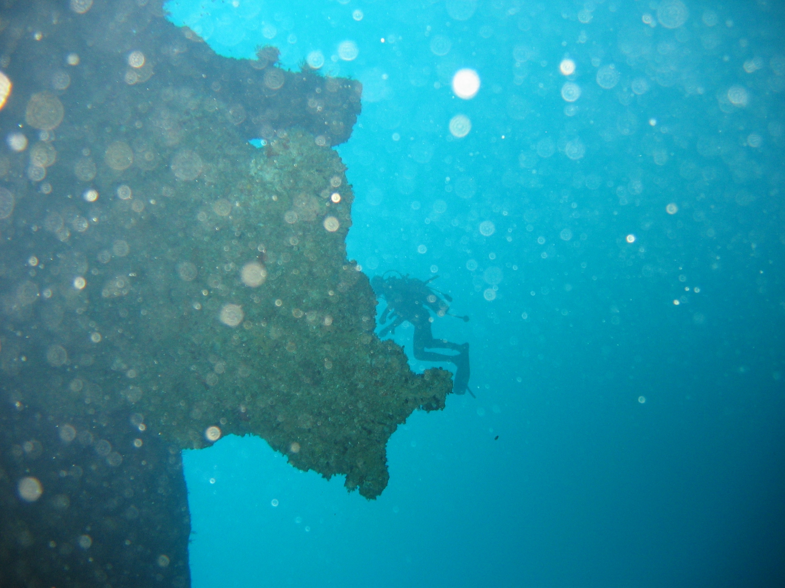
120 feet down in the Blue Hole

A Northward Adventure

One afternoon early in our San Pedro stay, we decided to explore the north reaches of the Caye.. This involved a 3-hour trek north until the road petered out passing by many elegant looking vacation homes and a few, not so elegant ones. The most interesting part of the trip was a high-tech man-powered ferry across the inlet north of San Pedro town. This 25 foot long barge-like boat attached to a rope tethered to the opposite shores of this 150-foot wide body of water. To move the ferry from one shore to another, the ferry “captain”, a very husky looking young man, simply pulled on the rope thereby powering the ferry and all its occupants and vehicles to the opposite shore. The cost for the four of us plus our golf cart was $4.00 Belize or $2.00 US.

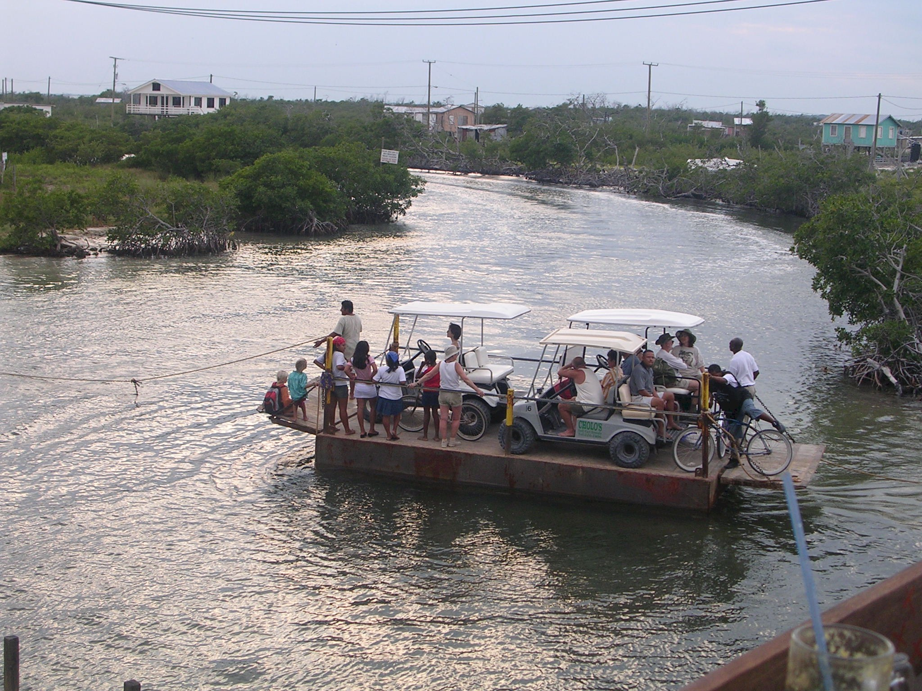
Man-powered ferry north of San Pedro

Total Relaxation

If we had to summarize Belize and Ambergris Caye, it would be a time of unhurried relaxation, several books read, wonderful weather, friendly people, excellent food, and (everything considered) moderate prices.

The Flight to Guatemala

On Monday. December 27th, we prepared to leave San Pedro for our next destination, Santa Elena in Guatemala. The weather looked great, clear skies and no detectible wind. This is a relatively short flight of about an hour, but first we had to fly to Belize City to refuel and to go through another bureaucratic paper drill. After breakfast, Morten and I packed up our gold cart with all our baggage and went out to the airport to pack the airplanes. Not having refueled when passing through Belize City, I was very short on fuel and had perhaps 8 gallons left. In theory, this is more than adequate for the 20-minute flight across the bay to Belize City, but it does not leave the traditional 30 minute reserve one ought to have for a VFR flight. I carefully measured the amount of fuel in each tank with my trusty school boy ruler, and concluded that unless some catastrophe occurred en route, I had plenty of gas. We packed carefully and dusted off our airplanes, neglected for the last 6 days. After breakfast at Georges, we paid our bill, turned in our gold cart, and hitched a rid on the hotel gold cart back to the airport.

Not wanting to be delayed en route because of my gas situation, it was agreed that I should takeoff first for Belize City. Morten and Monika did not have the same fuel urgency because in their F-model Mooney they had 10 more gallons of fuel than I did. After a perfunctory “Mexican run up” while taxiing the 100 feet to the runway we departed to the south and in 20 minutes landed at Belize City. Here we were met again by our “helpers” who took us through the reverse of our arrival procedures, obtaining in the process an equal number of impressive governmental rubber stamps as on our arrival. We filed our VFR flight plan to Santa Elena and ordered fuel. The whole process took the better part of two hours during which Gayle and Monika could only take turns guarding the baggage and roaming the terminal.

By noon, we were ready to take off. Our plan was to make a slight diversion to the north to over fly the Mayan ruins at Tikal where we were planning to spend the following night, and then to fly on to Santa Elena airport. Morton was about five minutes ahead of me after our takeoff and within 20 minutes we had left Belize territory and had entered Guatemala airspace. We contacted the Guatemala air traffic controller within a few minutes of each other. We did not, however, have N4344V in sight since he was perhaps 10 miles in front of us.

Shortly after I called in, we detected a small note of panic in the voice of the controller. We suspect that he was used to handling 3-4 planes a day and here he had two in roughly the same place at the same time. I suspect the workload was overwhelming. After some questions about our positions, he gave me an order for an abrupt 30 degree turn to the south (so as to avoid 44V, we presume). It did not appear that they had radar since our transponders were not blinking. So the controller was treating us like instrument traffic and providing separation. So much for my over flying Tikal. Fortunately Morten took some spectacular aerial shots of the ruins that only whetted our appetite for our upcoming visit.

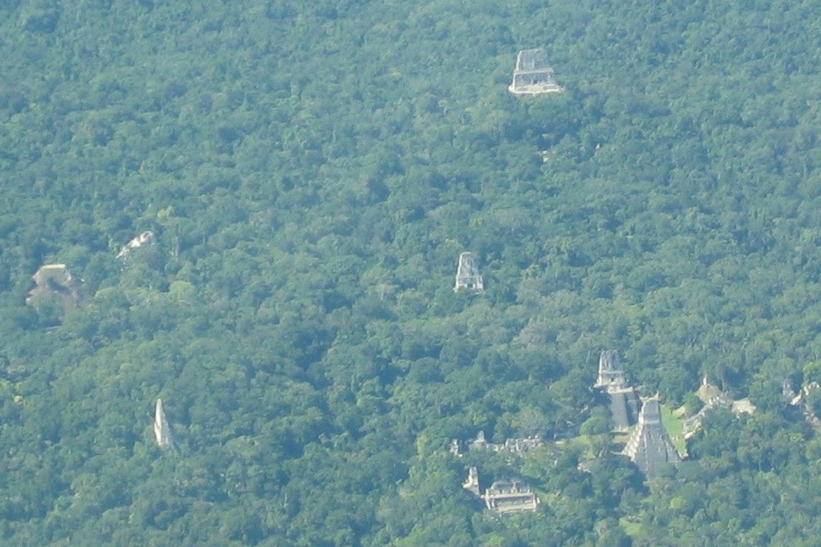
Aerial view of Tikal

Flores

Our destination airport in Guatemala was in the city of Santa Elena but our real destination for the night was the island city of Flores. Flores sits just offshore of Santa Elena in the middle of the huge Lake Peten Itza. Flores is a colorful, somewhat sleepy, semi-touristy city is a jewel-like setting completely surrounded by water except for a narrow causeway connecting the island to the mainland. It made an impressive sight from the air.

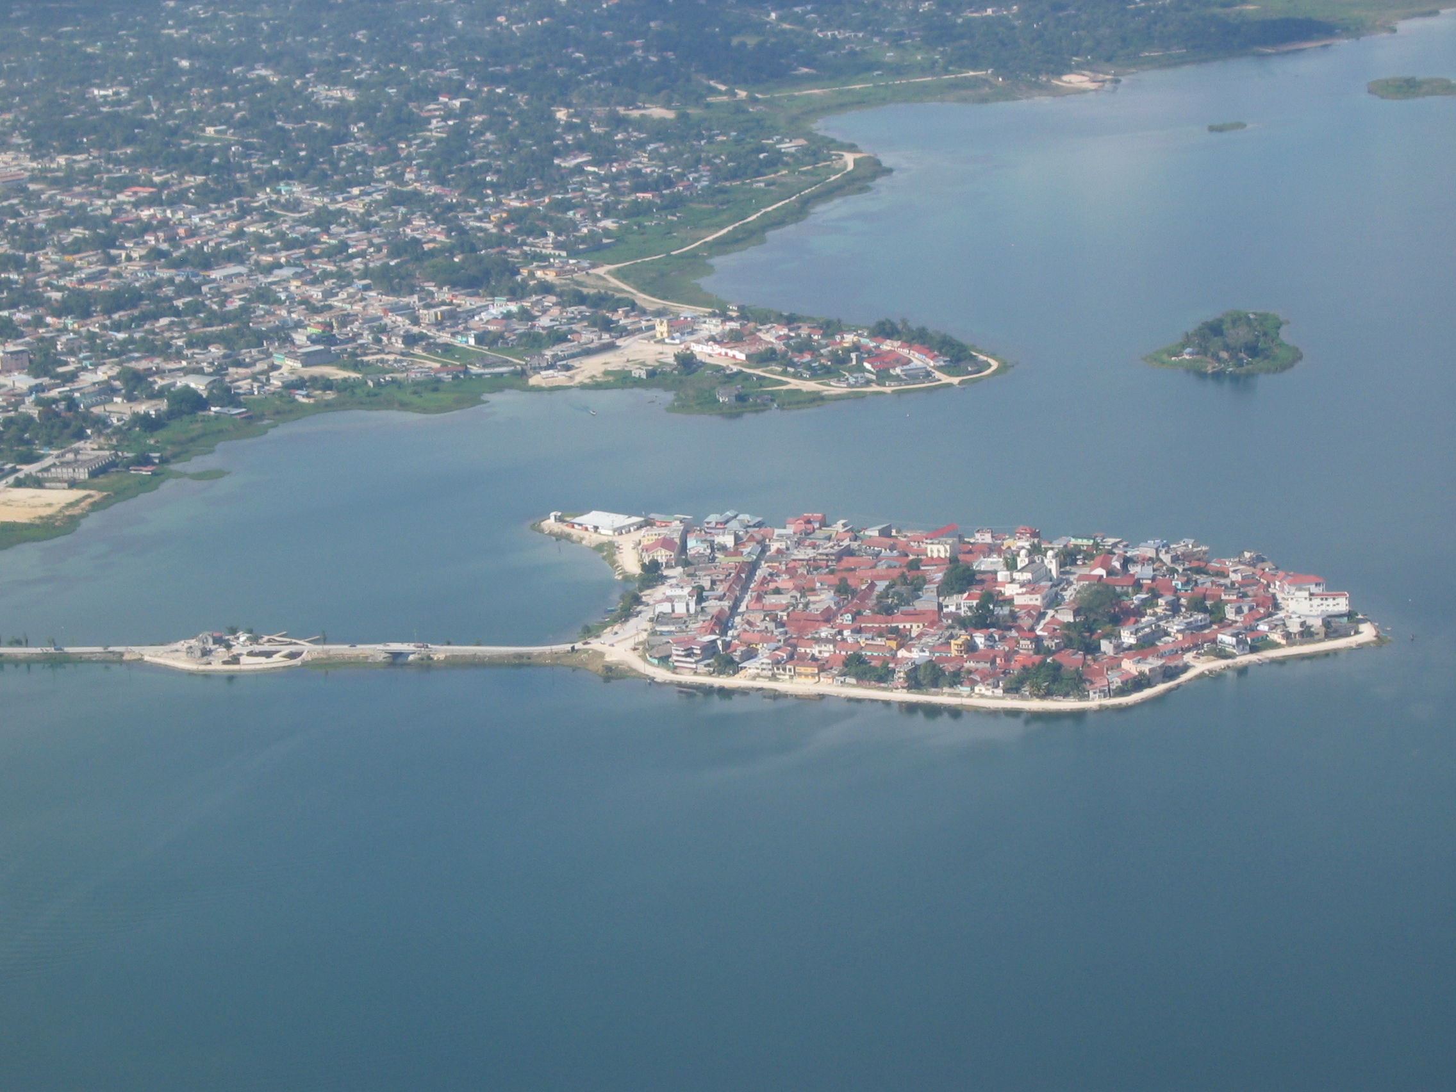
The Island city of Flores, Guatemala

Santa Elena “Formalities”

We landed at Santa Elena airport without colliding in mid air, much to the relief of the Guatemalan controllers. The local controllers, both en route and at the tower, spoke excellent aeronautical English. After landing we were directed to a suitable parking place where we were met by a young airport functionary who apologetically asked for permission to disinfect our aircraft with some sort of insecticide out of a spry can. He then asked for $2.00 for the service. I figured, “Oh boy” here we go again. We removed our baggage from the airplanes and with the help of a baggage cart we transported it up to the customs area where our papers were examined. The impression of the airport was one of quiet and inactivity. We were then told to go to the Flight Service office to close our flight plan. This took but a minute and we returned to the customs area only to find no one in sight to process our baggage and to extract the usual pound of flesh. We waited patiently for about 20 minutes waving occasionally at the taxi driver from our hotel who had come to fetch us. Getting impatient, we tried to search out the now disappeared officials by poking into various offices. In our non-existent Spanish, we could not hake our desires understood. All we wanted was to pay our money, get our official papers, and be off. Finally, in desperation, we went back to the Flight Service office where a little English was spoken. Much to our surprise, we learned that we were finished. No money, no papers, no hassle. My god! Guatemala must be the grand exception to travel in Central America. We sheepishly picked up our bags and followed our patient driver to the waiting taxi.

Flores City

We had made reservations at the Hotel Isla de Flores, apparently owned by the same people who owned the Tikal Jungle Lodge where were to spend the following night. We had arranged for a packaged deal of sorts for the two-night stay plus special transportation back and forth between Tikal and Flores. The Hotel Isla de Flores was a relatively modern well-kept three-story building with light airy rooms with a fine elevated view of the lake. The hotel had rooms clustered about a three-story light well filled with hanging plants, a precursor, I hoped, for the jungles of the next day. The young lady behind the front desk was pleasant and charming, as was nearly everyone we had so far met in Guatemala.

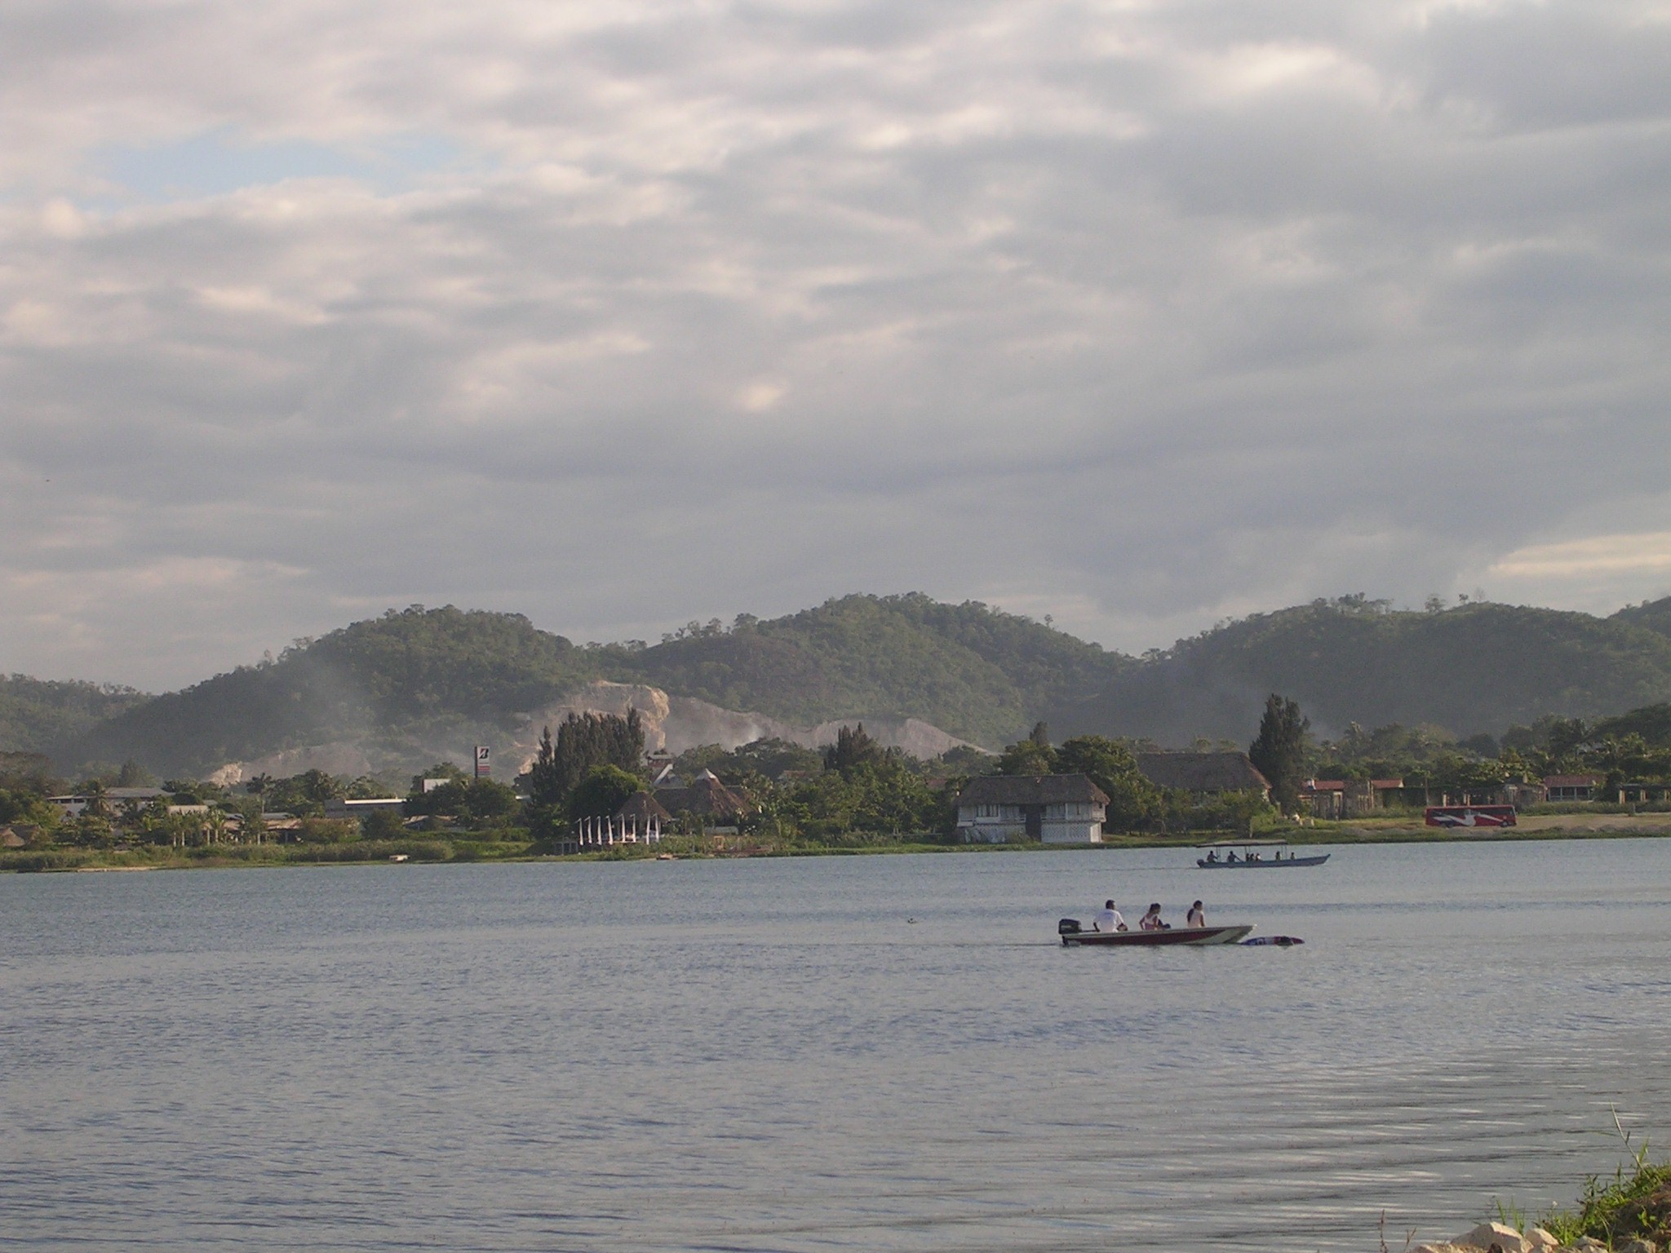
The lake surrounding Flores

Being that it was now after 2pm, we were quite hungry so we set out on foot to find a restaurant. About a block away we found the Restaurant Luna, quite empty at this hour and went inside. In short, we ordered a full meal, mostly fresh fish (presumably from the lake) washed down with a bottle of Chilean white wine. The meal was excellent. We were feeling quite proud of ourselves for having gotten into a new country without any hassle and, in general, were pleased how well the logistics of trip has so far gone.

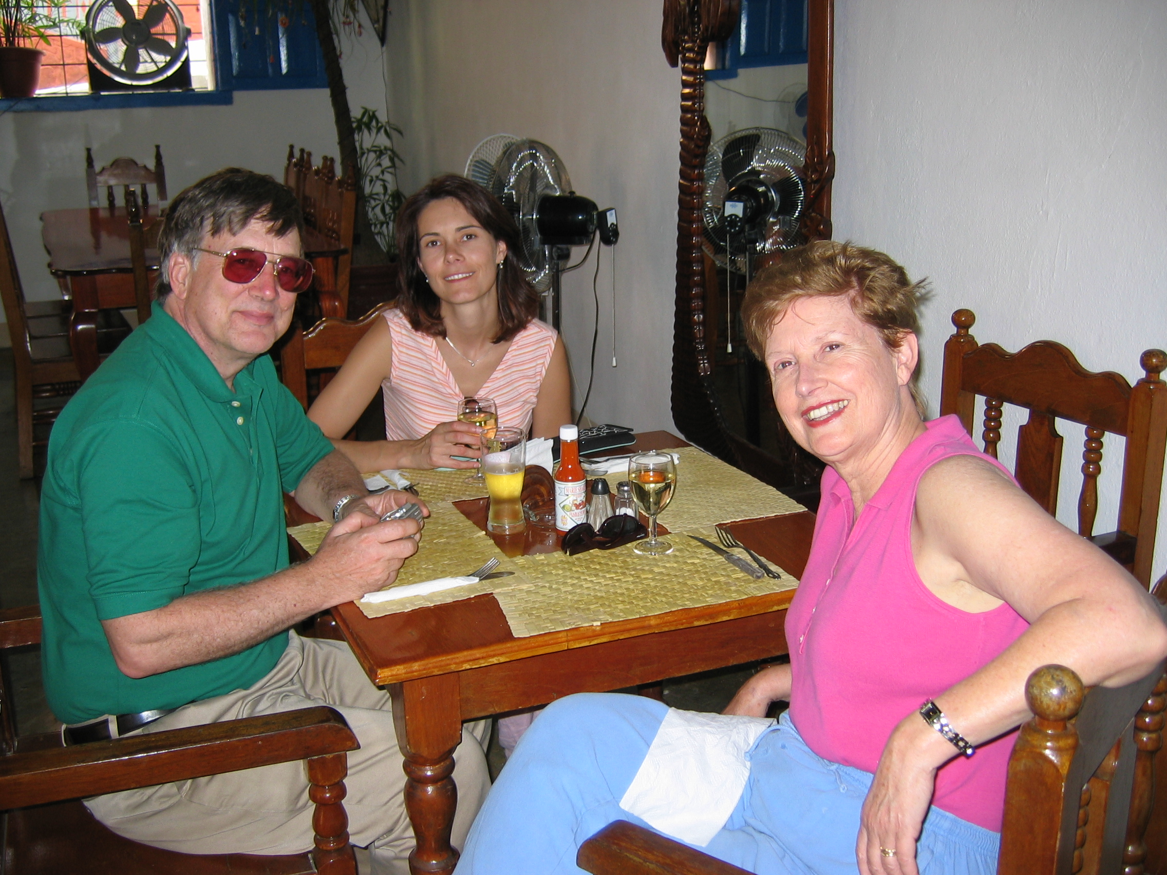
Lunch at Restaurant Luna

After lunch, we walked completely around the perimeter of Flores Island and then up and down the charming narrow and often steep streets.

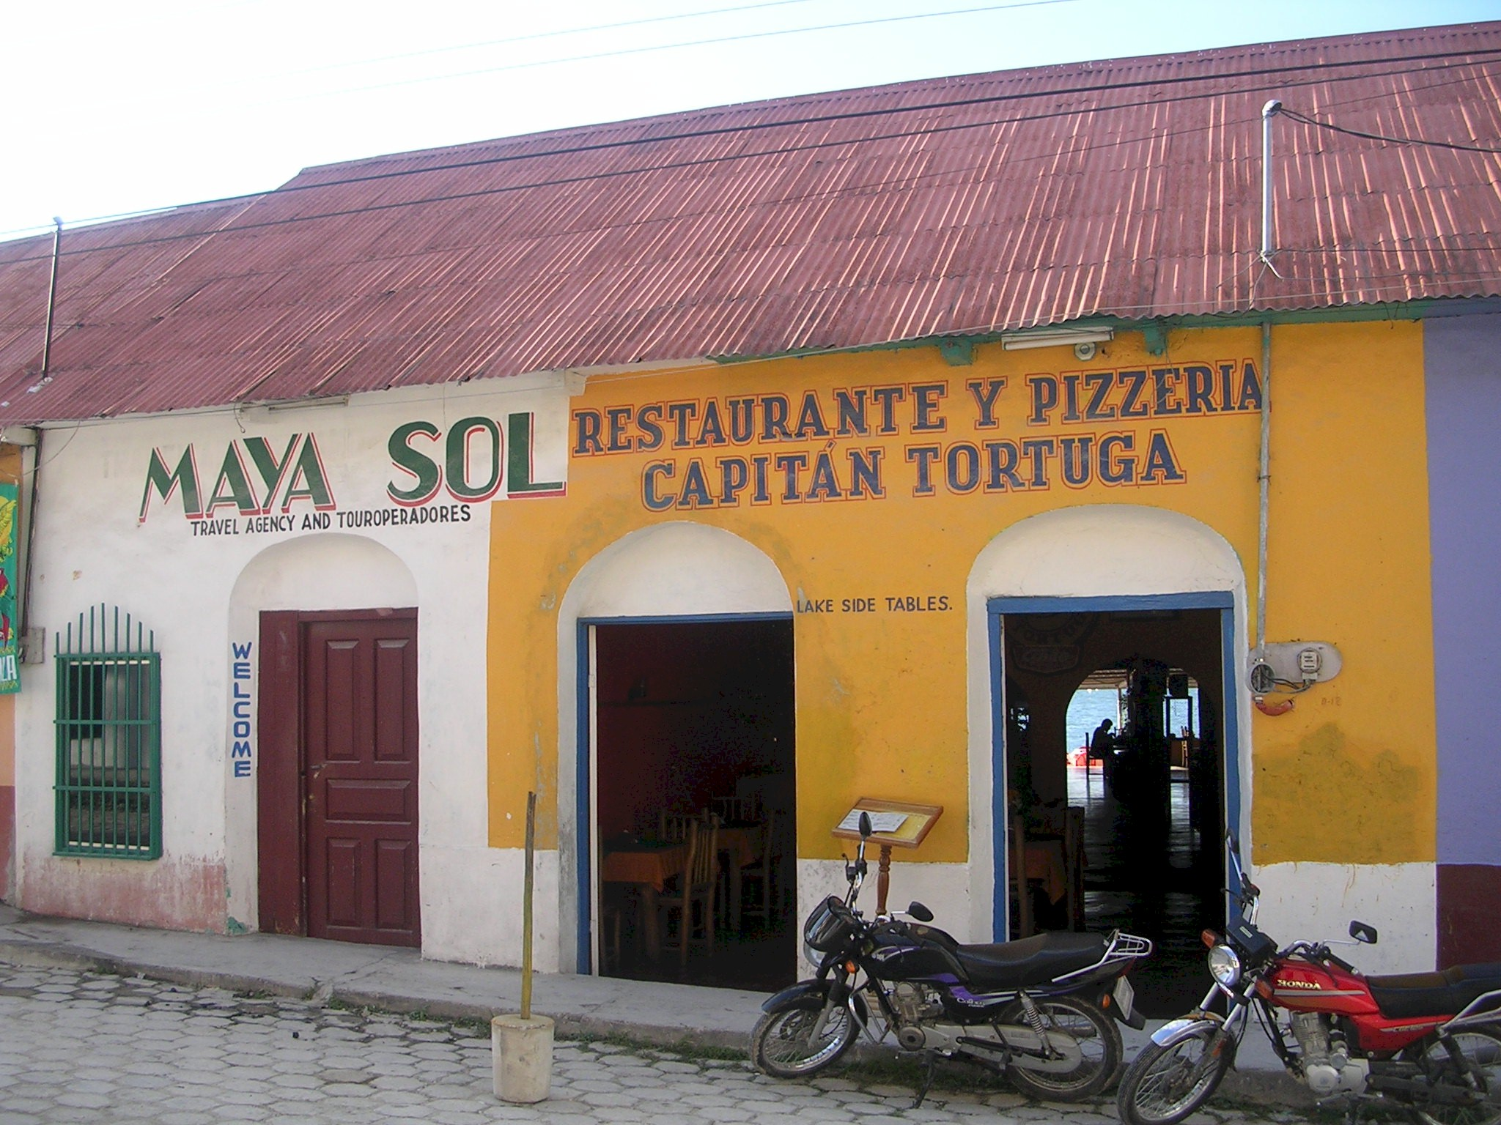
Colorful storefronts on a street in Flores

Flores is a rainbow of colorful buildings, interesting shops, charming hotels. It is a real cultural contrast to anything in the United States. And it did not seem to be just a tourist town. Most of the people we saw were Guatemalans living and working in this interesting place.

After walking around the island and exploring for several hours we met M&M at a lakeside cafe and ordered excellent margaritas as the sun set over the lake. I have no recollection of having dinner on Monday evening.

Tikal

On Tuesday, December 28th, we had arranged for a special ride to the Tikal ruins that are located in a national park about 30 miles north of Flores. After a fine breakfast at the hotel, our driver was waiting for us at 9am. We piled into the van and started on our way. The first 25 miles are on pretty good roads, by Guatemalan standards that swing around the lake to the east and then headed north to the park. As we drove north, the elevation increased and the terrain became hilly in a small way. We passed through several villages that seemed neat and tidy but quite primitive. Most houses were of wood construction with either a tin roof or some sort of palm leaf thatched roof. The use of color, that was so common in Flores, was evident in villages too. There were lots of signs of cultivation (on a small scale) and farm animals. Chickens scattered as we drove through. The last 10 miles of the trip were within the park itself. After passing through a manned entrance gate, the vegetation became much thicker, the cleared fields disappeared, and the sun was blocked from our view by the canopy above. Also the speed limit was apparently reduced to about 40 kph (28 mph) because we just just crawled along for the next half an hour. I seem to recall a few jaguar crossing signs but that might have been a figment of my lively imagination.

Jungle Lodge

Our hotel was the Tikal Jungle Lodge. We arrived at a large lodge-like building and checked in. This building housed the restaurant and the common area including the “front desk”. Our rooms were little cabins that had two rooms per cabin. We were assigned two rooms in the same cabin, but unfortunately M&M’s room was occupied when they arrived. So they were reassigned a room across the path.
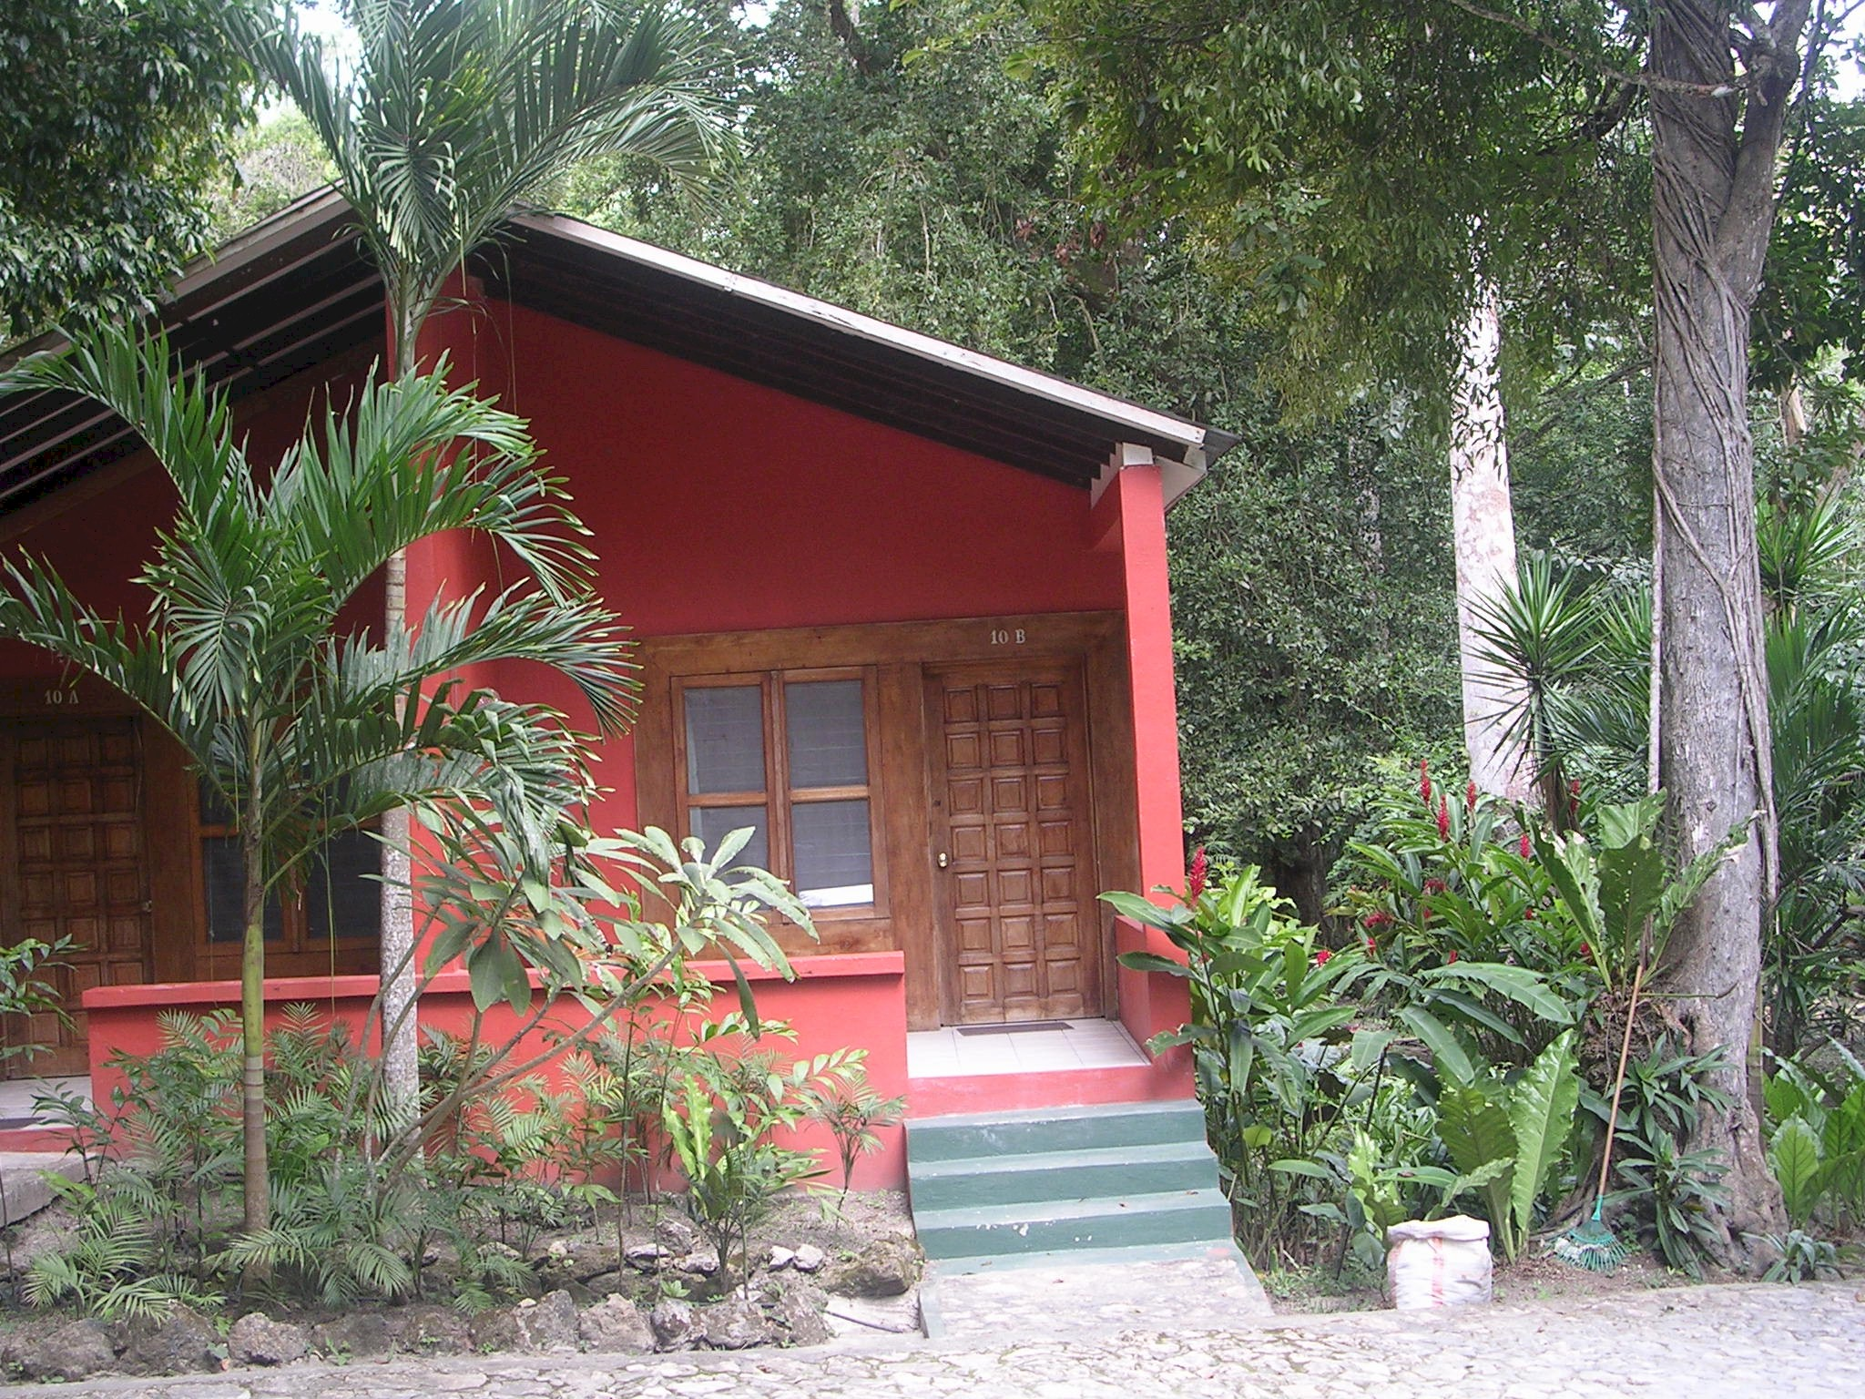
Our room at Tikal Jungle Lodge
The rooms were large, airy and had a nice tile bathroom with a shower. The most interesting aspect of the rooms was the mosquito netting. I had never stayed in any place that offered mosquito netting over the beds although one has often seen it in films situated in African, Asian, or South American locales. As it turned out, we did not need it and the mosquitoes were not much in evidence during our stay.

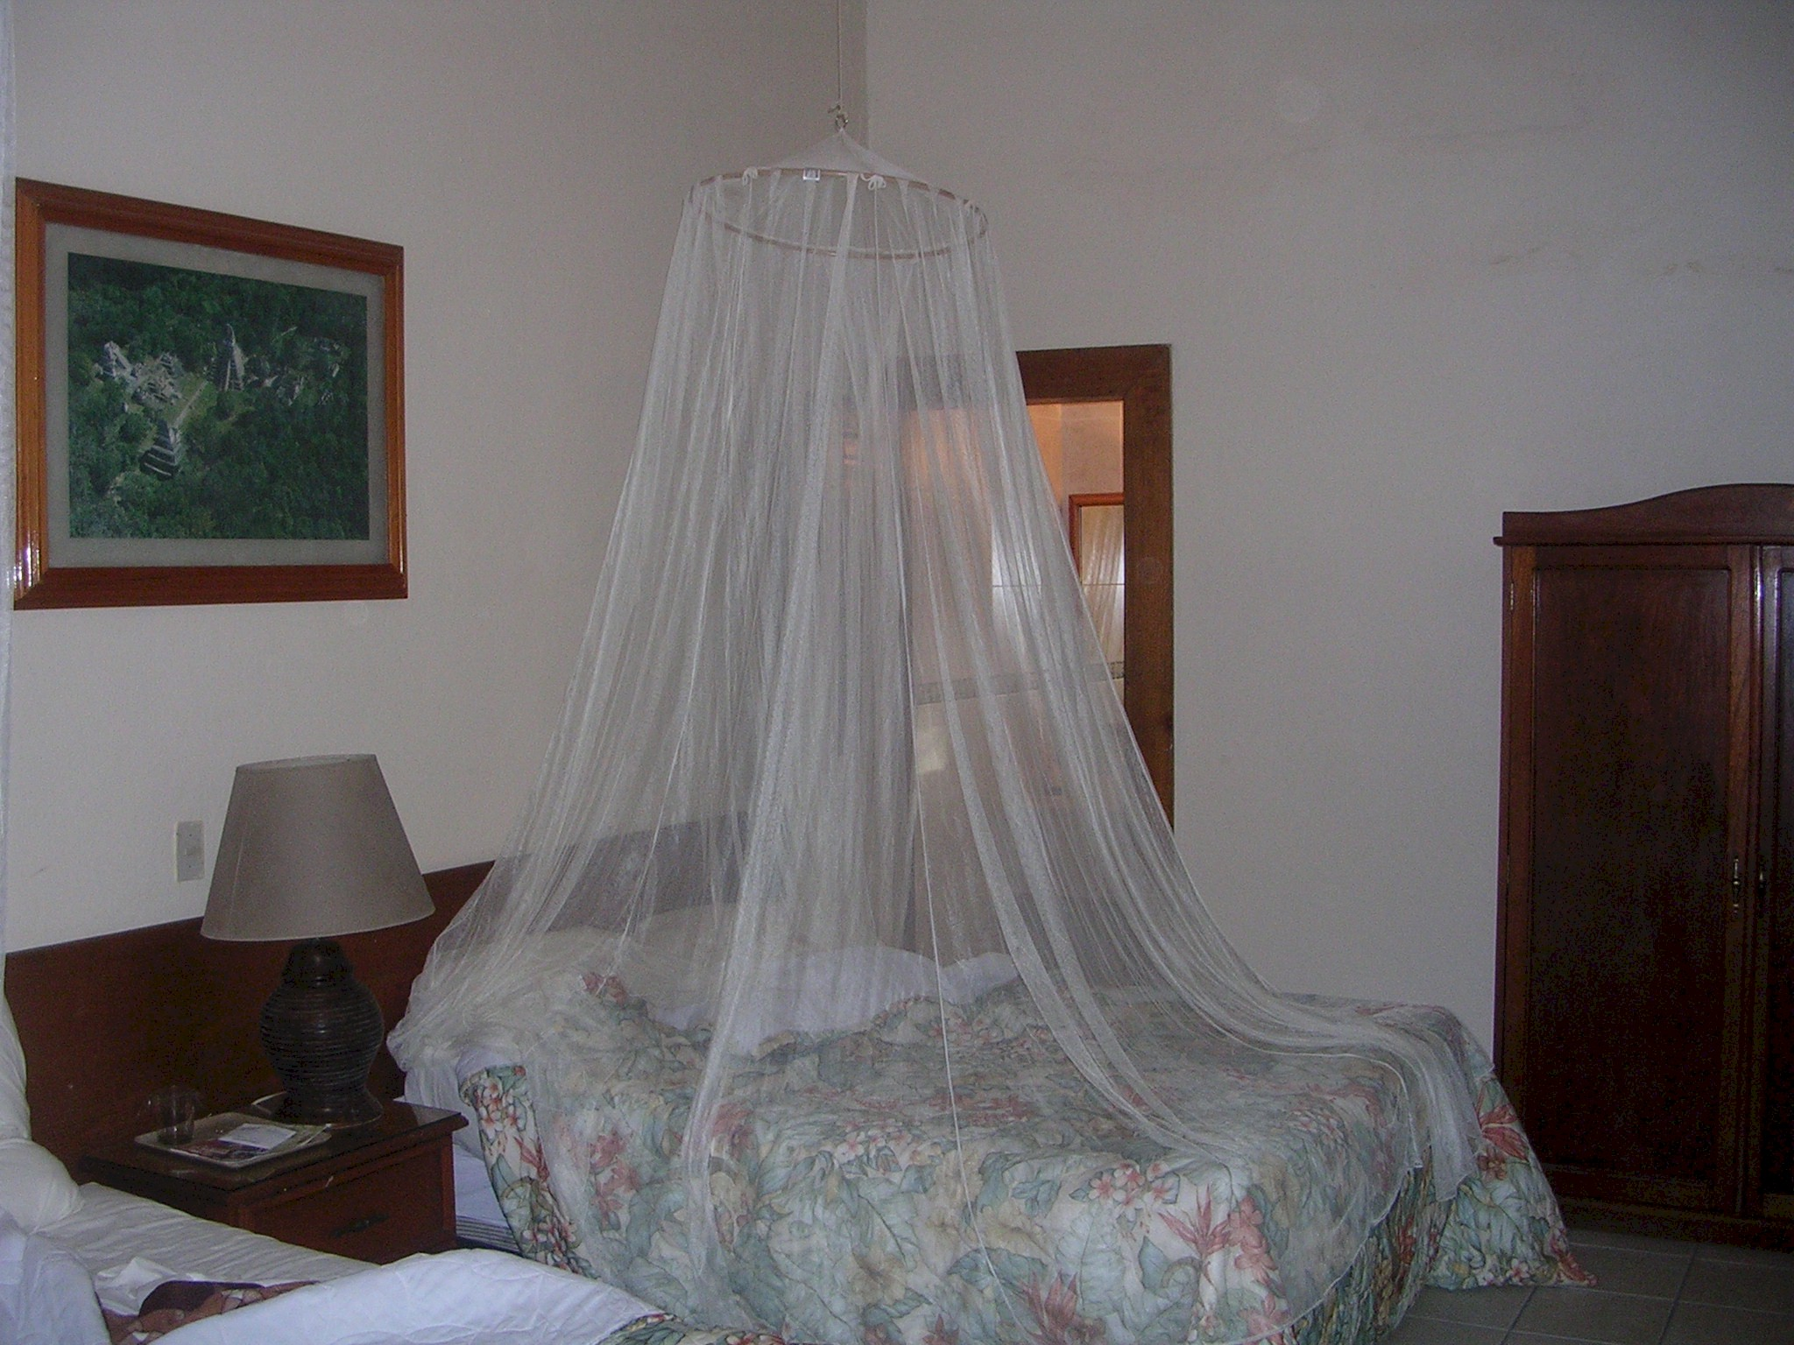
Protection from the natives

The Ruins

After taking possession of our rooms, we set out to explore the ruins. We were given a large, nearly incomprehensible, map and set out to find what there was to see. We followed the signs, paid our ticket price at the gate, and began our stroll down the wide and well-maintained trails. There were lots of other visitors, mostly Guatemalans so far as I could tell.

It quickly became evident that the ruins are huge and spread over a 25 square mile area and largely still unexcavated. We were told that the many large mounds of jungle vegetation that we passed, some up to 100 feet tall, were, in fact, additional ruins that have been reclaimed by the jungle and not yet excavated (if they ever will be). The scale of Tikal is surprising, not just the number of ruins, but the size of the principle temples. There is no doubt in my mind that the Mayan must have been one of the great civilizations of the world, wealthy, organized and imaginative. I think the Mayan ruins suggest a civilization as great as those of Europe and Asia, albeit very different. And without a written language (apparently) much of the sophistication of the culture may be lost. So today, we see only the remaining monuments and probably very little of the nuances of the civilization.

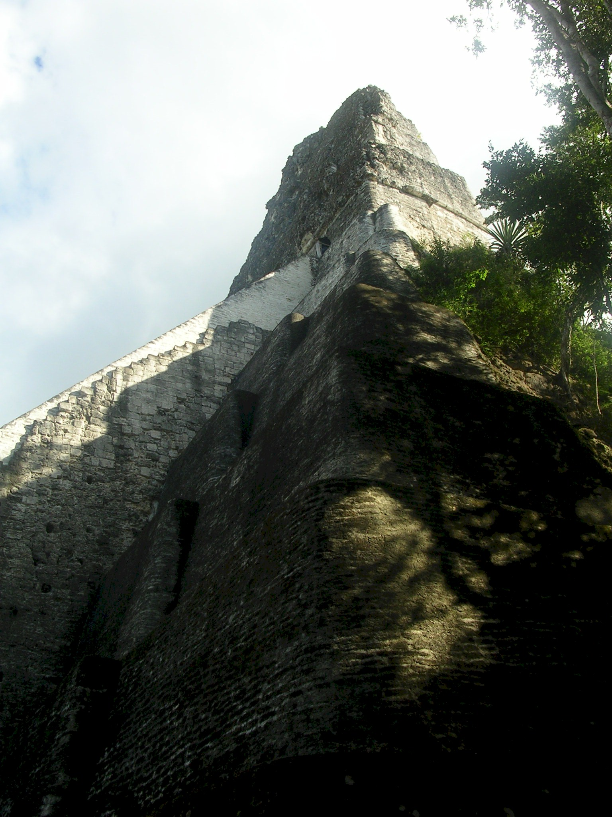
Mayan Temple I at Tikal

These temples until the early 1900’s were nearly completely lost to the jungle. They were hidden by centuries of vegetation and dirt

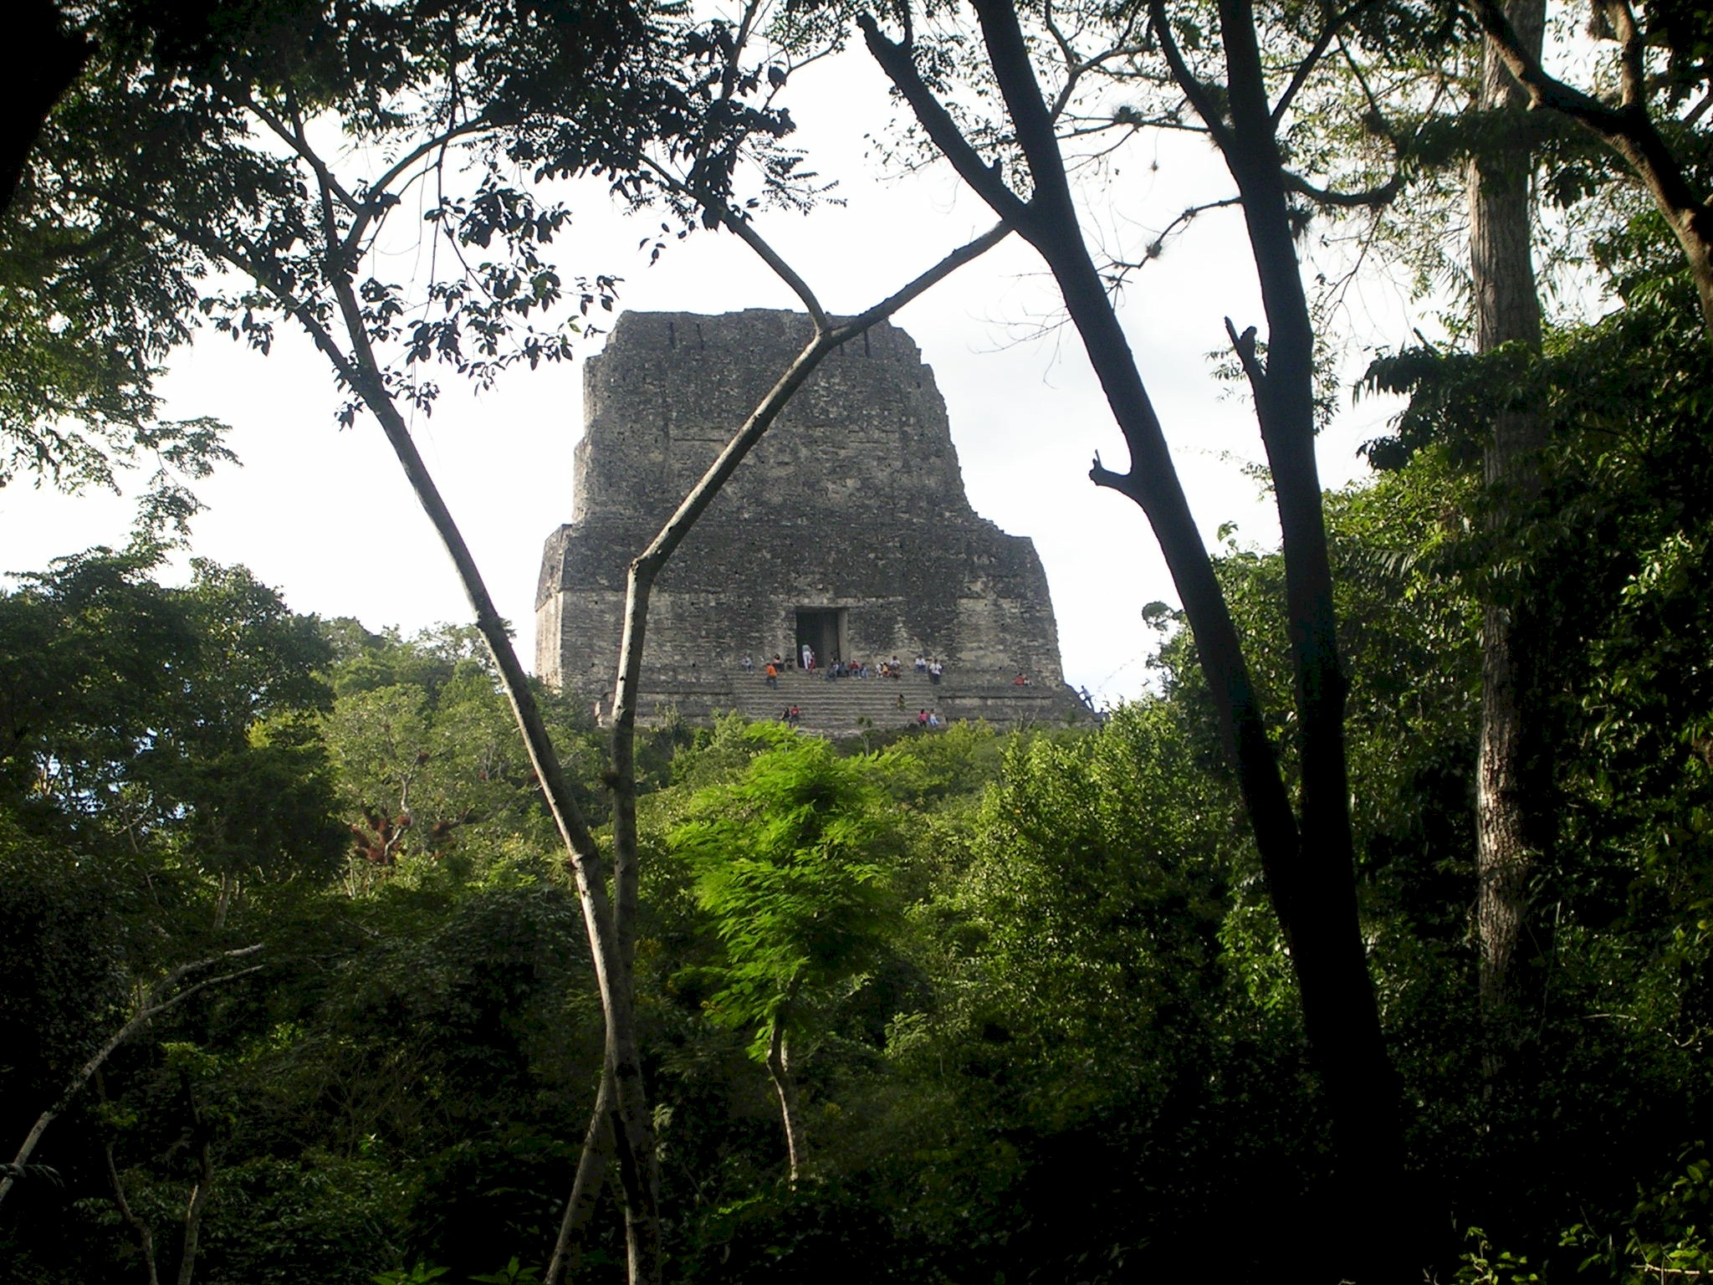
Mayan Temple V at Tikal

A Dangerous Climb
Temple IV, which we visited in the afternoon after a nice lunch at the lodge, is one of the tallest and is separated from the main group of temples, called the Acropolis. It is one of the few temples that one is allowed to climb. The frontal staircase is badly eroded so access to the top (or nearly the top) is by means of a rickety wooden staircase hanging, seemingly without means of support off the left hand side of the temple. It is more of a ladder than a staircase. There is one narrow staircase for going up and another staircase for coming down. To enhance the feeling of stability, a guard at the bottom allows only a few people on the staircase at once. M&M clambered up the staircase without a second thought. I decided to follow and had a very revealing experience.

The staircase shook with every step. As I ascended, I actually found it more secure to grasp the stair at chest height rather than the railing that seemed very tenuous. So I sort of hugged my way up the stairs. I found myself increasingly alarmed by the height and the unstable structure on which I was depending.

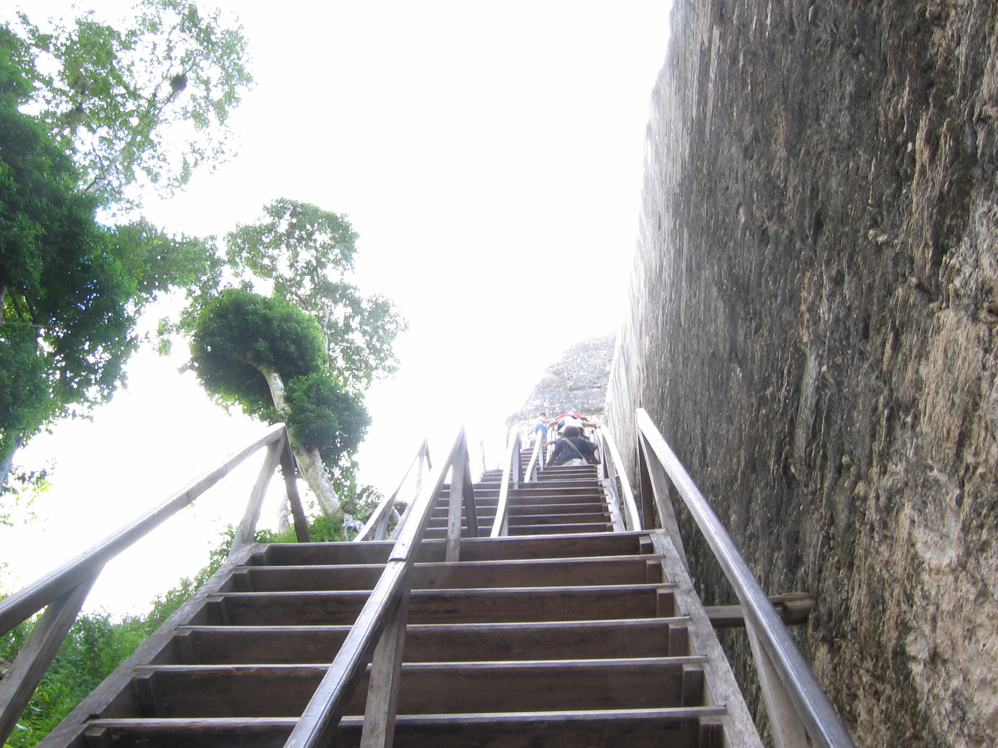
The rickety stairway up Temple IV

By the time I got to the “top” I was in a state of some alarm. What greeted me was a narrow stone platform perhaps 30 inches wide nearly fully occupied by tourists sitting down admiring the view. From the narrow ledge, it was 200 to 300 feet nearly straight down. To find a place to sit, it was necessary to pick ones way down the ledge by stepping over legs and bodies. One unexpected lurch, I thought, and one could trip over an outstretched leg and be over the edge in an instant. With panic rising, I worked my way down the ledge to an open spot leaning heavily into the vertical wall and hoping people would stop squirming. I plopped myself down on the ledge bracing myself against the wall behind me. I calmed myself and had to conclude that the view across the jungle tops to the other temples was truly breathtaking.

My “panic” really surprised me. I was never aware of any fear of heights before. In fact, if anything, I am exceedingly uncomfortable with small spaces. As a pilot, heights have never bothered me except, perhaps in the few cases where the ground suddenly drops away to great depths such as flying along the perimeter of the Grand Canyon. Hmmm… I thought. I learned something about myself. To add insult to injury, Gayle bounded up the stairs behind me and almost skipped down the ledge to join me.

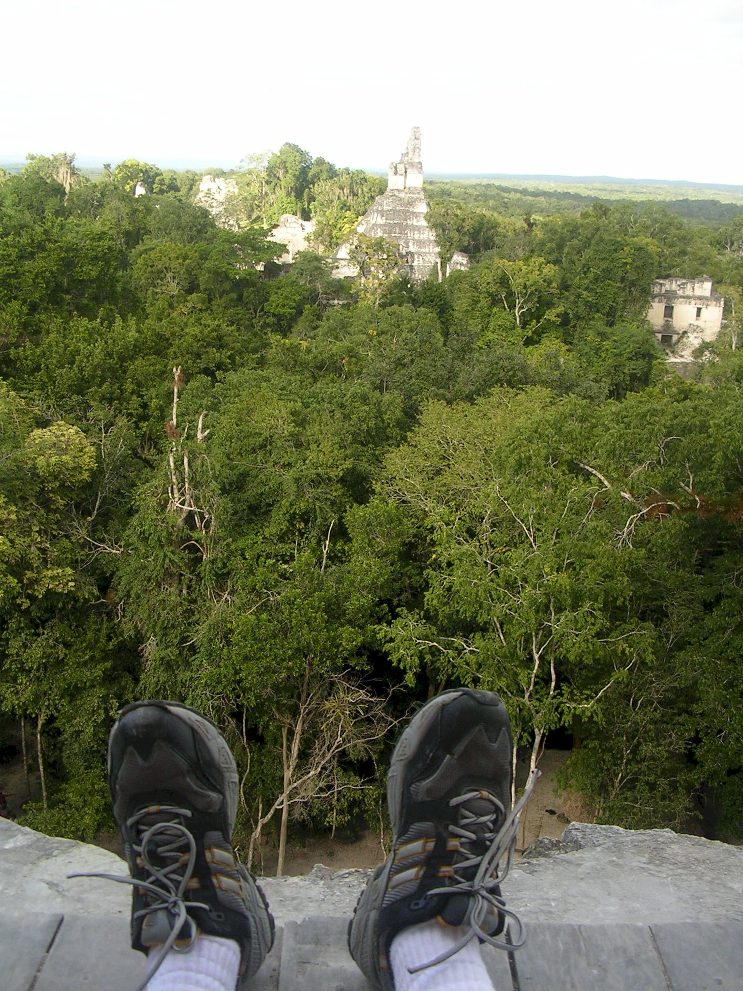
The view from the top of Temple IV
The trip down was something of an anti-climax since all the while I felt I was getting closer to solid ground and safety.

We spent the entire day walking around the ruins until the sun was setting and the jungle was taking on a much darker hue. We saw some interesting sights. Monkeys in the treetops. Columns of huge ants guarded by soldier ants with enormous pincers on their very enlarged heads. And finally, our very own virgin sacrifice ceremony.

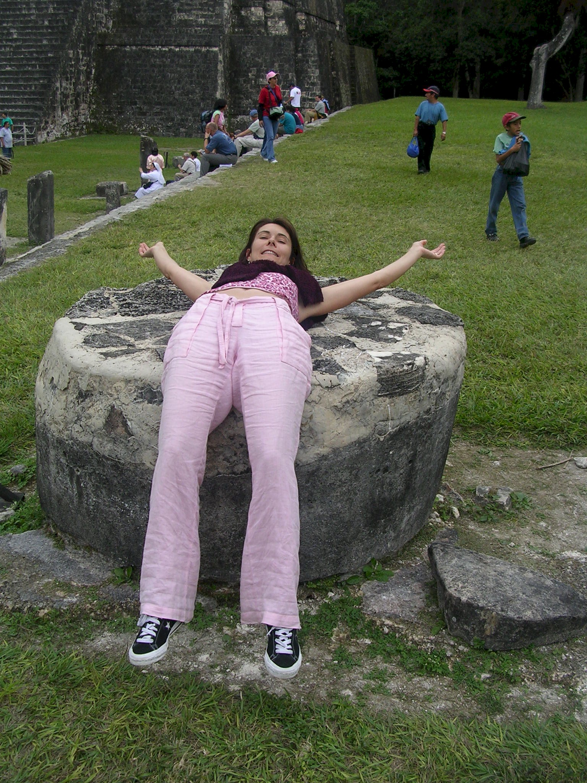
Virgin Sacrifice

Blood Curdling Screams in the Night

The lodge dining room served a nice dinner multi course on white linen tablecloths. We finished off the evening with a few drinks and trundled off to our rooms with the knowledge that the power went off at 11pm and would not be turned on till morning. We were very tired, however, and ready for a restful night’s sleep. It wasn’t meant to be. Some time in the middle of the night, we were awakened by an horrendous noise that was so loud that it almost hurt the ears. Our first thought was that the jaguars was killing some poor beast of the forest, perhaps a wild pig or similar prey, on the roof of our cabin. I was going to investigate by peeking out the front door but Gayle forbade me to unlock the door. “Are you crazy” was her sage comment muttered from the security of her covers. I could see nothing through the windows. Each shriek was followed a second or two later by an echo from somewhere far away. The horrible sounds continued for 15 minutes or so and then trailed off. The performance was repeated about 3 or four times during the night. Each chorus seemed more gruesome than the one before it. What was amazing was the huge volume of the sounds and the apparent close proximity to our cabin. We hadn’t a clue as to what could be making this dreadful noise.

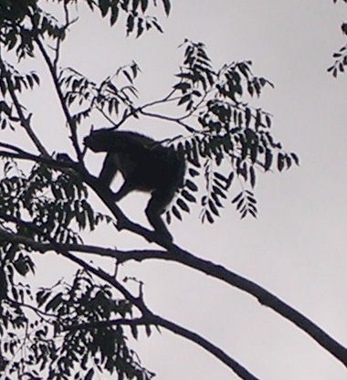
Monkey in trees above Tikal
We inquired the next morning at the front desk and were told, with a smile, that these nocturnal sounds are made by howler monkeys.

The Flight to Oaxaca

After our “restful” night’s sleep, we packed and prepared for the next leg of our trip, a three-hour flight to Oaxaca, Mexico. I had suggested a stop over in Oaxaca to M&M on the recommendation of my sister who has visited that city regularly. She described it as a charming city, seeped in southern Mexican and Indian traditions and noted for its folk art, vibrant colors, and its outstanding food. Our taxi driver was waiting at the appointed hour of 8am. The one hour trip back to Santa Elena airport seemed much quicker than the outbound trip.

We packed our plane, went through the minimal formalities required by Guatemala, filed our VFR flight plan to Oaxaca and departed. The weather was glorious and the forecast was good except for a possible overcast around Oaxaca which was due to burn off by the time we arrived. This leg was to be quite different from our flying thus far because of the mountains. These are the southern continuation of the Rocky Mountain chain and are just as high and imposing. Oaxaca itself is situated at just over 5,000 feet. The city is surrounded by towering mountains in all quadrants. Our flight path was further constrained by a large restricted area covering most of our route that had its floor at 7,000 feet. This forced us to fly below 7,000 feet until we went beyond the restricted area and by that time we were at the beginning of the mountains and would be forced to climb to at least 12,000 feet for the last hour or so of our flight.. Once again, we did not fly in close formation, but we had 44V in sight for most of this flight. Morten took the picture below of 08M not too long after we departed Santa Elena.

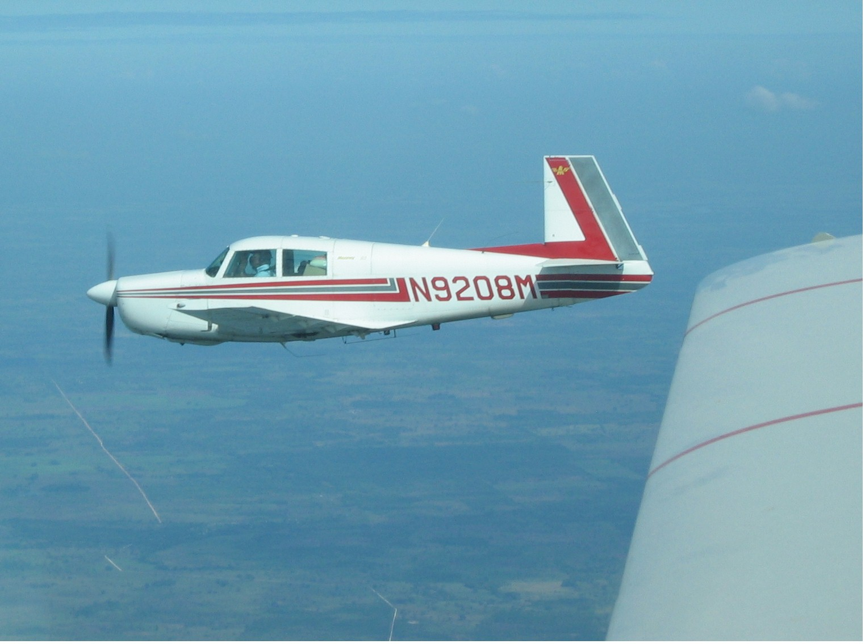
N9208M early in our flight to Oaxaca

The Overcast

My new GPS showed very clearly our departure from Guatemalan airspace and our entry into Mexican territory. We were flying at 6,500 feet on a slightly dog leg course designed to avoid some of the most southern mountains and to keep us clear of a multitude of restricted areas that dipped down to the surface. After about 2 hours of flying, we started to see increasing cumulus clouds (the puffy kind) as the ground also began a gradual rise. We were able to zig and zag through the bigger buildups but it was clear, to me at least, that they were quickly going to close ranks and become a solid overcast above us. This posed a dilemma, of sorts, because we had to get higher to cross the mountains but could not yet climb because of the restricted area. There was a risk, if we continued at 6,500 feet, of being trapped below the overcast and therefore unable to climb while maintaining visual contact. At this point, Morten and I made different decisions. I decided to climb above the clouds while he decided to continue on the assumption that he could climb later on through some hole in the clouds that would present itself. My decision forced me to violate the restricted area as I climbed to 10,500 feet. I turned off the altitude reporting mode of my transponder that told the radar controllers (if there were any) what my altitude was. With no altitude reporting, they could not bust me for any violation of the restricted area. I doubted that my action would in any way endanger myself or any military aircraft in the area since the visibility above the overcast was excellent. In fact, we could see the rising towering mountain range at least 50 miles ahead.

Morten reported that, in fact the overcast closed in above him and within 15 minutes he too reported level at 10,500 feet having once again found a virtual hole in the clouds. I guess we both broke the rules in different ways but we each had to deal with the weather situation in the way we were most comfortable with.

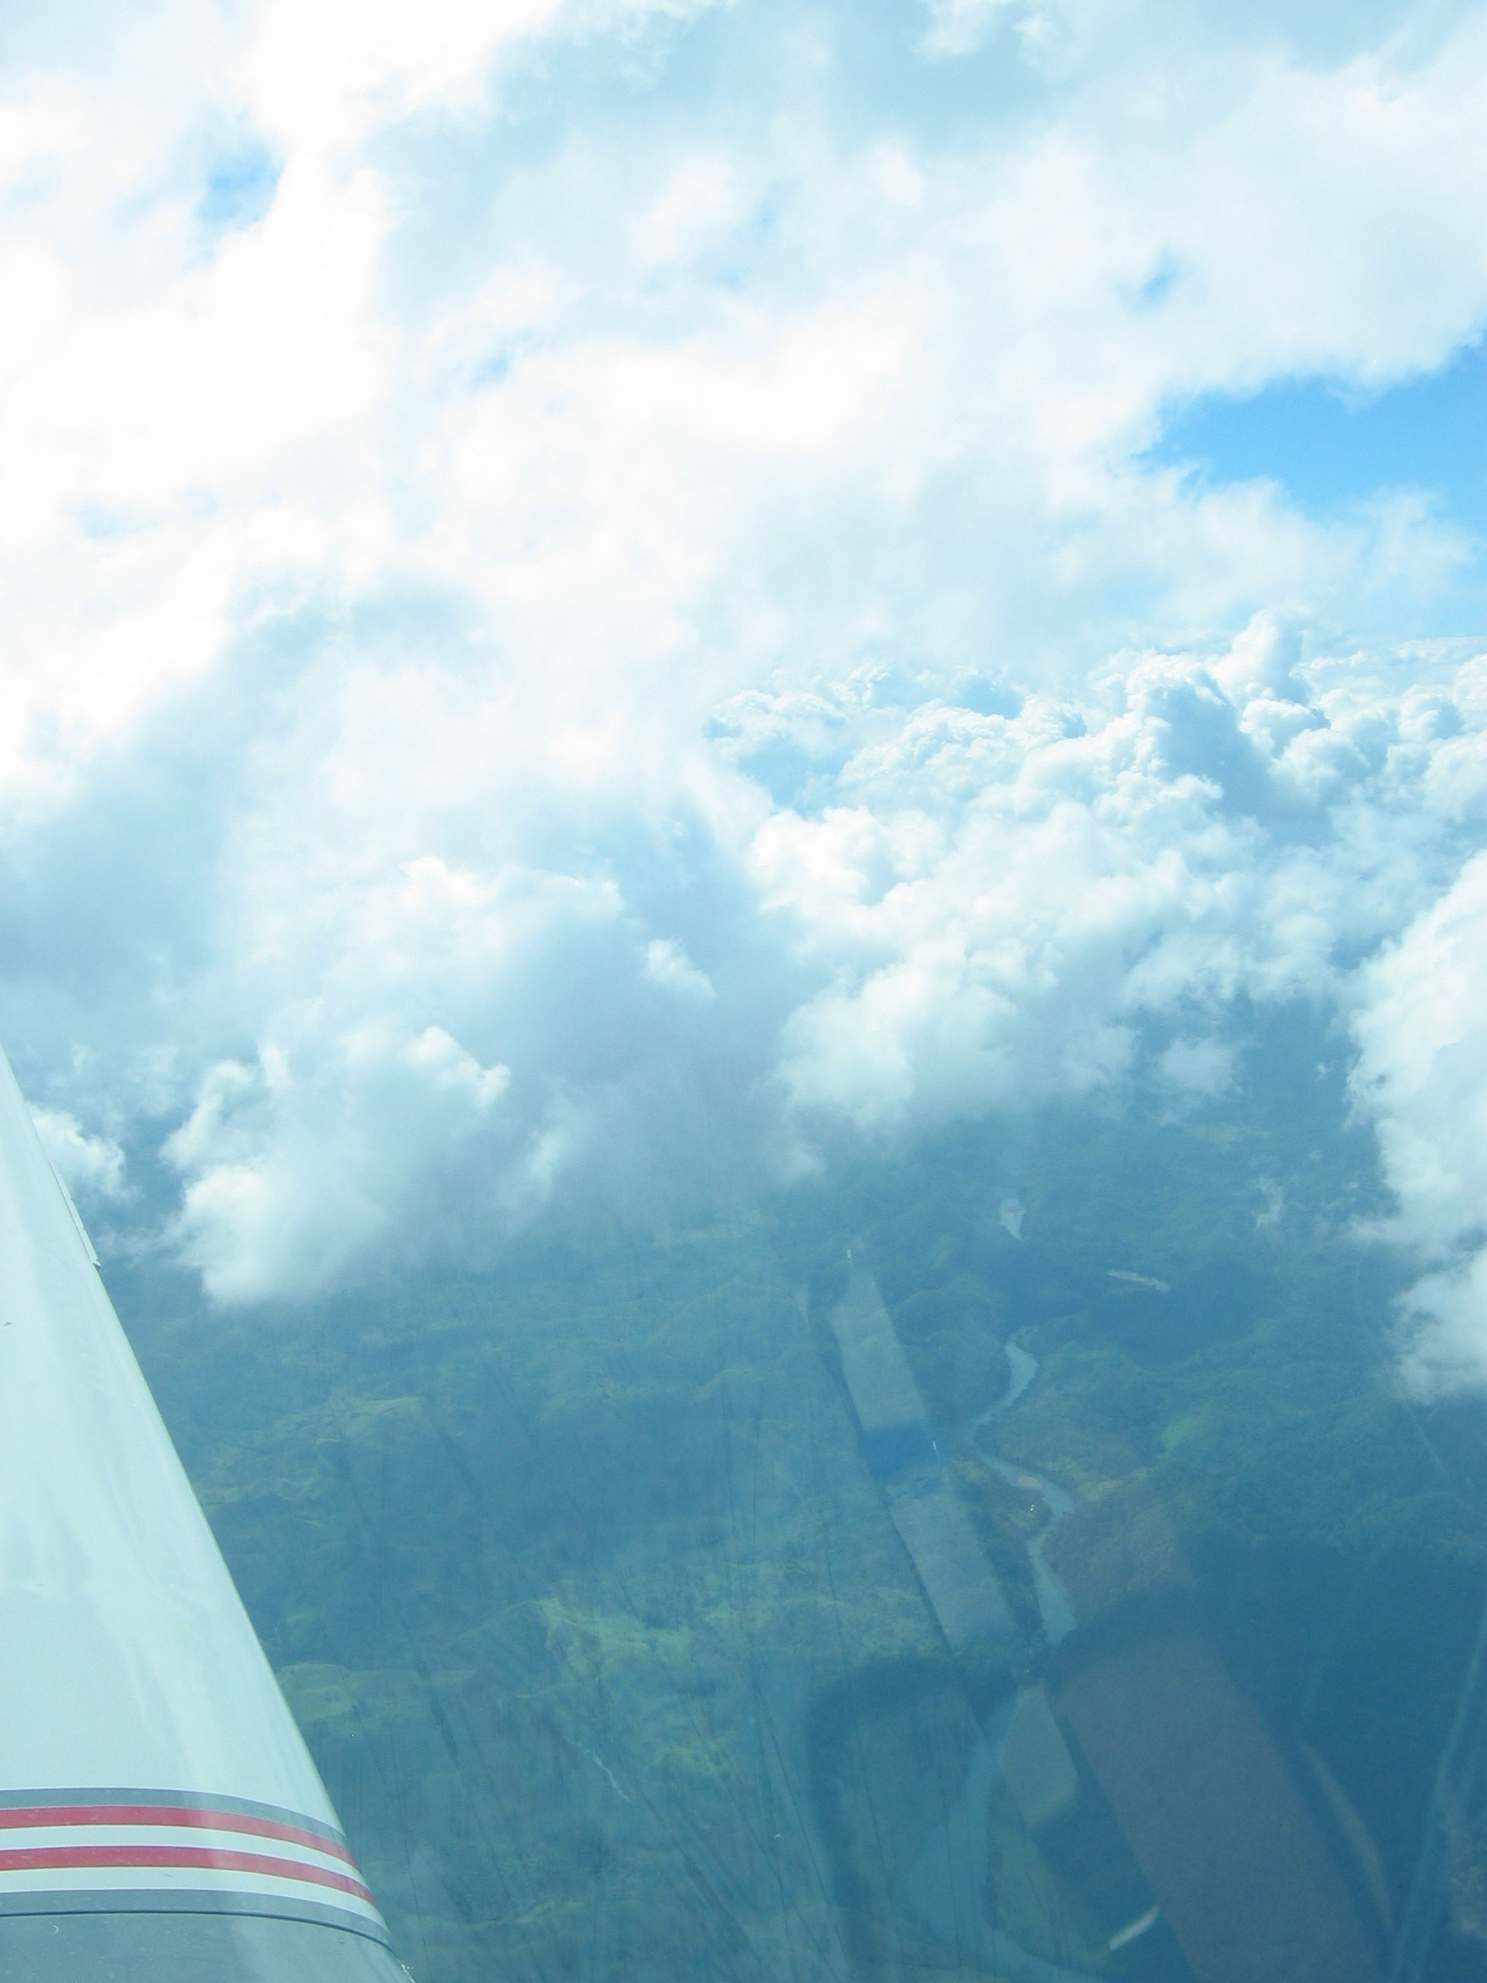
The overcast breaks up as we crossed the mountains surrounding Oaxaca.

The mountain peaks got closer and before long we were among them and just a few minutes out of Oaxaca. As forecast, the overcast started to break up and the Oaxaca ATIS (weather condition broadcast) was reporting clear conditions.

We both contacted Oaxaca tower at about the same time and were directed to land on runway 36, that is the main runway facing north. I lost sight of 44V as we approached the airport and that was a bit worrying but not unusual. Actually the reason we lost sight of him was that we were making an approach to different runways. He was following the correct procedure but I made a mistake that even now embarrasses me. My new GPS was setup to paint my desired course to the airport as up. Since I was approaching the airport from the northwest, the apparent position of the airport on the moving map showed runway 18, the southbound runway, as being “up”. And north is up, right? In this case, it definitely was not. On short final I realized my mistake and apologized to the tower for my error. The lady controller was very nice about it and told me to continue my approach and land. I am still shaking my head about this mental lapse. Perhaps it was the lack of oxygen. And I had two bottles of oxygen handy. I just had to put on the mask and open the valve.

Drug Sniffing Dogs

Back in Mexico we were prepared for excessive bureaucracy and fees. And we were not disappointed. We parked in a far corner of the main ramp and were met by sizable group of uniformed soldiers (or policemen). They asked to see our papers. I notice that they had two large dogs in tow and that one of the members of the party was making a video. It turned out the dogs were drug sniffers and the inspectors wanted the dogs to inspect all our bags. At one point my dog actually jumped up on the wing and poked his/her nose into the airplane. I still had tarry dog prints on the wing when I returned home. Because of the large group of observers and the video being taking, I suspect the dogs were a new program and our arrival was designed to showcase the apprehension of big-time drug dealers arriving from the south. I guess we failed the test, because after a considerable period of sniffing and paper shuffling, we were pointed in the direction of the terminal building. There we suffered the usual delays, fees, and uncertainties of Mexican customs and immigrations. Unlike Vera Cruz, however, there were no special fees for arrivals on Tuesday afternoons and our multi entry declaration worked as advertised and we did not have to spend $50 US on another one. In short, we got off easy.

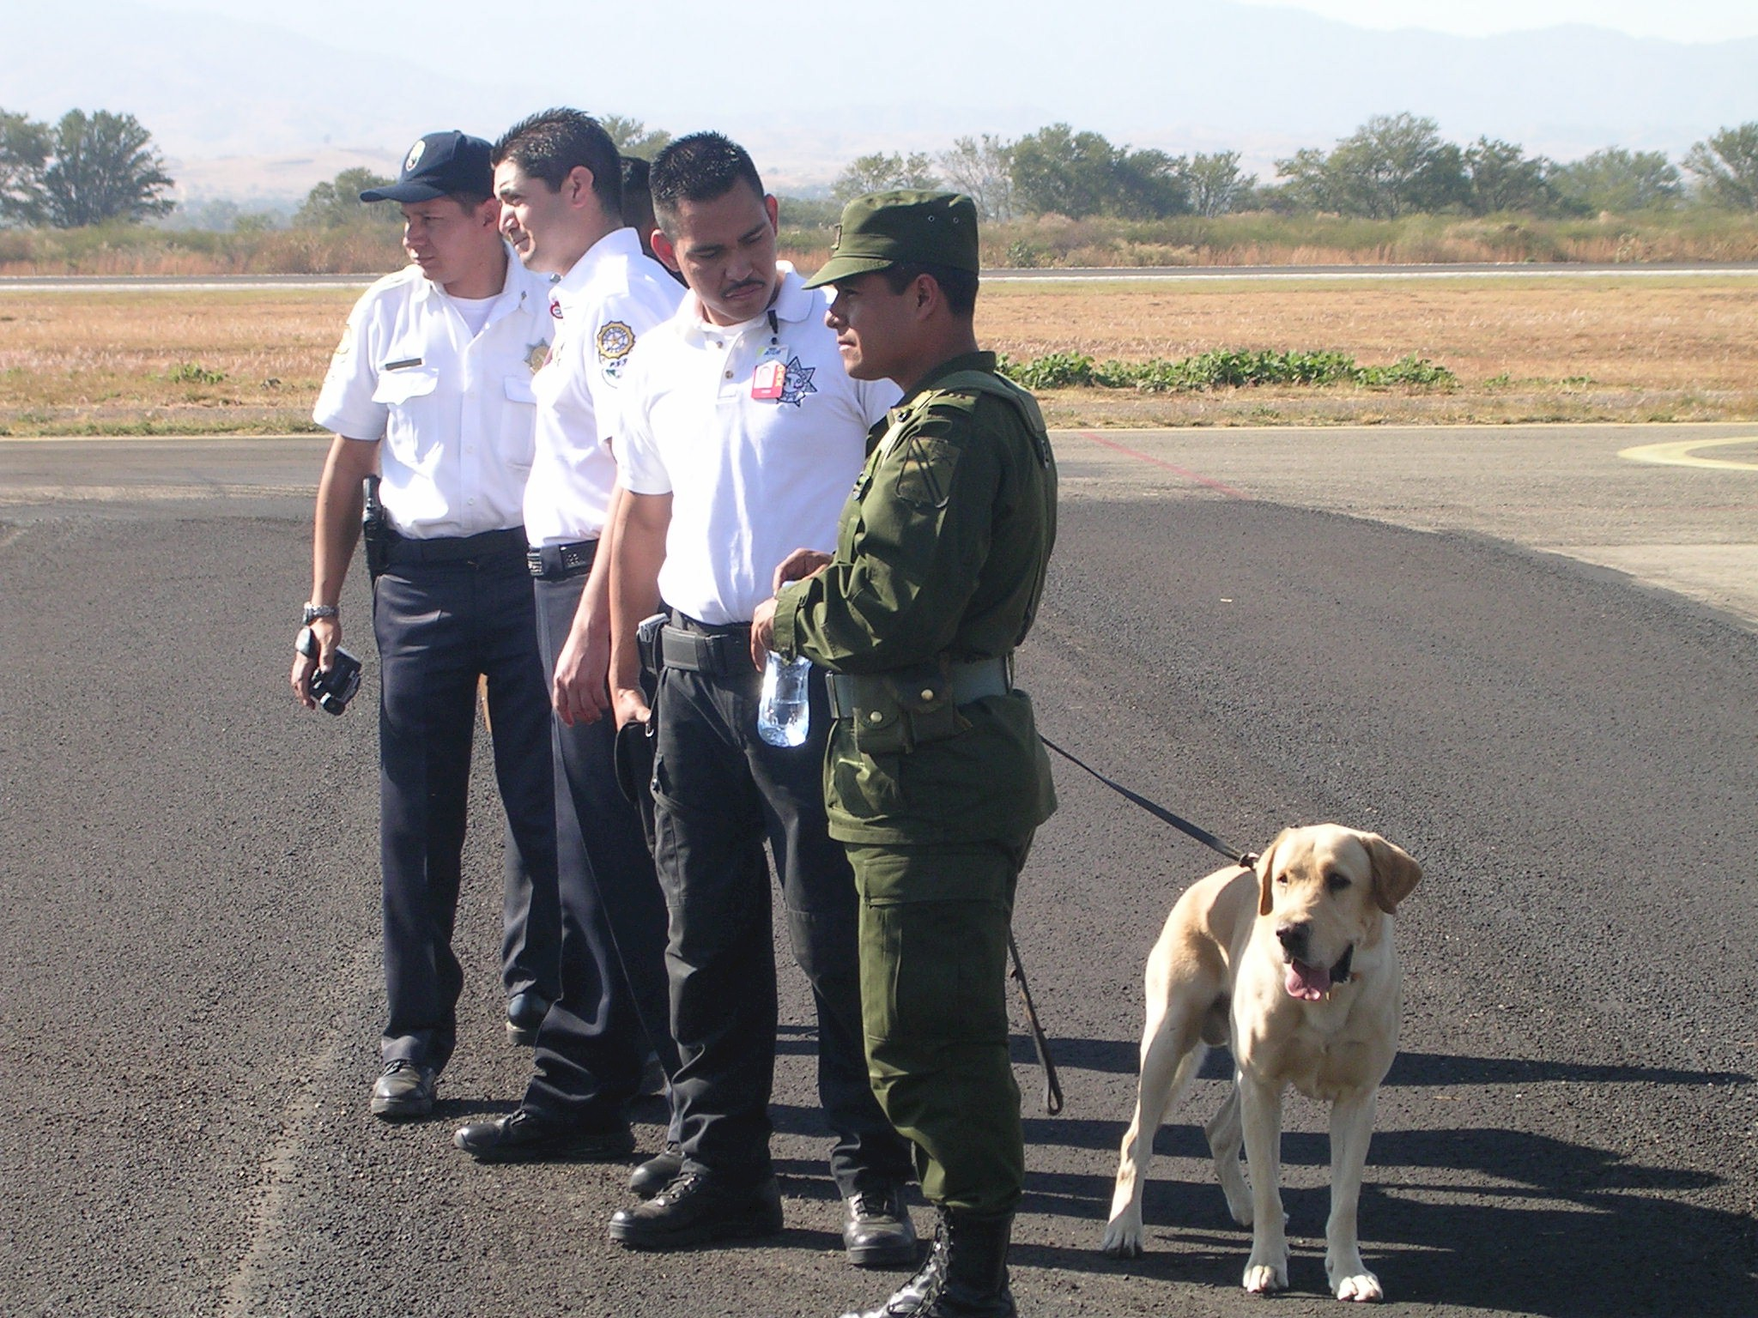

The Cooking School

We got into an airport taxi and headed into the city to stay in our next accommodation, a B&B and cooking school. This was sort of an odd combination, I will admit, but the advertisements on the Internet looked charming, the price was about half that of big name hotels, and we were traveling for adventure as well as comfort (Gayle might not have agreed entirely with that objective). In any case, I was somewhat apprehensive since this reservation was made entirely by me without any consultation with M&M who had said, “Go ahead, you make the arrangements”. I had no idea what to expect.

After some 20 minutes, and passing through what seemed to be an exceptionally clean city (by Mexican standards) we came to the colorful building in the picture below.

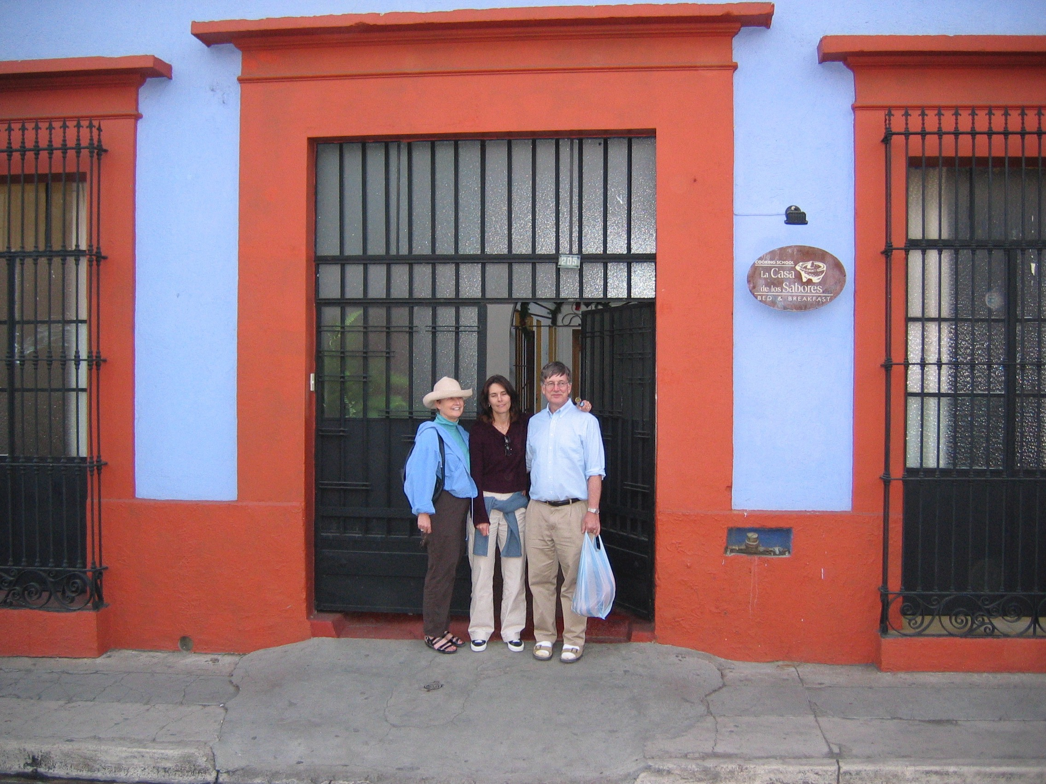
In front of our B&B, La casa de los Sabores

The driver checked the address and assured we had been delivered to the correct place. And, sure enough, next to the big iron door was the sign La Casa de los Sabores (the house of flavors). We rang the bell and an attractive young woman came to the door and let us enter. Like many Mexican dwellings, particularly older ones, this one was built around a courtyard open to the sky. All the guest rooms (and there were four) opened onto the courtyard. Set into one side of the courtyard, protected by an ample overhang, was the dining area and kitchen.

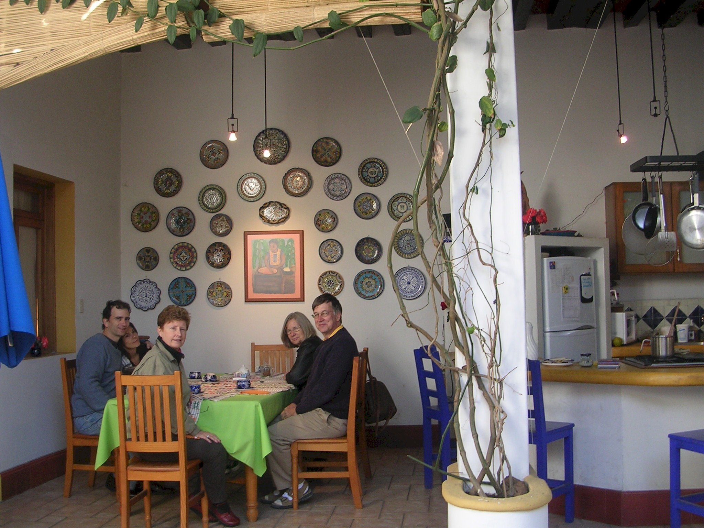
The Dining Area and Kitchen
It was very charming, however, as Gayle pointed out there was no central heat and being we were at 5,000 feet and it was December, it was actually a bit chilly. It turned out we all ate breakfast bundled up in sweaters, jackets, and blankets. As the day passed, the temperatures became exceedingly pleasant.

A Charming City

Oaxaca warrants a week, at least, to see all the sights and to get a flavor for the place. It’s a subtle place to visit when compared to, say, Belize or Tikal. It’s a big city and it takes time to get to know a city. We had only a day and a half so I believe we just skimmed the surface. It would be nice to return with a week on our hands. I can summarize Oaxaca as attractive, old and colonial, very colorful, and with excellent restaurants.

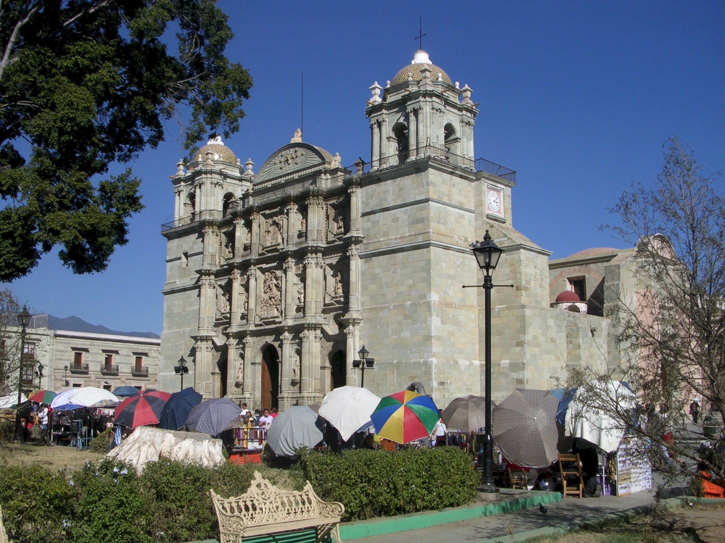
The main cathedral off the Zocalo or main square

Running Short of Cash

In Oaxaca I learned a lesson about planning for a trip to Mexico. It is not necessary to bring a whole wad of cash with you. Just find the nearest ATM and it will replenish your supply, in pesos, of course. We found ourselves getting a bit short on cash after all the unexpectedly large cash purchases, including airplane fuel which was no available by credit card. And the Banco de Boyd (that is Morten and Monika) was also getting short on cash so I couldn’t keep hitting up on Morten when money ran short. The Oaxaca ATM solved the problem. Just remember that $400 means pesos (about 40 dollars US) and that you really need to press the $4,000 button (400 dollars US).

Excellent Food

We found the food in Oaxaca to be excellent. The best by far, in my opinion, was the La Olla Restaurant which was owned by the same people who owned our B&B (plus cooking school). It was very popular and the associated B&B was very much to Gayle’s liking. We also had a good lunch at an upstairs restaurant overlooking the Zocalo. The meal was good and the service was excellent, unfortunately, there was something in one of the “authentic” local dishes that did not agree with Gayle and would affect us on the morrow.

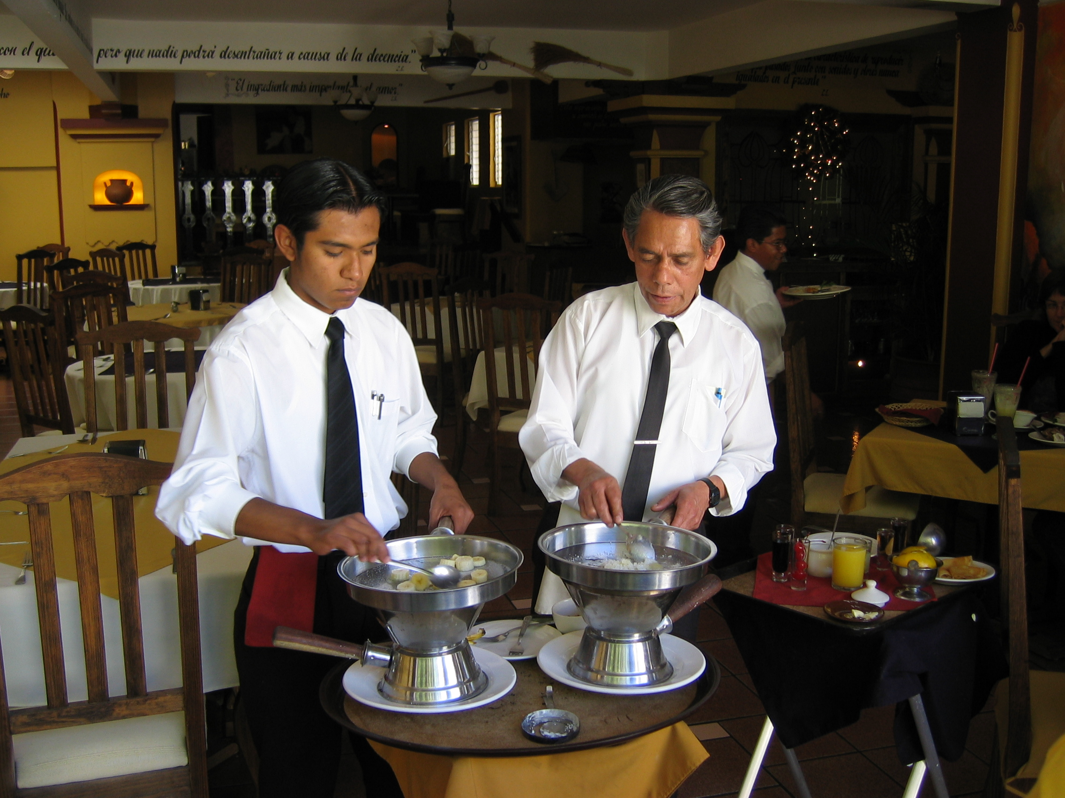
Flambé deserts in the restaurant overlooking the Zocalo.

Crafts and Art

We had hoped to pick up lots of Mexican folk art in Oaxaca but found it somewhat expensive and bordering on the touristy. My guess is that one needs to venture out of the city into some of the villages where it is made to get a good price.

The Flight North

December 31st, New Years Eve, was to be a busy day for us. We planned to make two flights, each about four hours in length so we had a full day of flying ahead. Our goal was to get to Alamos, a small colonial era city in Sonora where I had made a reservation for a New Year’s Eve gala with dinner and dancing. So we had to get an early start, up at 6am, taxi to airport at 7am, hopefully airborne by 9am. We would make a fuel stop in Puerto Vallarta and then direct to Alamos.

When Gayle awoke, she announced that she was not feeling well. She blamed something in the lunch we had had the previous day. She was, in fact, very sick to her stomach. As it turned out, we had very little flexibility in our schedule. We had to get to our next reservation and it was unlikely that we could make alternate reservations on New Year’s Eve.

We had good luck getting off from Oaxaca on time. Of course the dogs were summoned to check our plane and baggage once again, but they were faster this time, possibly because nobody was filming the procedure. The weather was good, high cirrus clouds, favorable winds, and good visibility. Our route was basically direct to Puerto Vallerta with a slight dogleg to the west to avoid a huge restricted area that occupied hundred of square miles (or kilometers) south of Guadalajara. The terrain was daunting with high mountains for virtually the entire flight. We were flying at 10,500 feet and we passed over ridge after ridge with only a few level areas between where there was some cultivation. It would have been a poor place to have any sort of engine problem.

Gayle was a real trooper. In spite of being violently sick, and that is not pleasant in any circumstances, she never once questioned our need to fly onto Alamos. Later, when she was feeling better, she proudly proclaimed it was possible to throw up in an airplane for four hours and not make a mess. Thank goodness we had good quality air sickness bags handy. The one disconcerting thing was that Gayle loves to make a statement and whenever she had a stomach spasm, she let out a bellow that would have awakened the dead. All I could do was fly the plane and ignore her. There was nothing else I could do. And she didn’t ask me to do anything other than what I was doing.

Colima Volcano

Needless to say Gayle was not enjoying the scenery. When she wasn’t actively using the barf bag, she was trying to shut out all worldly stimuli in some semblance of sleeping. To bad, because she missed one of the grandest sights of trip, 14,000 foot Colima Volcano. It towered above our altitude. It is supposedly quite active but was on its best behavior as we flew meekly by.

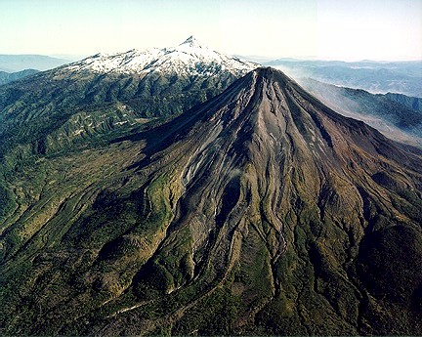
Colima Volcano

A Quick Stop in Puerto Vallerta

After nearly four hours in the air, the Pacific Ocean began to appear to our left. The GPS was ticking off the miles to Puerto Vallerta and it was time to begin our descent. However we were still over an imposing set of ridges and, as it turned out, we could hardly begin our descent until we passed over the final ridge and were then almost directly over the airport. We both made a wide descending pattern and were cleared to land. It was a blessing to be on the ground. Gayle was being very quiet. Our only goal was to fuel up and depart as quickly as possible. Monika took Gayle into the general aviation terminal where she was able to lie down on a row of plastic chairs. Morten and I attended to the fueling and the paperwork. Both went like clockwork and in record time, perhaps less than one and a half hour we were airborne again. Although not feeling chipper, the horizontal time had done Gayle a world of good and at least she was not actively nauseous. This terrain below us on this leg of the flight was very different from the prior leg. We were actually flying over a relatively narrow coastal plain that was punctuated with marshes, lagoons, and estuaries. As the flight progressed we edged away from the coast on a heading that would take us direct to Alamos. We flew over farms and grazing land and fairly frequent habitations.

A Helicopter Goes Down

About the time we were passing abeam of Los Moches, a coastal city about an hour out of our destination, we heard a commotion on the ATC frequency entirely in Spanish. One voice was very excited. We had no idea what the meaning of these transmissions was. A little while later, we heard the controller ask a US registered aircraft if they would fly to a specific location because there was an indication that a helicopter had crashed. The pilot agreed, and a little while later he announced that he could see nothing and then, apparently, continued on his way. That was the last we heard of it.

Arrival in Alamos

We arrived in Alamos at about 4pm just about on our original plan (somewhat remarkable considering that this was Mexico). The airport at Alamos had been recently paved and was in good condition, much better, in fact, than on my earlier visit in April. We were met by the entire family of the airport manager. This gave us lots of little hands to help us with our baggage and tying down the airplanes. We asked for a taxi which arrived almost instantly.

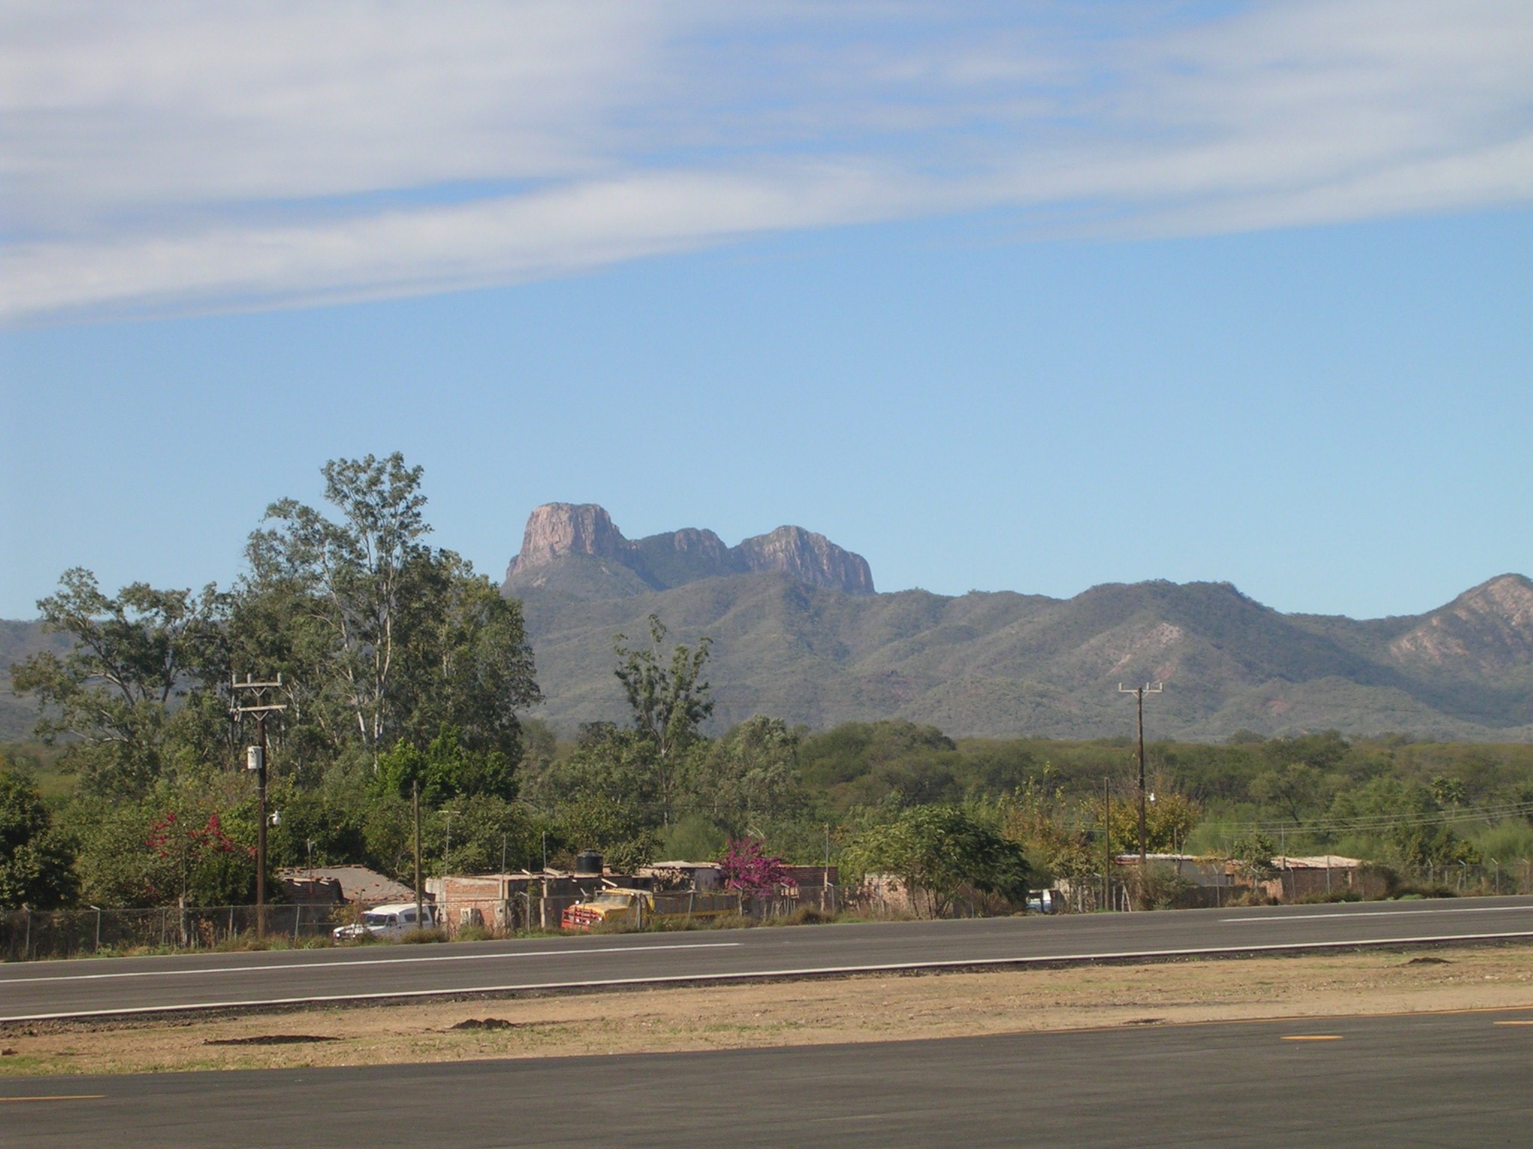
The mountains surrounding Alamos airport

Colonial Grandeur con Gringos

Stopping in Alamos was again my contribution to our travel itinerary. I had taken a one-night trip to Alamos in the spring after attending a wedding in Tucson. I found in very picturesque with a lot of the earlier 19th century colonial grandeur well restored. It is an interesting place, in part, because there is a sizable American community living here and that accounts for a good deal of the wealth and the restoration of the older casas. Alamos has a beautiful town square complete with the obligatory cathedral. And there are a number of hotels, restaurants, and shops that would seem to cater to Americans and tourists. There is also a covered market place that serves as the combination Safeway and Wall Mart for the locals and visitors alike.

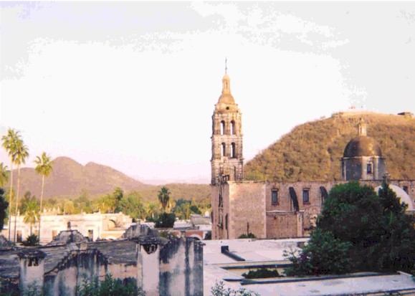
The cathedral at Alamos

Casa de Maria Felix

The taxi dropped off at our lodging, the casa Maria Felix, hotel and museum. The museum part is a tribute to the 40’s-era Mexican movie actress Maria Felix who has been born in Alamos and lived on the very site where the hotel was located. I was again somewhat apprehensive about the accommodations since I had made them and was not at all certain if my traveling companions or my wife would approve. As it turned out, Casa Maria Felix was very satisfactory and we each had a private casita or guest house in the back overlooking the garden and pool. Gayle, in any case, was not very appreciative and simply wanted to go to bed. I tucked her in and gave her a bottle of Coca Cola to settle her stomach..

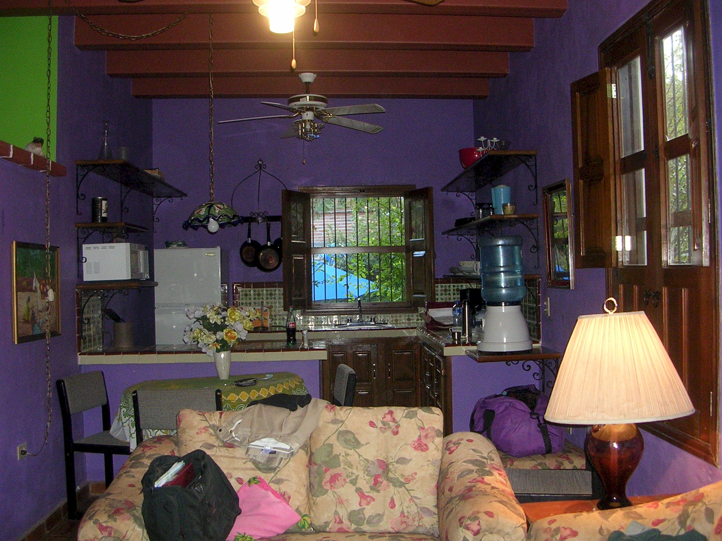
The living room of our casita
There was an interesting story about casa Maria Felix that I learned from the owner named Barbara the following day. She was a Canadian woman architect who had built the casa about four years earlier. Nothing was spared. The house and the casitas were all beautifully designed and authentic to the flavor of the original Mexican architecture. It was not really intended to be a “hotel”. But it seems that Barbara, the owner, had fallen on hard financial time, something to do with being overly invested in Enron and Worldcom. Further, she had, the previous year, fallen head first into the swimming pool which unfortunately did not have any water in it. She suffered serious head injuries and is now in precarious health. So she opened her home as a ”B&B” except she does not serve breakfast. The establishment is for sale for (if I remember correctly) for $450,000 US which is quite a lot of money for Mexico. In Monterey, the house would be worth 3,000,000.

New Year’s Eve “Gala”

The hotel where I stayed in April was hosting a big gala New Year’s Even dinner and dance and we all had reservations. After 8 hours of flying, I expected to be very tired, but we all (except poor Gayle) were feeling quite chipper. M&M and I decided to walk into town to get a little local color while there was still some light. The quickest way to the center of town was up a little back alley to the top of a hill that overlooks the town and then down the other side. This walk was almost entirely through a part of town occupied by local Mexican families. It was interesting to see the little homesteads that were all pretty primitive looking but very clean and tidy. We were greeted with “Allo” from all the little children. We went to the hotel to confirm our reservation, had a margarita at the bar, and headed back to our lodging. All of the buildings in Alamos seem quite barren and un-welcoming from the outside, but they are all designed around courtyards and the charm faces inwards and all the buildings offer a cold shoulder to the world at large. One could peek through the occasional open oaken door or wrought iron gate to see the lushness and warmth inside.

At the appointed hour, Monika, Morton and I returned to the hotel hosting the gala. It was all decorated as befitting a New Year’s Eve celebration. There were perhaps 50 large tables set up in the courtyard and in the arge dining room with white tablecloths, blue napkins, china and glassware. We found our table and our places were marked with our names. We were seated with a large Mexican family that looked very aristocratic, a husband and wife, five well-behaved children, and a matriarch. I imagined they were Don Cristobol de Santana-Ortega and his wife Donna Maria Anna Isabella Margarita Rodriguez-Fuentes owners of 150,000 acres of prime Sonora ranchland, and direct descendants of the recipients of the original land grants from Queen Isabella of Spain. They of course, retained title to their land through the revolution by displaying true democratic political leanings and a personal friendship with Pancho Villa. Actually, we cannot verify the above suspicions because they spoke no English and we no Spanish. We smiled at each other from time to time.

The meal arrived, served by a small army of attendants. The meal started off with a superb appetizer but as the courses progressed, the meal became very ordinary. We ordered (I think) two bottles of wine and there was none remaining when we left.

At one point M&M got up to dance, and I was immediately engaged in conversation by four middle aged ladies in the adjoining table. I think they were thrilled to find an unattached male person approximating their age. I may be exaggerating a bit, but I felt they pounced on me like a family of cats vying for a tasty small mouse. They were exceeding curious as to what was the exact relationship between me and Morten and Monika. We had a polite conversation and it quickly turned out that in Alamos everybody knows everybody and I received a full background briefing about Casa Maria Felix and our hostess. It turned out that because of our long-standing reservation, several local ladies were forced to find other accommodations for the evening.

At about 10pm, I looked at Morton and Monika and realized that they looked as tired as I was beginning to feel. It was decided in a moment, that it was time to go to bed and we got up and left well before the witching hour. I found Gayle sound asleep and crawled into our bed and pulled up the colorful covers and was out like a light.

Last Leg

We awoke refreshed the following morning. Gayle, was feeling much better (although not 100 percent). I scoured through the main house and found the promised pot of coffee and brought the spoils back to Gayle and we shared the events of the previous night. After some time, M&M appeared and we decided to walk into town for breakfast. The only place we could find open was the same hotel where the gala was held the previous night. The tables had been taken down, but decorations still gave the place a festive morning after look. Our water said he served at the dinner and had had only 2 hours sleep. After a good breakfast, we strolled around town and prepared to leave.

Our departure from Alamos took place around noon which actually was 1pm Oaxaca time but we had gained an hour as we entered Sonora state and would gain another hour when we reentered the USA. The first order of business was getting fuel and simultaneously going through departure procedures. To do this we made the 20-minute flight to Ciudad Obregon. There we were handled with great dispatch and were soon on our way for the final foreign leg of our vacation. It was approximately three and one half hours to Calexico, California which was to be our airport of entry. It was interesting to me that we had filed this flight plan for our reentry into the US over two weeks previously with San Diego flight service. And here we were completing our vacation, almost to the minute of our expected arrival time. To imagine that the entire vacation had gone exactly as we had planned it was quite amazing. By the time we arrived home we had traveled over 5000 miles, traversed four countries, landed in 13 different airports, and I had added almost 36 hours to my log book.

While on this final leg together, we tried to form up with Morten and Monika and 44V. But, for some reason, it didn’t seem that easy. I guess we were really quite tired.

Calexico

We updated our arrival time at Calexico with San Diego Flight Service through the Yuma RCO (Remote Communication Outlet) when we were about 35 minutes out. Our final contact with the Mexican authorities was with Mexicali tower as we passed through their terminal control area. Calexico is a totally insignificant looking airport, a single runway about 500 feet from the imposing fence that separates the USA from Mexico. It is always rather dusty and brown. The runway is famous for having huge heaves in the surface that make it almost impossible to arrive without a few extra bounces.

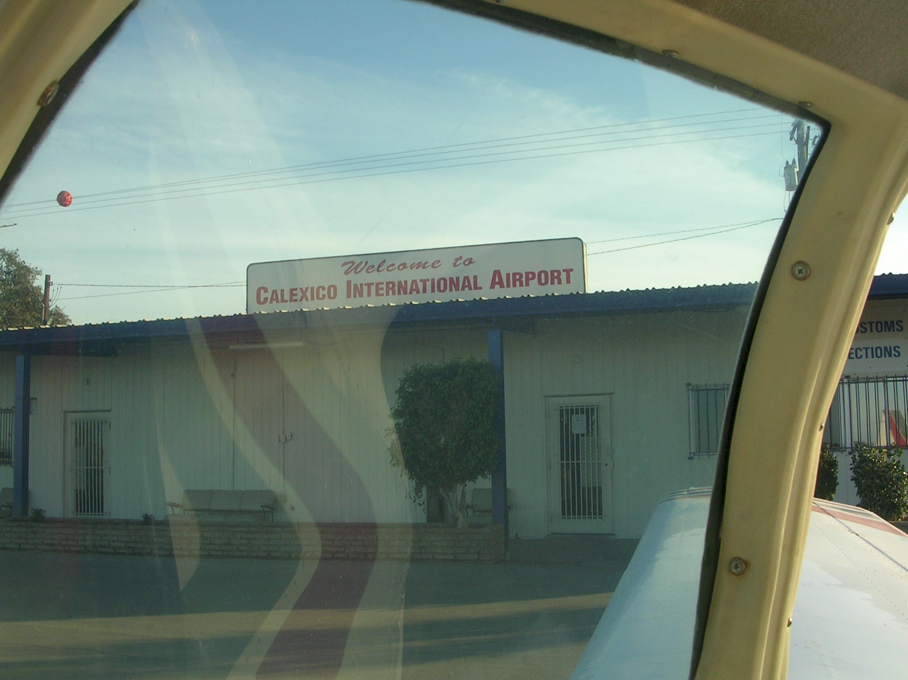
Calexico US Customs Service Building

The arrival procedures went smoothly helped by having the declaration filled out ahead of time thereby saving the custom officer the trouble of writing everything down. Beside, it gives the impression of being an old pro at this international flying game. We were quickly fueled up and ready to leave.

This was, in some ways, a very sad moment. We were now to part company with Morten and Monika our nearly constant companions of the prior two weeks. In retrospect, this trip may have been something of a gamble. We did not know M&M that well nor did they know us. It could have been a disaster of incompatible personalities, dissimilar interests, or conflicting desires, especially when you consider that Gayle and I are old enough to be their parents. Instead, M&M turned out to be relaxed, attractive, fun, and in every way delightful to be with. We are lucky to know them and expect to be their good friends for a long time. What a great trip! We embraced on the ramp. Said all the right things. There was an emptiness inside.

A Short Visit in Palm Springs

From Calexico we flew about 30 minutes to Bermuda Dunes airport which is part of the Palm Springs metroplex. There we were greeted by our good friends Gaylon and Pam McSmith who own a weekend house in palm Desert. Gaylon is a former Mooney owner with whom I have traveled (by Mooneys) to Alaska and Oshkosh. We had a cozy evening dominated by Gaylon’s excelled martinis and Pam’s excellent cooking (Gayle ate sparingly). We heard stories about the two weeks of almost constant rain and cold weather than had occurred while we were gone. At about 9:30 they took pity on us and let us go to bed. We slept like logs.

Bad Weather

We arose in the morning, January 2, 2005 to sunny skies with a high desert overcast. I routinely checked the weather with flight service to discover that a serious cold front was sweeping in from the Pacific and that Salinas was forecasting some bad weather later on in the day. Our plans to spend a leisurely day in Palm Springs were cancelled and after breakfast we returned to the airport and departed on an IFR flight plan to our home airport, Salinas California.

Initially the weather was pretty good. We were generally clear of clouds although there were ragged clouds in the mountains below us and a high overcast above. The surrounding Sierras were bright with their blanket of snow. After Palmdale (next to Edwards Air force Base) the weather started to close in and we were more or less between layers. 100 miles south of Salinas, be picked up a touch of ice and I requested lower (8,000) feet which was in the clear. 30 miles out I picked up the localizer and was told to descend to 5,500 feet. The windscreen iced up with a thin film and the wings had a quarter inch of rime ice. But we were nearly home. I flew the ILS . The ice melted and we broke out at 2,500 feet. We touched down and I wanted to announce to the entire tower crew (perhaps one person) and anyone on frequency that we had just arrived from Belize. Instead, I played it cool and requested taxi to our hanger as if everything was quite normal.

Salinas California
February 2005

