ALASKA DIARY

July 13-July 27, 1990

Introduction
Between July 13th and July 27th of 1990, my daughter Victoria and I took a two week flying and camping vacation to Alaska. It was a memorable experience, one of life's best.
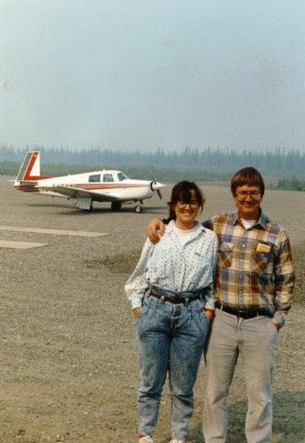
Our flight took us north from our home in central California through British Columbia and the Yukon Territories to Anchorage, Fairbanks and return. . The trip itself had seventeen (17) flight legs totalling 42.7 hours.

Writing a Record of the Trip
On returning, I found it difficult to remember with certainty the details of what we had done. Also it was difficult (if not impossible) to convey to my friends and family the excitement of our trip. A retelling of our trip, I thought, would create a permanent record of our experiences.
Why write a diary of a vacation? It's a bit like home movies that bore everyone. But this diary is not really written for others. Rather it's written for me and, probably for Victoria. I can't expect others to be truly interested today. Perhaps, in years to come it may have some quaint historical interest.
Most of all, I realize, I am writing this because I expect to enjoy reliving the experiences. Writing about something is a means of recreating (in one's mind) the experience and to preserve the memories before they fade. In the process, it is possible that this diary might be of interest to others. It will give us great pleasure to share this trip in this way, but that's not the main point.
I realize that this document is not a diary since it was not written daily during the events recounted. It was written between November 1990 and March 1991 from an outline of events put together in the late summer after the trip. No doubt, the events are not as fresh as if they were transcribed daily, but perhaps, the document as a whole will have more balance written, as it were, from a perspective viewing the entire trip.
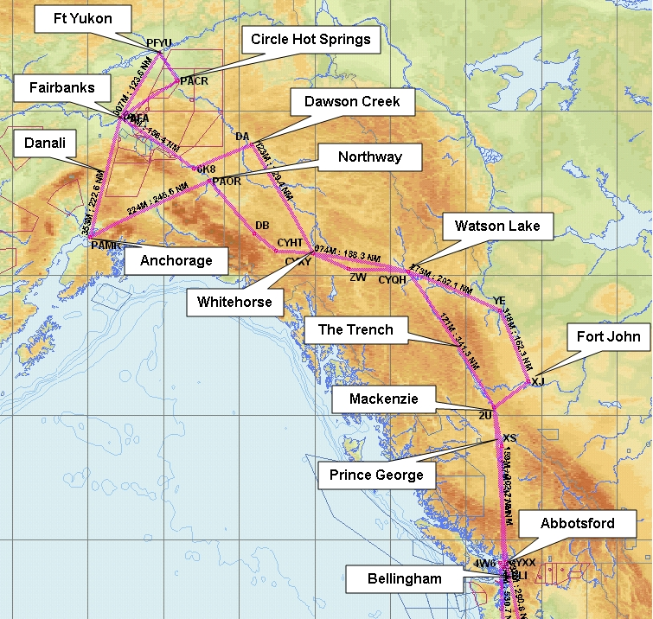

First Idea, Preparations, and Departure
The idea of a flying trip to Alaska probably had its first genesis with my New York friend Peter Williams. About 10 years ago, Peter flew his Cessna 182 to Alaska (almost) and talked about the trip on many occasions. He had some hard luck when his plane caught fire while starting up in Whitehorse, Yukon Territory, and was totally destroyed.
Peter and I have, for the last five years, flown our respective planes to Oshkosh Wisconsin for four or five days at the EAA convention. At the convention we have camped "under the wing", looked at airplanes until we could throw up, and enjoyed the camaraderie "around the campfire". We learned to camp in comfort.
Having become somewhat bored with Oshkosh, I was looking for a vacation alternative. Peter, himself, mentioned a trip to Alaska after the convention. With some trepidations, I began to explore the idea.
First I mentioned it to Victoria who, except for one year, has been my companion during each odyssey to Oshkosh. She is as much a part of the Oshkosh experience as the plane. She was enthusiastic and immediately began to do some research on her own.
Finally, there was another influence. Our local Mooney Aircraft owner's group, West Coast MAPA, has periodic fly-in get togethers. One member from Los Angeles, John Kaminsky, had become the guru of flying to Alaska within this group. He gave several talks about his five or six trips. He characterized these trips as extraordinary and wonderful. It sounded interesting but somewhat hazardous. It seemed far away and foreign.
As the idea formulated, I read James Mitchner's novel Alaska and John McPhee's book Coming into the Country. These two books gave me further insights into the wonderful richness of life in the North country.

Preconceived Notions.
There is limited literature on flying to Alaska. The best source of information and the only book in print, is Dan Downie's book, Your Alaska Flight Plan. In addition, there have been several magazine articles and the official literature from the Canadian and Alaskan governments. This material, coupled with Peter's comments gave me my preconceived notions of the trip.
- First, it was my impression (from the books) that the standard way to fly in Alaska (at least for the tourist) is contact flying. One followed roads or rivers at all costs. In the process, the inevitable poor weather was sure to occasion some creative scud-running, but that was to be expected. If things got uncomfortable, the best rule was to stay on the ground.
- Second, the trip would be over absolute wilderness. There would be nary a sign of human habitation for hours on end. This notion was confirmed by the survival kit that was required to be on board including firearms.
- Third, the weather would be terrible most of the time, especially near the coast.
- Fourth, the mosquitoes could carry you away.
Many of these impressions proved to be totally wrong or greatly exaggerated.

Planning.
Flying to Alaska provided an excuse for excessive planning. Planning can be a lot of fun in its own right. To the extent possible, I fell right into excessive planning mode (and had a very good time at it).
I was somewhat handicapped by having to be in Australia nearly the whole month of June. I returned to the US on July 7th and we planned to leave on the 14th. So I had less than a week for the final preparations.
Fortunately, I was not making this trip alone. Victoria has grown up with "Camping with Dad" and now, being a full-fledged adult, could assume full responsibility for aspects of the preparations. I asked her to do all planning for itinerary, food and diet, and survival equipment (a major part of the problem) while I would assemble the camping equipment, manage the plane, and do the flight planning.
The amount of reference material we acquired was astounding. We took it all with us (about 25 pounds of paper) and used nearly every piece of it at one time or another.
Tory bought Arthur Fromer's guide to Alaska which defined many of the points of interest but was lacking information about the Canadian portion of our trip. We actually spent as much time in Canada as we did in Alaska. Downie's book offered information flying routes and likely conditions. I bought over one hundred dollars worth of aeronautical charts for Alaska, Canada, and the U.S. Northwest for both visual and instrument flying.
The most valuable purchase was the Jeppesen Trip Kit for Alaska. This $60.00 purchase weighed 12 pounds and contained all the instrument charts and approach plates that made the instrument portion of our trip possible.
AOPA (Aircraft Owners and Pilot's Association) was a rich source of useful information. Their Alaska trip kit weighed ten pounds and contained maps, customs brochures, regulation pamphlets, survival tips, reprints on Alaskan flying, and miscellaneous gems of wisdom unavailable except through personal experience. This stuff filled my flight bag which was our heaviest gear item at 26 pounds. This was stowed in the back seat within our easy reach.
Tory planned a five day menu . It was our intention to recycle this menu twice with local variations. It was an adaptation of our Oshkosh menu which provides tasty food requiring only one small ice chest for refrigeration. Several innovations came from Tory's jungle diet from Cameroon, West Africa. One could characterized the menu as plush. This was not back packer's C-rations and we never suffered from an uninteresting diet. Dinner, in particular, was a cooked sit-down meal missing only the candles for atmosphere (since it never got dark, this was not a problem).
I printed out my Oshkosh check list. It is on the computer. It grows and adapts with each year's experience. The checklist contains the following sections:
- Camping Equipment
- Kitchen Gear
- Food (Tory's department)
- Personal Items
- Clothing
- Airplane Gear
- Survival Gear (Tory's responsibility)
- Tool Kit
Getting all the gear together took weeks on both our parts. The final purchase of food supplies was accomplished on the day of our departure with a trip to the local supermarket.
The weight of gear in an airplane was a major concern. The plane has a specific maximum gross weight and the payload must also be evenly distributed so as not to cause an out of balance condition. We did a rough weight calculation which showed we were over gross weight but not dangerously so.
I borrowed a hunting rifle from Don, Gayle's brother. It is a required item in the survival kit. I don't have much experience with firearms, and this "thirty-aught-six" cannon was much bigger than the 22's I had previously shot in boy scout camp. I went behind our house and set up a milk carton on a stump. I paced off about fifteen feet and took sight, squeezed the trigger, and missed. The explosion (and that the best way to describe it) caused every dog in the neighborhood to start barking. I distinctly heard someone say on the other side of the canyon "George, that was a gun....". I slunk back to the house, put the rifle back in the case and it never came out again during the entire trip.

Maintenance Problems.
As if the preparations weren't enough to worry about, the plane itself, our trusty Mooney, 9208M, was having some problems. It had just come out of it's annual inspection. I had taken the plane to a new shop which was an authorized Mooney dealer, Del Monte Aviation in Monterey. They couldn't get anything right. The annual took six weeks (it should take 3 days, maybe), and most everything they fixed wasn't.
The major problem (it seemed) was a leaky right gas tank. They had tried three times to seal the small leak that caused the cabin to smell gassy after being filled up overnight. After three tries, the leak was much worse. It looked like the trip would have to be canceled. I called up Paul Loewen (a local California Mooney guru) who suggested that the leak was not life threatening and the plane could be flown safely, especially if I didn't keep the tanks full overnight. So we decided to ignore the problem. It would have been major anguish to call off the trip the day before we were set to leave.
Del Monte had also done a repair on the oil filler access door. This work looked awful and I very annoyed. Being that the problem was cosmetic, I figured we could deal with that later.
Finally, during the annual, an oil line was replaced in accordance with a Lycoming service bulletin. That work, at least, appeared to have been done correctly (or so I thought).

Friday, July 13.
Our vacation actually kicked off on Friday afternoon when I flew down to Burbank, north of Los Angles in the San Fernando Valley, to pick up Tory. We agreed to meet at 6:30 and she was right on time. The trip down was beautiful and sunny with a slight tail wind. I flew the direct route over the Fellows VOR which always makes me respectful of the rugged and wild mountains that guard Los Angeles to the north.
We loaded Tory's personal gear, a big duffel, backpack, a camera case, foodstuffs (non perishable) and the survival gear and took off after the usual Burbank ground delays. The flight was uneventful except that it was getting late and the slight head wind delayed our arrival in Salinas.
As we approached Salinas at about 8:30 the sun set behind the coastal mountains and the Salinas weather conditions were deteriorating with a low fog layer. I requested and received a clearance for an ILS (Instrument Landing System) approach from the south. We were in the clear for most of the approach but the airport was hidden under the fog layer which was reported to be hovering 400 feet above the field (200 feet is the minimum). This approach was strictly a no sweat affair except for the fact that I rarely fly at night and had never done an ILS procedure after dark.
As we descended on the ILS to about 2000 feet and started entering the stratus (fog) layer, a small hole appeared in the fog which revealed the runway and approach lights. These lights were icy blue and seemed to float in space above us rather than below us. It was a striking scene as we came down like an orbiting body in space disconnected from any other solid ground. Tory commented on the total lack of reality. I concentrated on keeping the needles centered but the beauty of the scene was not lost on me.
We taxied in the dark to the hanger and decided to defer any packing until the following morning. A dinner of pasta and pesto was our reward.

Saturday, July 14. (Day 1)
Departure day was beautiful. There is nothing like the excitement of getting ready to leave on a long awaited vacation. But we had a lot to do.

Final shopping for provisions
All of our food plus a number of miscellaneous items still had to be purchased. Our gear was piled up in the living room and in the hanger. We were organized but we were not ready to leave.
We went to the local Lucky's supermarket with shopping list in hand and spent an hour and one hundred dollars. A quick trip to Payless Drugs next door provided some hardware items. Then we drove to the airport.

Packing The Plane
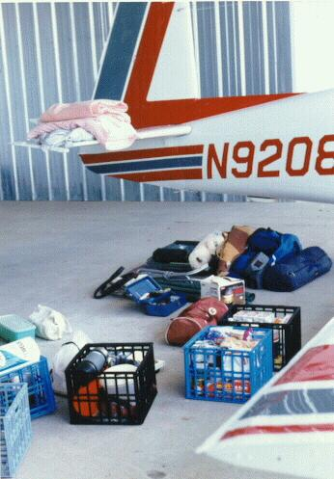
A partial view of our luggage. There was no back seat. The baggage compartment began immediately aft of the front seats and the luggage rose to the roof. We were about 100 pounds over gross weight on every takeoff, but the airplane flew well in spite of the overload.
All our gear was unloaded from the pickup truck. It made a formidable pile. I had decided, based on our Oshkosh experience, that the loose items needed to be organized and segregated. Therefore, we had five plastic milk crates for all the smaller items. These could stack in the back seat and each would be available as a unit. By segregating similar items into a milk crate, it would be easier to find a particular item.
We had the following crates:
- Paper Products
- Food #1
- Food #2
- Pots and Pans
- Miscellaneous
Packing the plane is a science. Without five years experience, we couldn't have done it. The process it like a Rubic's cube. Each step must go in sequence. For example, the folding table must be the first item loaded. It fits in only one place, the front of the baggage compartment. If any other object else in the airplane, the table won't fit. The table must do a pirouette with a twist and must end up with the rounded edges up. And so on for each item.
The objective is to get the lightest items in the aft of the airplane and the heavier items forward. Thus the tool kit and survival equipment (both unusually heavy items) were placed near the front seats. The pillows and sleeping bags were stuffed in the aft hat rack.
As we loaded the gear we weighed it and it became evident that we were going to be about 100 pounds over gross weight at takeoff. Further, we were almost at the most aft C.G. (center of gravity) loading permitted. This was safe but we wouldn't have any room for the acquisition of souvenirs during the trip. As it was, we deliberately were leaving some heavier items home such as the oxygen system and the portable bicycle.

Last Minute Glitch
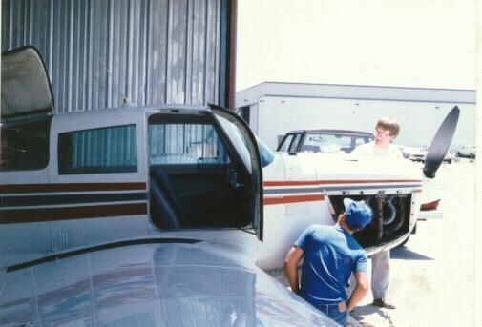
There was a last minute glitch in the oil access door. It wouldn't open!
I noticed that there was an oil leak from the engine. This would account, I figured, for the moderately high oil consumption I had observed since the annual inspection. Oil leaks are not uncommon. There was nothing that I could do for now.
When I tried to check the oil, I discovered that the new oil door wouldn't open. The new fastener was stuck somewhere. Del Monte Aviation's incompetence was being felt already. Fortunately, the resident of the hanger next to mine, a young man named Chris is a mechanic. He was working on his own airplane, a Grummen Tiger, and he helped me remove the cowling and release the stuck fastener. But the door now had an unattached fastener that could get lost if one wasn't careful when the door was opened. This was why the door was replaced by Del Monte Aviation in the first place. This maneuver took over an hour and further delayed our departure. I was getting quite edgy by now and was very eager to be off.

Salinas-Prinville, Oregon (3.9 Hours)
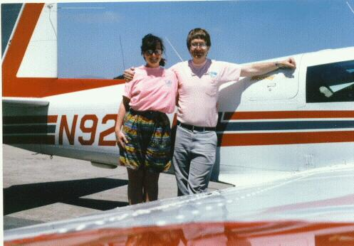
Ready at last to takeoff at 2pm.
At 2:30 we started the engine and taxied out for our first loaded takeoff. We requested a full length takeoff (somewhat unusual for the Mooney) just to have the maximum runway ahead of us if there were any surprises. Not unlike earlier Oshkosh trips, the plane seemed heavy and sluggish after takeoff. This is an illusion due to the different feel of the plane after flying lightly loaded (its normal condition). Although we took off many times at the same weight during the trip, I never again experienced this uncomfortable heavy feeling.
We planned to fly to Sunriver Oregon (where we have a vacation home) and camp at the Sunriver airport. The house is rented so we couldn't stay in our house. We would fly to the east of San Francisco bay over the Livermore Valley, up Interstate 5 to Red Bluff, then passing to the east of Mount Shasta direct to Klamath Falls, and finally follow Route 97 to Sunriver.
Shortly after we took off, Monterey Approach Control inquired if we had heard SIGMET (significant weather report) Julliet for thunderstorms over northern California. We hadn't so they read it to us. It predicted severe thunderstorms on a line from Red Bluff to Reno. The controller acted like he expected us to turn around immediately and return to Salinas. That thought didn't occur to me since the area as described could be circumnavigated to the west and it wouldn't hurt to "take a look". As it turned out, we saw some isolated buildups to our east near Red Bluff but there was never any problem on our route of flight. It goes to show that a forecaster or controller on the ground cannot make decisions for the pilot in the air. Ground personnel are (rightfully so) very conservative. It was the slightly disapproving tone in the controllers voice that was inappropriate in this case. Tory was somewhat alarmed by the report, I think.
At about 4:15 we flew over Red Bluff. I was reminded that Gayle (my wife) was there visiting her parents after a week in Sunriver with our niece Stacy and friend Robin Flannery and her children. Robin figures into our story later on. I wanted to yell down to the house to say hello but we were at 8,500 feet.
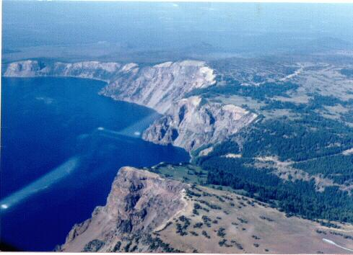
Crater Lank, Oregon.
Mount Shasta at 14,000 feet was as dramatic as ever but with very little snow after another drought year. As we flew over the lava fields (only about two thousand feet below us), I suggested to Tory that we divert to fly over Crater Lake. She was interested. Approaching Crater Lake at 8,500 feet is deceiving. The top of the cone is at about 7000 feet and the lake is hidden until one swoops over the edge. Then it is very breathtaking. Actually, its a little intimidating from a low flying airplane since there is absolutely no place to land should there be an engine problem. We did two full circles for photographs and then resumed our northern course for Sunriver.
Approaching Sunriver the visibility dropped and we smelled smoke. A call to flight service confirmed forest fires in the area. This was our first exposure to smoke. We would see a lot of smoke in Alaska.
We called Sunriver Unicom to inquire about camping facilities. They were very discouraging, in fact downright unhelpful. So we considered our options. It was fairly late (almost 6:00 pm) and it was clear that this was to be our last (and only) flight of the day. I selected Prineville Oregon, 10 miles west of Bend, for our destination since I saw they had fuel and there would probably be little opposition to our camping there. We arrived over Prineville and circled twice. Tory said "Stop circling before I throw up". So we landed.

First Campsite
Prineville really is in the high desert and the airport had that lean and thirsty look. There wasn't a soul about at 6:30 on a Saturday night. The gas shack was closed up tight. A nearby road was busy though. We parked across from a big hanger that proved to be empty. Then we ran into a small problem. We couldn't find any water. It took a half hour thorough search of the airport before Tory found a hose bib hidden in some bushes.
With water in hand, we set up our first campsite and had our first happy hour. Although the airport was pretty ugly, we concluded that we brought our own atmosphere with us and the only thing that mattered was not being disturbed by airport officials, weather (wind or rain), or animals. We were feeling quite content.
After dinner, the sun set over the Cascade Mountains to the west and we could see a string of beautiful volcanos. It was very quiet. I think we were very happy and looking forward to the adventure ahead.
As we tied down for the night, I noticed more oil drops on the ramp.

Sunday, July 15. (Day 2)
The night at Prineville was punctuated by the sounds of scurrying rabbits or prairie dogs on whose homes we had pitched our tent. This did not add to the restful qualities of our sleep in spite of comfortable cots and fluffy sleeping bags.

What our Camp Looked Like
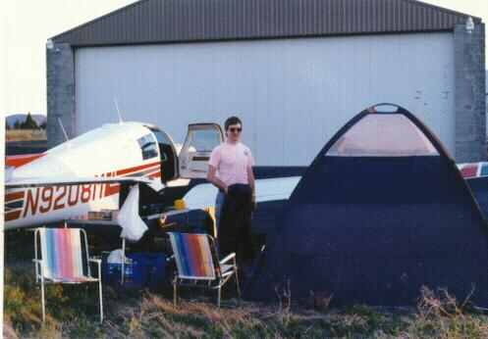
Our first campsite at Prineville Oregon. We were pretty confortable with our tables chairs and tent.
Our camp looked pretty much the same at each stop we made. We usually pitched the tent close to the right side of the airplane, usually behind the right wing and near the door of the plane. We had a large 10 foot by 10 foot nylon dome tent with a flexible internal frame. Packed up it weighed 17 pounds and was spacious enough for our two aluminum and canvas cots, all our gear, and (in a pinch if it is raining) our 6 foot long table. Normally the table was set up outside the tent with our propane stove and two folding aluminum and canvas chairs. All this gear was carefully selected to both be light weight and small enough to fit into the skimpy interior of the Mooney.
Water was stored in a plastic bag which we hung from the propeller of the plane. As required, the plastic milk crates containing the supplies were removed from the plane and used.

Sunday, July 15 (Day2), Oregon, Over the Rockies, Some Troubles
We awoke at Prineville and did our usual morning chores: coffee, toilet (don't ask where), breakfast, cleanup, and camp breaking. Packing always took about an half hour or more but we got so we could break camp and pack pretty quickly after we each had our jobs understood.

Professional Advice
As we were having breakfast, a car drove up to the big hanger next to the one we were near. It turned out that central Oregon's biggest tire dealer, Les Schwab, has its headquarters in Prineville and this was where they kept their Citation corporate jet. We were worried that 1) we were in the way and 2) the jet, when started, would blow us away. Neither was a problem and we spoke to the two pilots who turned out to be very friendly and interested in what we were doing.
One of the pilots had a lot of Alaska experience. He offered one piece of advice that proved very helpful (this very day, in fact). When learning that I was instrument rated and that the airplane was appropriately equipped, he advised us not to be afraid to fly on instruments in Alaska. This went against all the previous Alaska wisdom I had heard. I listened and, as it turned out, we did a lot of instrument flying. Without instrument flying we would have been stuck on several occasions or would have had to resort to low visibility low altitude flying.

Prineville, Oregon-Abbotsford, B.C. (2.5 hours)
Our next leg took us to Abbotsford near Vancouver and into Canadian airspace. The high point of this trip was a flight around Mount St. Helens. The area around the mountain still looks devastated and the Spirit Lake area is just a mud flat.
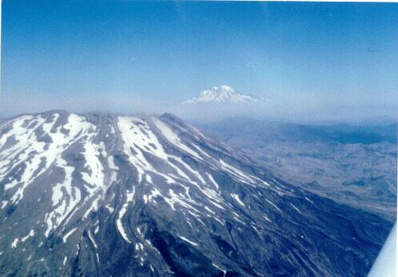
The south side of Mount St. Hellen. Mount Rainier is in the background.
Getting through the Seattle TCA (Terminal Control Airspace) was an exercise in patience as they didn't want to talk to us at first. We persisted and finally they let us fly over the TCA (our right anyway) and right over downtown Seattle. Puget Sound was beautiful and since the weather was absolutely clear we could see quite a bit from Mt. Rainier to Mt. Olympus.

Canada
We arrived at Abbotsford at about 12:30 and customs consisted of a phone interview. We were advised that handguns are prohibited in Canada and could cause the confiscation of our airplane if found. We assured them "no handguns".
Landing at Abbotsford revealed a curious Canadian custom. When cleared to land they always say "Check gear down". When I heard this for the first time I became quite concerned since I thought there must be some problem with the gear which, so far as I knew, was down and locked. I quickly checked and learned later it is a routine reminder for all aircraft, sometimes even those with fixed gear.

Abbotsford, B.C.-Fort St. John, B.C. (4.0 hours)
We had lunch at a little coffee shop at the airport and prepared for out departure at about 2:45 pm. One difference between US and Canadian flying is that VFR (visual flight rules) flight plans are mandatory in Canada. So we filed our flight plan to Fort St. John which is basically at the start of the famous Alaska highway. Our route of flight was to be up the Fraiser River Canyon to Williams, Quesnel, Prince George, and then by a highway pass across the Canadian Rockies to "John" which is on the plains to the east of the mountains. I grumbled a bit to have to add another quart of oil to the airplane after only two hours of flight.
Since our departure was well into the afternoon there was increased turbulence and cloud buildups. The weather forecast indicated the possibility of some afternoon thunderstorms.
Our navigation methods changed a bit from this point on. We were definitely using the road as our guide. Also we started using our ADF (low frequency receiver) more. This instrument is rarely used in the U.S. but it quite necessary in Canada because of the large separation between the more usual VHF navaids. Tory had designated herself as chief navigator so she was giving the directions.

The Fraiser River Canyon
We followed the Fraiser River Canyon for about 100 miles after leaving Hope, BC. It is really rugged with steep walls and a rocky angry looking river. On both the east and west sides are unbroken steep mountains. A roadway is gouged out of the canyon walls. Every so often there is a flat space big enough for a town. This canyon would be a bad place for a forced landing.
All went well until I glanced over at the map and noticed that we had just gone past a critical right turn in the canyon. Tory had not really gotten the feeling for how fast the airplane goes in relationship to the map and thought we were about fifty miles further back. We did a timely course change and were soon out of the canyon and over flat ground once again. Thereafter Tory's navigation was right on. The turbulence in the canyon was mildly annoying.
We were awed with the fact that we were flying over "Sparsely Settled Areas". We hugged the road as if a grizzly bear would attack if we got off course. This was all by the book. Frankly, there was a sense of foreboding as we headed into the "unknown". The ironic part of this behavior was that during our return flight over this same area we felt we were nearly home and flew direct from one navigational fix to the next. By then we knew what sparsely settled area really were.
Although there weren't many towns, there was always some sign of human habitation. Most of the land that wasn't swampy was farmed or mined.

Rainbows Over Prince George
As we proceeded north over this relatively flat land, the clouds increased. There were occasional rain showers most of which we were able to avoid and still stay near the highway. As we went by Prince George at about 4:00 pm there was real gully washer in progress over the town. We missed most of it by keeping to the west and got some good pictures of the resultant rainbows.
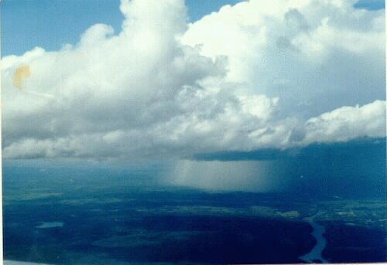
Thunderstorm over Prince George, British Columbia as we pass by five miles to the west.

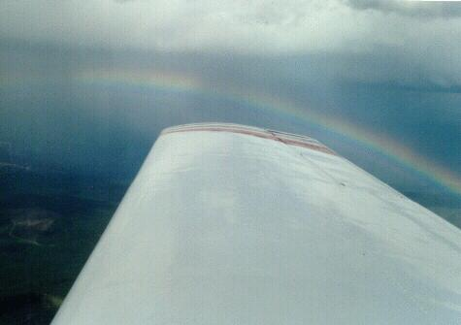
Rainbow from thunderstorm over Prince George.
But it was clear that the weather was somewhat worse than forecast.
We proceeded north to a town called Mackensie at the southern tip of Williston Lake. At this point we planned to leave the flats and follow the highway through the Rocky mountains for about 100 miles. But there was no way. The clouds were nearly on the deck and the pass was clearly closed. The choice was to land at Mackensie (private airport), thread our way back through the rain showers to Prince George or try to fly IFR over the Rockies to St. John.

IFR Over the Rockies
I chose the latter option. It appeared I would be heeding the advice of the Prineville pilot (was it only this morning that we had that conversation) sooner than I thought. This plan was aided by one fortunate circumstance. To continue on instruments we needed an air traffic clearance. To get a clearance I needed to talk to an air traffic controller at Edmonton Center. At Mackensie there was a so-called RCO (Remote Communication Outlet) connected to Edmonton. In spite of being in the wilderness and in the mountains, I could talk to ATC as if I were on the telephone.
I called Edmonton Center and requested a clearance to Fort St. John. Within minutes we were on our way up into those dark ugly swirling clouds. The weather wasn't that great but there was no serious rain and no thunderstorms. A few times we got a look down through a momentary break in the clouds to the even uglier Rockies below us. And they weren't that far below us in spite of being at 9,000 feet.
The only possible problem was airframe icing. The temperature at 9,000 feet was exactly 0 degrees Celsius and there was plenty of moisture. Although it was a bit warm for ice, I wished I had left a little greater margin to react (descend) if there was icing. On the other hand, I was in a no descent situation for only about 75 miles (30 minutes). I figured we could tough it out with ice for a little while if we had to.
It took about forty five minutes to get to St. John. The weather lightened up after we crossed the Rockies and the actual weather at St. John was good enough to shoot a visual approach (600 foot scattered clouds, 800 foot broken clouds, 40 miles visibility). We landed and tied down at the Northern Caribou hanger next to a red Cessna 170 and pitched our tent before the heavy rain hit.

Fort Saint John Campsite
Our second campsite was in a grassy area in the lee of a big Northern Cariboo (sic) DC-3. I felt we had really rejoined an earlier age of flying. We had landed at about 6:30 pm. We set about getting oriented, talked to two older men in a red Cessna 170 tail dragger (also enroute to Alaska), made dinner (entirely within the tent because of the rain), washed up in the airline terminal, and were then about ready to turn in. But something was wrong, it was 9:45 pm and it was still light is spite of the gloomy weather. We were going to have to get used to this.
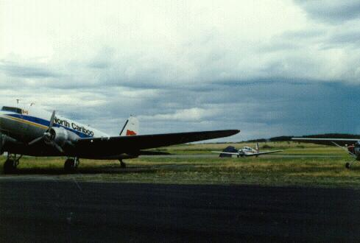
Our Campsite at Fort St. John near the DC-3 belonging to Northern Cariboo Airlines. Note the gloomy skies. We had just landed after our IFR flight over the Rockies.

Monday, July 16 (Day 3)
We awoke at Ft. St. John ("John to everybody up here) to find the airport surrounded by mist and low clouds. The weather was just plain lousy. A check of the weather didn't forecast any improvement for a day or two. But the bad weather was localized and was much better to the north. It looked like more instrument flying.

Mechanical Assistance at Northern Cariboo
I noticed more oil leaking from the cowl and decided to take this opportunity to have a mechanic look at the engine. I walked over to Northern Cariboo. Their operation looked top notch, clean and modern with several mechanics busily working on various aircraft. The chief mechanic was very friendly and said he would be happy to look 08M over. Would I taxi it over right away, he suggested. We did and Tory and I went off to check the weather and buy some ice.
I returned about 45 minutes later. The mechanic called me over. Our conservation went like this:
"How's your engine been running"
"Just fine"' I replied.
"Are you sure".
"Yes, I'm sure. Why?" I was getting suspicious.
He went on to explain that they had found oil leaking from one of the two magnetos. When they handled the magneto it was loose to the touch. It should have been firmly bolted to the engine. He said any further loosening and there would have been the possibility of a catastrophic engine failure as the gears sheared off.
I was stunned. I recalled the last hour of flying over the Rockies in the clouds. The last few days the engine was trying to tell me something. "Look at me you dummy, I'm leaking oil". And I was thinking it was nothing to get worried about.
Then I got to thinking. How did these bolts get loose. They are supposed to run thousands of hours and never loosen up. Then I remembered. Del Monte Aviation had removed the magneto to replace the oil line. Those turkeys. They forgot to tightened the bolts. Damn! I would deal with them later.
Did somebody (up there) make the weather marginal so that I would have time to get the engine checked and repaired? My reaction was somewhat strange, I thought. I should be shaking, but instead I was so relieved to discover that there was an explanation for the oil leak and that it was now fixed. I felt a supreme confidence in my engine. I felt like the wretch who was lost but now is found. Amazing Grace.

Fort St. John, B.C.- Watson Lake, Y.T. (2.9 hours)
The weather was truly evil looking. There were wisps of fog hanging down nearly to the ground. The clouds were black and turgid in just the direction that we wanted to travel (North).
I pondered the filing of an instrument flight plan. All the admonitions in favor of contact flying came back to me. "Stay in contact with the road". To fly IFR we would have to fly the airways, 30 or 40 miles to the east of the Alaska Highway which loops off to the west. The spirits whispered in my ear. "If you go down, they'll never find you". The two old codgers in the red Cessna shook their head and headed for the tourist delights of Ft. St. John.
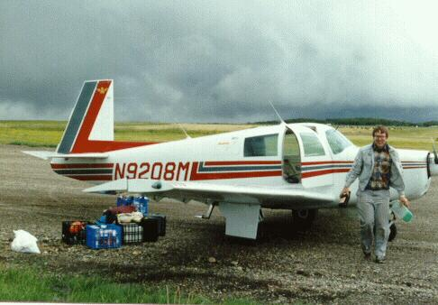
Fog and clouds obscured the skies as we prepared to leave Fort St. John on our next leg to Watson Lake. It looked worse than it really was.
I decided to file the instrument flight plan. We were to follow the low frequency airways which were lower. We took off into the gloomy north and were soon enveloped in the clouds. It was good flying. Only a few bumps and occasionally we got a glimpse of the ground below. It was truly empty. Rolling ridges. Forests. Muddy rivers. Swamps.
As we approached Ft. Nelson, the halfway point, the weather cleared up and we were only occasionally in the clouds. Although we were navigating by the ADF, we were out of range of the DME for only a few minutes and never lost the VOR signal. The voice communication with Edmonton center was also pretty good. We were feeling pretty good to have proven the contact flyers wrong.
At Ft. Nelson we turned westward and the airways followed the Laird River Valley. The highway swung away to our south and once again the clouds took over. The occasional break showed a dark mountainous bleak terrain below us as we recrossed the Rocky Mountains, this time going west. We climbed up to the MEA (minimum enroute altitude) of 8,000 where the temperature indicated 0 degrees Celsius (the freezing point).

Hail
The clouds were getting darker. We were in and out of light to moderate rain. The turbulence was picking up. All of a sudden in the middle of a heavy rain shower the airplane vibrated like a snare drum. The noise was deafening. Tory turned to me with some alarm. "Hail", I said trying to be professional. ("Ladies and Gentlemen, we are passing through an area of light hail. There is no danger but there will be some noise. We will soon pass clear. [sotto voce] Hopefully the hail will be small and light because large hail make the airplane look like a golf ball and will render it unairworthy". As soon as it started, the hail was behind us.
After nearly three hours in the air we approached Watson Lake. Watson Lake is on the extreme southern boundary of the Yukon Territory. This is the land, I thought, of Sergeant Preston and his wonder dog King, sourdough bread, the Klondike, Sam McGee, and gold. We had really made it into the "far north". As we approached the airport, the ground we could see was verdant and lush. It was rich with fecundity as only 22 hours of daylight can make it. The airport itself is nestled on the very edge of Watson Lake, a body of water of considerable size and beauty.
I reported my position twenty miles to the East and was told I was cleared for "an approach". We now had one of those Canadian American misunderstandings due to different procedures and practices in the air. I asked which approach was I cleared for (they have two). In the U.S. I had always been cleared for a specific approach. He said, much too critically, I thought, that he didn't care and that I was cleared for THE approach and would I please read back the clearance. I complied and then cancelled IFR as the airport was now clearly visible. We landed and taxied to the gas shack.

The Watson Lake Flight Service Station
The Watson Lake Flight Service Station (FSS) is located in one end of the commercial terminal. Since the air terminal always seemed deserted, the FSS is the center of activity at the airport. It seemed to be manned by two specialists and a dog at all times. In the remote areas of Canada, the FSS also perform elements of air traffic control when radio contact with Edmonton Center is not possible. In addition, they perform a social function on the airways with the numerous transient aircraft both native and tourist. We spent a fair amount of time in the FSS and found them superior to their US counterpart.
Shortly after we arrived, the heavens opened and poured for over an hour. Five centimeters in one hour they said. During that time some guy in a Cessna was orbiting "out there" unable to get in. He had a cool head and got a lot of support from the FSS. As the thunder and lightening moved off, he flew in, none the worse for wear. I wonder how I would have handled that one.

The Most Beautiful Campground In Canada
As the rains let up, we taxied over to the campground on the other side of the airport right next to the lake. This campground was, without doubt, the best we found during our trip. There was a wooded area right next to the campground that contained the privy and there was fresh water and picnic tables. The best feature, though, was the beautiful lake. We slogged through the puddles and pitched camp.
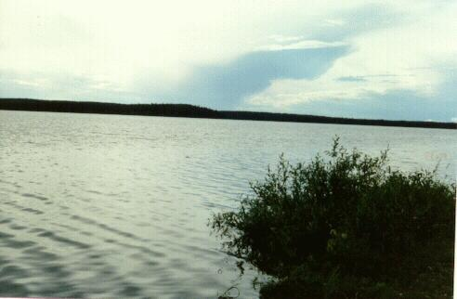
The view from our campsite across Watson Lake, a place of particular beauty.

Game Fishing
As soon as the tent was up, I assembled my fishing rod and small collection of lures. As a total non-fisherman, I had spent several hours in Sydney Australia (the prior week) practicing casting into the Macquarie Resort Hotel's olympic sized swimming pool. I thought I was pretty adept. I fished with no success for some minutes and Tory requested a try. She was as inexperienced as I and made one tentative cast about ten feet out. I could tell she was having some difficulty reeling it in but to both our surprise, her first cast landed a fish. That was the good news. The bad news was that it was about six inches long. With much tenderness, I removed the hook and set him free to float away belly up. We did get him turned right-side-up and he revived after awhile.
I took over again and soon bagged an eight inch fish. Since this poor guy was hooked in the eye, we couldn't put him back in. Therefore I cleaned and scaled him and we had him for dinner (along with some other things). It was really quite tasty.

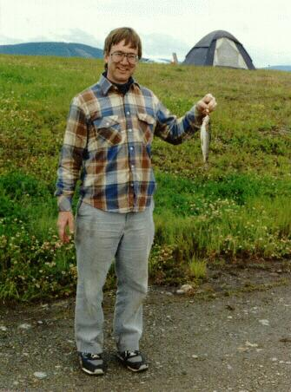
The big game fisherman holds up dinner. This was the big one
.

Caught Poaching
At this point a "dune buggy" ATV came cruising toward us on the small road that ringed the airport. I was very worried about the legalities of fishing without a licence. So I pitched the rod in the bushes and we stood there like two Cheshire cats who hadn't been doing anything.
The man on the dune buggy came by and wanted to talk. We were thinking fish warden and were very non-communicative. Just when he looked like he was getting ready to leave he asked "You guys got a fishing rod". "Oh my god", I thought, "We're Caught". At least two days in the Watson's Lake civil gaol. I sputtered out my answer (I was never good at lying), "Yeeees..Sir". "Well", he said, "You should try that dock down the lake a bit". He sped off on his ATV.
I looked over at Tory. On the front of her shirt, as plain as could be, was caught the fishing lure with the line trailing off into the bushes. I was glad I hadn't told a lie. The man certainly would have wondered why we had fishing lures on our clothing without a fishing rod somewhere.

Family Phone Calls
After dinner (fish and pasta), we walked back to the air terminal/FSS. We called Tory's aunt Hillary in Anchorage. Hillary was just a little girl when I last saw her in New York twenty years earlier. She was now the mother of two small children and neither Tory nor I knew whether or not we would be welcome visitors. Tory had a pleasant talk with Hillary's mother-in-law (who apparently lived with Hillary and her husband) and it seemed we would be welcome. Anyway, we were to call when we got to Anchorage. This was a great relief to us both.
I also called Gayle back home in Salinas who told me that all the checks were bouncing and that I had obviously made some dreadful mistake. I asked her to move some money between our accounts. Later I figured out that I had recorded the deposit of my last paycheck twice and my company had, of course, only paid me once.

The Cowboys Roll In
We returned to the campground just as a Bonanza (or "V-tailed doctor killer" as Gordon Baxter calls them) rolled up. Out jumped three men. One was about seventy five, the second was a younger crippled man, and the third (obviously the pilot) was yelling at the other two. This plane had flown up VFR through the trench, gotten lost, run short of gas, and had somehow found an airport to refuel and had continued merrily on their way. The crippled man confided in me that "Bill" was a hell'va pilot or else he wouldn't fly with him because otherwise he was a miserable human being.
It turned out that they were off for two weeks of camping, fishing, and boozing. Great fun. At eleven o'clock Bill was still ranting and raving (in a very loud voice) about how you can always pick out a New York Jew-boy because....(I can't remember how) but he had the system down pat, it appeared.
At Watson Lake we felt we were really in the Arctic. At ten thirty we watched a beautiful sunset. Then it got really cold. The night was not a happy one.

Tuesday, July 17 (Day 4), Watson Lake, Whitehorse, Anchorage
It was pretty cold overnight. In fact, for me the night was a misery. It probably go down to 35 degrees Fahrenheit. My old "Big Blue" sleeping bag just couldn't cope with that temperature. I vowed that this would be my last cold night (it was) and the next day I would buy some good horse blankets to add to my insulation. Victoria was perfectly warm.

Waiting for the fog to clear
We woke up surrounded by fog. It was bone chilling cold. We got up around six or seven (it had never really gotten dark) and made coffee. There didn't seem to be any great hurry since the weather looked pretty dismal. The three men in the Bonanza had not yet arisen. We sat around all bundled up and had our yellow plastic mug full of coffee, mine black and Victoria with her milk and sugar. We finished breakfast and pondered our next step.
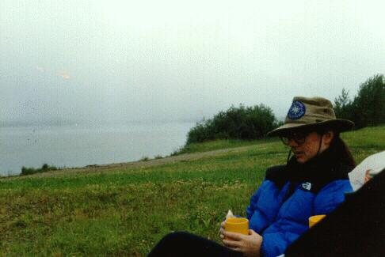
Moring coffe after a frigid night. Waiting for the fog to lift for the flight to Whitehorse

Decide to file IFR
A trip over to the Flight Service Station promised better weather later on but nobody was sure when the fog would lift enough to permit a VFR departure. Emboldened by our IFR successes of the day before, I decided to file IFR and forego the Alaska highway once again. The route to Whitehorse was pretty simple, two hours via Telsin Lake with good VHF communications all the way. We filed for 10,000 feet and returned to the plane to continue our packing up.
The Bonanza crew was up and around and making a big racket. They were planning to depart VFR (what else) as soon as the weather permitted.

Watson Lake, Y.T.- Whitehorse, Y.T. (1.8 hours)
The flight was quite nice, about 30 percent in and out of cumulus clouds at our altitude and above. Some of them looked pretty active, dark and icy but they were sufficiently separated that we could always pick our way through to avoid the worse looking ones. By Telsin lake, conditions were mostly clear. The terrain below us was very rugged. There were occasional lakes but very little flat ground. I'm sure this would have been a bad area in which to put down.
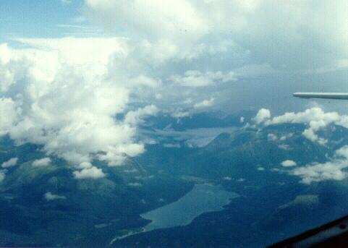
On the way to Whitehorse from Watson Lake. IFR at 9.000 feet.
As we approached Whitehorse there was a lot of chatter on the frequency. The wind was pretty stiff in our face so we weren't making very good time. We were cleared for a straight in to runway 31L and landed without much ado.
The Yukon River is to the east of the airport. The city is between the airport and the river. The airport lies on a bluff perhaps 500 feet above the city so when one is within the airport boundaries, the town is completely hidden. On all sides there are mountains, particularly to the east.
We parked near the tower and queued up for gas. There were about five or six general aviation aircraft waiting for fuel. Most seemed to be families or couples like us on a summertime adventure. We talked to a few people and compared notes.
It turned that the "camping area" was simply the tie down area about a quarter mile south of the terminal building. We taxied over there and found a vacant spot. We were the only campers. Most of the planes looked like they lived there, beat up bush planes used to living outdoors. Although the parking area was quite barren, the wild flowers had run amok, particularly the blood red fire weed. We found out later that we were also located in a major chipmunk/prairie dog city.
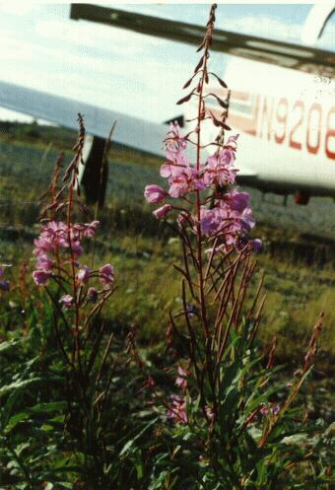
An example of the Fireweed near our campsite at Whitehouse Airport.
We did not pitch camp but instead unpacked our wet towels and clothing and laid them out in the hot sun to dry. We took the precaution of weighing everything down with stones lest a stiff breeze spring up. With these preparations done, we had a quick lunch (the usual being whatever was in the ice chest placed between two slices of bread) and headed for town. We called a cab from the terminal building (near the tower) and were soon on our way into town.

Impressions of Whitehorse
Whitehorse is the capitol of the Yukon. It is built on the banks of the Yukon river and represents the most upriver point navigable by river boats. If I remember, it is nearly two thousand miles downstream to the mouth of the river in the Bering Sea. Whitehorse is about five blocks wide and about twenty blocks long with the long axis paralleling the river. The downtown area is composed of two and three story commercial buildings. The rest of the town is residential apartment buildings and single family houses. It all looks very modest and unpretentious. It was "small town" and had none of the depression of the inner city. One only had to look up and see the wilderness of the mountains that surround Whitehorse in all directions to realize one is close to nature.
Near the river is the state capital complex, a few better-than-average buildings that pass for monumental in the Yukon. Monterey, by comparison, is five time the size of Whitehorse.

Inebriated Indians
The cliche of the drunken Indian is sadly true in the Yukon Territories. As we walked around downtown Whitehorse, there was an idle Indian on each street corner. Many seemed to be drunk. They were generally friendly but the impression was one of non direction, hopelessness, and boredom. It was a strong impression and perhaps the only negative one we encountered during our entire trip.

The Yukon Museum
We visited the Yukon Museum housed in a small complex near the river. It was exceedingly interesting with exhibits on the animals and history of the region. There was a photographic display of Whitehorse scenes during the gold rush days (1895-1905). Outside were artifacts of the era including a small cabin reputed to have belonged to Sam Mcgee.

The Klondike River Boat
The high point of Whitehorse was undoubtedly the river boat Klondike II. This river boat, now a museum on dry land, was the largest boat built for the Yukon. They ran an excellent interesting tour preceded by a film on the history of the region, the river, and the boat. The boat was carefully restored. We thoroughly enjoyed the tour.

A Walk Accross Town
After the river boat it was getting late (5:00) so we decided that we should be getting back to the airport. But we needed to buy my blanket and get some provisions first. I recalled seeing a shopping complex on the other side of town, so we walked from one end of town to the other (a mile maybe). We found the shopping center and entered a Montgomery Ward's just as they were closing. In the near darkness of the store (they had turned off the lights) I found a garish cheap quilt that looked like it would do the job. It embarrassed Tory who thought I should have bought something more utilitarian. Anyway, this enormous mound of padding cost about 12 dollars US.
We finished our shopping by buying some food in the supermarket next door and called a taxi. As we waited, the heavens opened again and sheets of rain fell amid thunder and lightning. It is evidently a common afternoon phenomenon in the Yukon in summer. We arrived back at the airport and had to wait another half an hour in the FSS before the rains quit enough to venture out to the plane.

Whitehorse Campsite
We returned to our campsite and wrung out our towels and wet clothing that we had left out to dry. We had a beautiful view of the surrounding mountains. The most dramatic aspect of the campsite was the profusion of wild flowers, mostly "fire weed" a dramatic red flower. The sizable population of ground squirrels forms the principal protein source for all the local predators.
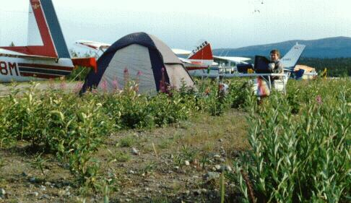
Our tentsite on the Whitehorse Airport. I was cooking dinner at about 8:00pm.

We had dinner, settled down for some serious diary writing and reading, and after the ritual hot chocolate, went to bed. I was luxuriously warm in my garish polka dot quilt.

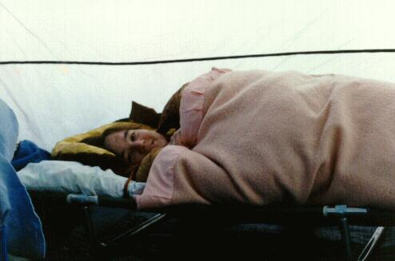
Bedtime at Whitehorse. It was probably after 11pm (note the light).

Wednesday July 18 (Day 5)
We woke up, as usual, with the sky obscured by fog. We could just see across the runway. But the day did hold promise for an early clearing. We checked with the Flight Service Station. The forecast was for perfectly clear conditions until 50 miles east of Northway when we would encounter smoke from the massive forest fires in the Tok area. We filed a VFR flight plan via the Alaska highway and asked for U.S. Customs in Northway. By the time we returned to the plane and had breakfast, the sky was clear. We packed up with anticipation since we were almost to our "destination".

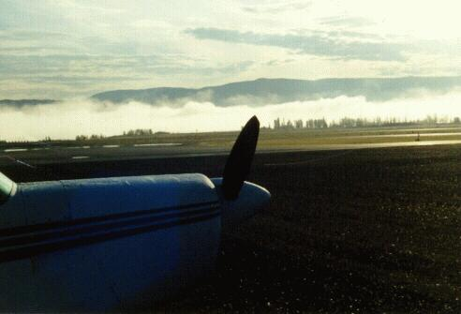
Early morning fog at Whitehorse. The town is just over the Estern edge of the airport where the fog can be seen. It soon lifted and we were on our way.

Whitehorse, Y.T.- Northway, Alaska (2.3 hours)
Our intention was to take off and fly low over the Alaska Highway until Northway where we would stop for fuel and customs. I shall always remember the first few minutes of this flight since it was our first (and only, it turned out) opportunity to fly low and in real contact with the ground. We took off from Whitehorse to the north and then hung a left turn to follow the highway out of the Yukon River valley. We flew the entire distance to Northway at about a thousand feet above the ground or about 3500 feet MSL descending to about 3000 feet near Northway.
Tory was looking intently for wildlife, especially moose which we had been told could be easily seen from the air. Alas, we saw no living creatures from the air. The only sign of life was the lumbering Winnebagos on the highway below.

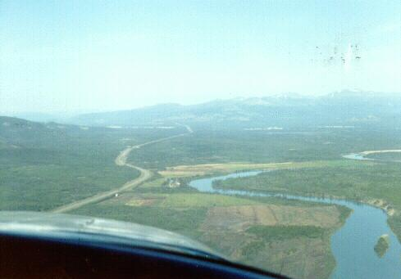
Low over the Alaska Highway (about 500 feet up) shortly after takeoff from Whitehorse.
The terrain was quite green, relatively flat around the highway, but mountainous in all directions especially to the south and later to the west as we approached the St Elias Range. We flew to the left of the road (the better for me to keep the road in sight). One could see that the road had evolved since 1942 (when it was first built). Curved sections had been abandoned in favor of straighter and wider sections. So far as we could tell it was all paved. There were occasional homesteads below set off some distance from the highway. They looked relatively poor (although it was hard to really tell) with a lot of trailers and old cars.

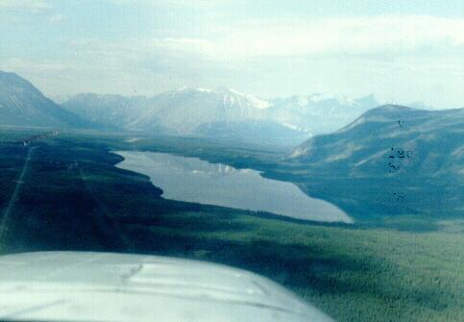
Pine Lake near haines Junction, 2000 AGL following the Alaska Highway. The St. Elias Mountains can be seen ahead. The road turns sharply north (right) after the lake.
After 45 minutes we came to the south end of Kluane Lake which is about thirty miles long and five miles wide. The highway is blasted out of the steep western shore. The most dramatic characteristic of this area was the abundant glaciers coming down the St. Elias range. With the good visibility, blue sky, and dramatic mountains, it was quite impressive.
After Kluane Lake we entered a rocky barren valley with a number of braided rivers flowing in and out of the connecting valleys. Gradually the terrain flattened out except for the numerous little rugged hills and, of course, the ever present St Elias range to our left.
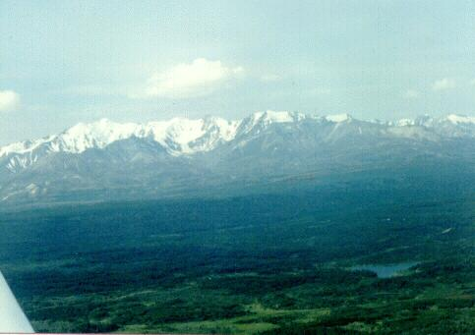
St Elias Mountains at the South West corner of the Yukon Territory, on our way to Northway Alaska.
About 20 miles after Kluane Lake, we started seeing smoke and visibility dropped progressively as we approached Northway. By the time we arrived, visibility was not better than 2 to 3 miles.
We noted our crossing of the US-Canadian border about twenty miles out of Northway and felt that we were once again "home". Actually, Canada had become quite familiar and comforting and Alaska represented the unknown and further adventure.

U.S. Customs
We followed the VOR and ADF signals into Northway and landed without incident on their long smoke enshrouded runway. As we taxied in, we were greeted by a dour bald headed pot bellied man perhaps in his late fifties. He turned out to be Clarence Boehm, the feared autocratic customs agent of the north.
He motioned us out of the airplane and asked us pointed questions, obviously designed to reveal any latent subversion. He then asked for all the paper work that normally accompanies an airplane. This was clearly bureaucratic harassment since an airworthy certificate has little to do with customs. But is was clear that this little man would take great delight in finding some flaw in the red tape that would occasion a fine or denial of entry. After unpacking the entire baggage compartment (aka Rubic's Cube) we unearthed the necessary paperwork which he glanced at with a disappointed grunt.
The final insult of our repatriation was a request to pay the 25 dollar customs fee. The fee, although large, was not unexpected. What was irritating was that he refused to make change for us and required us to go inside to the airport restaurant to get the necessary denominations. It was quite irritating and gave the impression "Boy, we really don't like your kind around these here parts".
We repacked the airplane, ordered fuel, and constructed our usual lunch of sandwich of "whatever was in the ice chest", usually cold cuts, lettuce, tomatoes, and mayo. We sat outside the restaurant under a pleasant tree and had a nice quiet meal.

Northway, Alaska- Anchorage, Alaska (2.3 hours)
After lunch we hiked about a half mile to the flight service station at the other end of the airport to get the forecast. The news was not good. Although the weather was magnificent, the forest fire situation was not. Our proposed route followed the Alaska highway west to Tok Junction where we connected with the Glenn Highway which would take through us the mountains to Anchorage. This route was completely closed by an area of restricted airspace set aside to permit the fire fighter tankers to operate. Clearly our day of contact flying was over.
The only practical way to get to Anchorage was to fly direct to the Glenn Highway over the mountains to the south west of Northway. The map showed this to be about 50 miles of flying over an area of rugged inhospitable mountains, miles from any habitation, roads or airports. The peaks were about seven thousand feet tall and arranged in about four or five rows before we got to Duffy's Tavern on the Glenn Highway. We filed our flight plan and looked forward to the reported good weather once we were clear of the smoke.
We took off and groped our way out of Northway in the smoke. As we climbed, the visibility improved but the view straight down was very limited. We climbed to 9,500 feet on a 230 degrees heading and watched the mountains build up below us. It was actually very pleasant at altitude and we put out of our minds the hazards of ground below. Sure enough, after about thirty minutes (it seemed longer), the smoke dissipated, the mountains shrank, and we could see the highway to our right converging with our course.
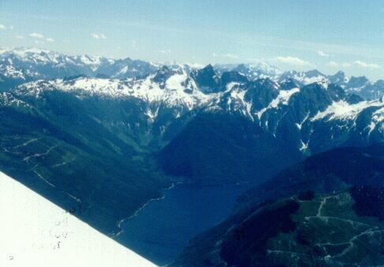
After Northway we flew over the mountains to rejoin the Glen Highway.
On our right we could see the magnificent summit of 16,000 foot Mt. Stanford. Otherwise the valley below us was fairly flat, wide, and mundane. It was also a great deal further down than our flight of the morning. About an hour out of Northway, the valley started to narrow and become pinched between two large mountains ranges. To the south, especially, the mountains were large. We were to the north side of the coastal range of mountains that surrounds Valdez and Prince William Sound. We passed two stupendous glaciers that came right down to the highway below. These were classic looking glaciers, with marked stripes of ice and stones.

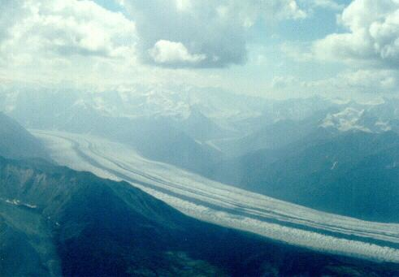
Matanuska Glacier about an hour before we got to Alchorage.
Two hours into the flight, the narrow valley we were following widened and fell away to a tundra plain of lakes and swamps. The river in the valley also widened to form an estuary, miles wide, that must have been no more than 6 inches deep since it had thick grasses growing in it. On the map it was called the Palmer Hay Flats Sanctuary. We were approaching Anchorage and the radio started getting downright busy.

Merril Field
The transition from wilderness to civilization was abrupt. One moment we were alone in the skies, the next we seemed to be in the vortex of a massive whirlpool which was trying to suck in every airplane (it seemed) in southern Alaska. We had been warned by the FAA publications about flying in the Anchorage area. There are three major airports within five miles of each other: Anchorage International, Elmendorf Air Force Base, and Merril Field, our destination. Each has its allotted airspace and specified routes for departure and arrival. Deviate from your assigned route and bye bye pilot's license.
Our route called for an approach from the north and a crossing of the bay, called the Knik Arm (don't know how it's pronounced), at an altitude either above 2,000 feet or below 600 feet. The altitude in the middle is reserved for landing traffic at Elmendorf. Since the Mooney would be going 200 mph after a descent from 2000 feet on short final, I elected to cross the Knik Arm at the lower altitude, 500 feet. As we reached mid channel, two fighters in close formation passed five hundred feet above us.
Unfortunately, at 500 feet I was too low to see the airport (remember that next time) and we had to ask for assistance from the controllers. They told me to follows a Cessna on floats (amphibious, I presumed) approaching from our left. We couldn't see anything that looked like an airport, just apartment buildings and houses and many airplanes buzzing around like bees around the hive. It was getting pretty frantic, the Cessna was getting closer and lower and still no airport. In fact it reminded me a great deal of opening day at Oshkosh except that at Oshkosh, one is expecting chaos. Anyway, we continued our approach, getting lower and closer to the Cessna when, Voila !, just as advertised, the buildings parted and there was a runway a quarter mile ahead and to our left. I banked and made a near perfect landing behind our guardian angel Cessna. We taxied through a forest of parked airplanes to a transient area near the tower and shut down the engine.

Finding an Hotel
We set about looking for a place to stay. This was to be our only night of the trip where we weren't camping out. We looked up in the AOPA guide for nearby hotels and noted that the Arctic Tern was fairly close and quite cheap. So we called them up and got a reservation for the night. The cab got us there in about ten minutes (after getting somewhat lost). It was not our idea of an appropriate place to stay. First, it was miles from downtown. It looked really tacky, like a three story flop house with a lobby ten feet square.
So we said to the driver, take us some place else, bigger, better, downtown. Well, that wasn't so easy in Anchorage on July 18th, the absolute apex of the tourist season. We went to one hotel after another (about eight in all) with the taxi meter getting bigger every minute. "Hello, do you have room tonight. Ha ha ha." Finally, somebody mentioned the Holiday Inn, so we drove over there an sure enough, they had a room. The reason was the highest room rate in town.

The Laundry Episode
We settled into our room. Tory called her aunt, Hillary, who said they would pick us up at six at our hotel. It seemed like a good time to do our laundry so I took all our clothes and ten dollars in quarters and went to the laundromat in the hotel. Well, I was washing away watching CNN (three loads wash and dry) and finally sauntered back to the room. Halfway back, I ran into Tory dressed in a bed sheet (remember, I had all the clothes). She had fallen into a drugged sleep for two hours, awakened in a start not knowing where she was, where her clothes were, and thinking she was late for dinner at her aunt's. Panic. I calmed her down, assured her that I had all her clothes, and that Hillary wasn't due for 45 minutes. Such relief.

Dinner at Hillary's
We were picked up by Hillary and her husband Donald. It was really strange to meet again somebody you last knew as a ten year old. Hilary was truly all grown up, thirty years old, mother of two, and very dominant (like her mother, my former mother-in-law), but sweet at the same time (unlike my former mother-in-law). I imagine Tory was unsure of our reception since the last time she had spoken to Hillary was when she (Tory) was a last minute canceler at Hillary's wedding.
They lived about 15 minutes from downtown Anchorage in a lovely neighborhood of attached condo-like apartments. Hilary's own mother-in-law had whipped us up a sumptuous meal and we had a truly pleasant evening. Their two boys aged five and three were neat kids. We had a good time. It could have been quite awkward, but it wasn't at all. At about 10:00 with the sun just sort of settling on the horizon, we drove back to the Holiday Inn where it was my turn to catch up on my sleep. It did not seem possible that just this morning we had left Whitehorse.
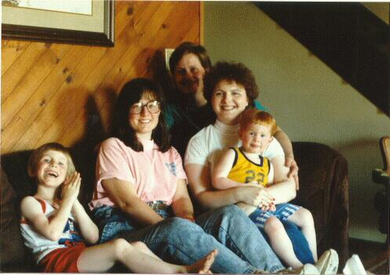
Tory and her Aunt Hilary and her family in Anchorage.

Thursday, July 19 (Day 6)
The day was beautiful, just like the day before. We had a leisurely restaurant breakfast (the only one on the trip), packed, and returned back to Merril field. The forecast was favorable, including a little tail wind, until Windy Pass when we should start getting into smoke.

Anchorage, Alaska- Fairbanks, Alaska (2.3 hours)
We took off from Merril and retraced our steps across the Knik Arm at 500 feet and headed north climbing to 8,500 feet. Our route followed the Fairbanks highway and railway north. The visibility was about fifty miles in a bit of a haze. The ground below us was a wide flat valley, bleak looking (for the most part) but rich with summer vegetation.

Mount McKinley (Denali)
After about 30 minutes, the Alaska range appeared on our left paralleling our course. This is the range that contains Mount McKinley. Mt. McKinley, or Denali (the high one in Alut language) really dominates the range although there are other beautiful peaks that are not nearly so tall. However, the really dominate feature of the vista were the glaciers that unrolled from the middle heights of these mountains and pushed themselves down into the valley over which we were flying. We edged over to the west to fly over the bottom of the glaciers. I knew that on the other side of this range was Denali Park, where we hoped to camp for several days. The wind was fairly calm since there was no turbulence in spite of being in the shadow of the highest mountains in North America. The peak was 12,000 feet above us.
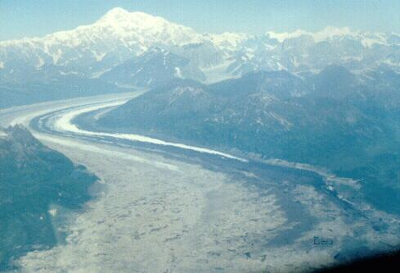
Mount McKinley and the Ruth Glacier.

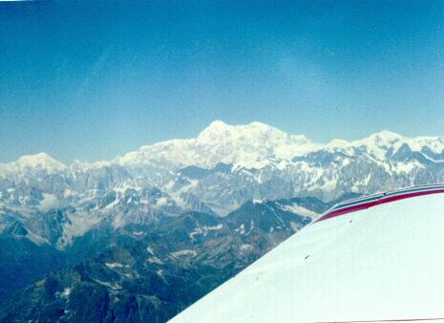
Another view of Mt. McKinley (Danali).
As we left McKinley behind, we came to Windy Pass whose features I recognized from the flying guide book to Alaska. We started into the pass and at the same time the visibility dropped to a few miles in the smoke. There was enough visibility to keep in the pass without trouble, but I was glad we had decided not to land at Denali airport (within the park boundaries) since the maneuvering room down there was tight and the visibility even worse. We passed over the park entrance and continued northwards. The road made navigation easy in spite of the decreasing visibility.

Zapped by the DEW Station
There was one hazard indicated on the map which I wanted to avoid. Near Nananna there is a DEW station (Distant Early Warning) radar station that is so powerful it can roast sea gulls that fly too close. The maps cautioned about possible radio damage. Maybe it was the gamma rays but our navigation seemed to get all screwed up and we couldn't figure how close we were to the DEW station. The Fairbanks DME signal was picked up and it indicated that we were probably right on top of the station. With that news we left the road and headed overland direct toward Fairbanks.
We were really IFR in the smoke. The ground wasn't visible straight down and there was nothing to see horizontally. We contacted approach control and groped our way toward Fairbanks using half VFR and half IFR procedures. They had us on radar after awhile and gave us useful vectors. Shortly runway 1-Left appeared out of the gloom and we landed.
Fairbanks has, in effect three main runways: 1-left and 1-Right and between them a big water runway for float planes. It is pretty amazing.

Rent-a-Wreck
We parked and immediately made lunch. Then we called our car rental company, Rent-a- Wreck. Assuming that rental vehicles were in short supply in July, I had reserved this car a month earlier and had reconfirmed several times thereafter. Within 30 minutes the car arrived, a nondescript red 4-door sedan with large plastic company logos on each door. I took the driver back to his office on the other side of Fairbanks. It turned out that his father had just crashed a Cessna 210 (a big single engine airplane) the previous month and was still in the hospital. The son was also a pilot but didn't fly much.
It should be noted that in Alaska every fourth person has a pilot's licence.
We unloaded the airplane into the car and headed off to Safeway for foodstuff replenishment. We also picked up some hardware items (more propane, etc) at the adjoining drug supply store. It took over an hour and $100 to restock but we got most everything we needed.

Thursday, July 19 (Day 6), Denali Park

The Drive to Denali
Tory, it seemed had developed a terrible thirst while shopping but we had forgotten to buy any drinks. As we pulled onto the street leading out of Fairbanks, I promised to stop at the first convenience store rather than do a U-turn. It was a good plan but within two minutes we were on the highway southbound with all signs of civilization well behind us. There was absolutely no settlements or commercial activity on the highway. Tory was gritching and blamed it all on me. Fortunately within ten miles, we came to a small roadside settlement that sold soft drinks.
The terrain itself was flat with small to medium sized trees bordering the road. It was quite green but not lush and might have been swampy under the surface. The smoke was very evident and visibility was certainly less than ten miles, often a lot less.
As we preceded south we became aware that it was awfully AWFULLY hot. It turned out that the heater was going full blast and we could not turn it off. The heater control just had no effect. This was not going to work, but we had already come thirty miles. It would take over two hours to return the car and get a new one or get the heater fixed. So we slogged on. At one point, we stopped and stuffed rags into all the heater vents. That didn't have much effect so we stopped and put duct tape (from the tool box) over all the vents. That wasn't perfect but it was better. All the windows were wide open. I, as the chief passenger, could put my bare feet out the window for their cooling effect, but Tory needed her feet on the accelerator and could do nothing to cool off. We were pretty miserable with a two hour trip (100 miles or so) ahead of us.
We finally, started climbing into the north end of Windy Pass through which we had passed at 8500 feet several hours earlier. It was about 5 pm when we arrived at the entrance to the park. We headed to the visitor's center to get the scoop.

Reservations at Denali Park
We really didn't know what to expect. It was disturbing to us that we couldn't drive into the park (or so we heard). It wasn't clear how we would camp if we didn't have the car. I thought maybe everything was done as a day trip on the busses we heard were available. It was possible, I thought, that we just couldn't get in at all.
It turned out that this was very nearly the case. We might have gotten nowhere except for the fact that Tory became quite assertive. And a good time for it, too. Tory, who had some notion of the procedures from reading her guide book, was in charge of the "negotiations".
Tory talked to a Park Ranger behind the desk who was very unhelpful, almost aloof, and it appeared that he was playing a game of "guess how to get a campsite". He was a young, tall, good-looking vain type, but Tory was not impressed. She would not take no for an answer. When told there were no campsites available, she probed and discovered that was only true tonight and that some campsites were available the next day and the day after (at different camp sites). But that didn't do us any good, since there were no available bus reservations, except (as the interrogation continued) for a pair that he just happened to have in his pocket, but no promises about the return trip, but (when pressed) if we didn't mind getting the early bus, there was some room. Tory kept pressing and smiling through clenched teeth and finally we were all set up for the next two days.
It seemed the system (if there was a system at all) is set up to give the few unreserved assets to those people who really wanted them and were willing to scrounge and scratch.
So we ended up with an overnight reservation for Thursday (the next night) at Sanctuary Campsite which was twenty miles into the park and at Wonder Lake Campsite, the farthest out campsite at 80 miles, on Friday night. Both these were accessed only by bus as private cars (the few that are permitted) cannot go beyond mile 14. Therefore we would have to pack in all our stuff for three days. Hummmm.
We poked around the visitor center and got the scoop on how to avoid getting mauled by grizzly bears and how not to damage the delicate tundra. Then we went into the book store and bought a Denali "trail map". I know it was a trail map because it said so clearly on the outside. But when we opened it up, no trails were marked. I was quite irate about this misrepresentation. We later discovered that the trails were not marked because there are no trails in Denali. All off-road hiking is done on the unmarked tundra. In fact, they don't want you to make trails since the tundra cannot recover from heavy use.

Camp Fairbanks Highway
But we had a small problem. We had no place to stay for this night. By now it was getting on toward 7 pm (early in the Arctic) and we were quite tired. It was suggested that lots of people camped at various turnoffs between the highway and the Nenana River. So we headed north again to snag a spot. We avoided what looked like the world's largest RV parking lot (we dubbed it Winnebago City) and found a nice, albeit very un-private spot, over looking the river. There were campers ten feet in each direction, but the spot had a good feel anyway.
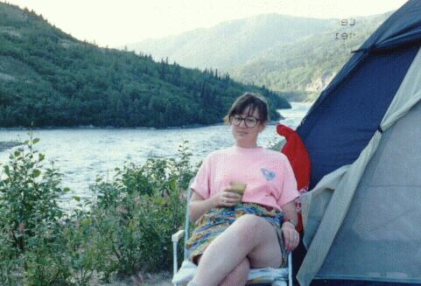
Camping on the Nenana River outside of Denali Park. In contrast with the bucolic appearance of this scene, the George Parks Highway is right behind the camera.
We were about 100 feet above the level of the river and the drop off to the river was nearly straight down. We had no need to get to the river but the slope represented the only semi-private place to have a pee. It was really possible to get killed answering a call of nature if one wasn't careful. The river was several hundred yards wide and looked like a swiftly flowing white water river. It flowed north through Fairbanks and thence into the Yukon River which, if you have been following our story, flows from Whitehorse to the Bering Sea. On the opposite bank, at about our level, was the cut for the famous Anchorage-Fairbanks railroad. We saw a moose cow and her calf walking unconcerned along this right of way.
While we were setting up camp, our "neighbors" came over to visit. They were a retired couple from (I don't remember) and, after hearing our story of the day, he offered to look at the car's heater. After pulling out the rags and duct tape, he flicked a lever under the dash so we would no longer be driving a rolling sauna. He said the temperature control cable had come disconnected.
We pondered how to carry in our camping equipment and provisions. We guessed (prayed, actually) that the bus would get within walking distance of our assigned campsites. We planned to take only the essentials. Remember that we had no light weight back packing equipment or, most importantly, any sort of a pack frame, so we would have to schlepp whatever we took in. It turned out that our gear totaled nine parcels that, between us and with difficulty, we could carry for short distances. The items we selected were:

- 1. One tent
- 2. One camp stove
- 3. One ice chest
- 4. Tory's backpack
- 5. Jon's duffel
- 6. Tory's duffel
- 7. Jon's sleeping bag
- 8. Tory's sleeping bag
- 9. Silver Cooler bag containing food
When we got onto the bus the next morning, we were the only people without well worn pack frames. I felt very un-cool and out of place, like we should be going to the beach. Tory couldn't have cared less. We both looked (and felt) like pack animals.
We were so tired after all our traveling, driving, and logistical planning that we hardly had energy to eat dinner. Around 10 pm we made some half hearted gestures toward preparing a meal and turned in for the night (which was still as light as day). This was our farthest point north (so far) and it had a noticeable effect on the sunset time

Friday, July 20 (Day 7)
Throughout the night (or day, as it really was ) we were occasionally awakened by 18-wheelers climbing up the grade next to our campsite. On another occasion, we heard what sounded like a mobile fraternity party, hooting and hollering and carrying on. But we slept on until about six. We were mindful that we had to get up early, break camp, eat breakfast, prepare our camping gear for the Denali adventure, and report (at 8 am) for the first camper bus. Tory's alarm clock provided the necessary stimulus.
Considering our fatigue and all the miscellaneous stress and uncertainty about our adventure, we were in very good spirits. After all this was our vacation and we were here to have fun not to grouse at each other. I give Tory more credit for maintaining the cheerful climate. She was always looking at the best side of each situation and often told me to "come off it" when I made a grumpy comment. Gradually I concluded that such comments had no effect, so they tended to come less and with less frequency, usually before my morning coffee.

The Camper Bus
We arrived at Riley Campground about thirty minutes early and were the first to arrive for the camper bus. Riley Campground is the campground closest to the park entrance and is set up for motor homes and campers. It is nicely laid out and although densely populated, still maintains a wilderness flavor. Gradually, the other bus reservation holders arrived with their backpacks and food safes. The latter are steel containers about the size of a gallon jug into which all edibles are to be placed when camping in the out back. It is mainly an anti-bear mechanism. Generally, the back packers were a lean and athletic lot preparing for a week or so away from the prepared campsites. Many of them had ski poles with them. Tory asked if they were somehow going skiing and was told that the poles are for balancing while crossing streams and rivers. It appears one of the major dangers is getting swept into some swiftly flowing river of glacier runoff.
The bus arrived at the appointed time. It was a regular school bus with the last five rows of seats removed to make room for camping gear. Several of the campers had mountain bikes with them so the baggage area was pretty full, especially with our nine bundles. In general, I felt pretty silly with all our gear when compared with the backpackers. But then, we had to use what we had and Tory told me to loosen up.
The driver was a grizzled mountain man who kept up a running commentary on the bus' public address system. We discovered why the busses take so long to go relatively short distances: Every animal or point of interest occasions a stop and a small lecture. It was quite interesting except that the PA system was weak and we only got half of the information content.
We left the Visitor's center at about 8:15 with a two hour schedule to reach our first night's campsite, Sanctuary Campsite. We departed in good spirits and curiosity. The traffic was light, mostly busses (both tour and transportation busses) and the occasional private car. Private vehicles are not permitted beyond the campsite at mile 14. The road was paved for the first ten miles. Thereafter it was firm packed gravel and dirt. Each bus raised a pretty good dust cloud, so one didn't want to be eating someone else's dust and the busses tended to spread out.
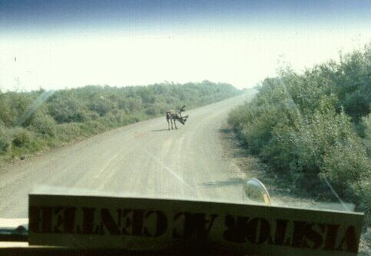
A carabou on the road. He was more intent on scratching his cheek than getting out of the way.
Once within the park there were almost no trees. It is mostly tundra with low brush, rivers, and, of course, mountains on all sides. The road seemed to be crossing river valleys that were perpendicular to our direction of travel. So the road would alternately climb to some ridge and then descend into the next river valley.
The rivers were unique. They all existed in fairly flat valleys so they spread out and were often several miles wide and very shallow. There were almost always several channels, often as many as a dozen for the larger rivers. This type of shallow, meandering, multi-channel river is called a braided river and is very common, in fact the norm, in Alaska. The channels were also barren gravel with very little vegetation in the river channel itself. Finally, the water was very turgid, totally saturated with silt and a light grey/brown in color. We were told that because of the silt which comes from the glaciers, the fishing isn't terrific. We were told what kinds of fish did inhabit the rivers but I don't remember now.
As we passed Igloo Campsite, at about sixteen miles, we were told that the campsite was closed due to some rowdy Grizzly bears.
As we went further into the park, it became evident that the smoke was getting worse. Apparently there were some big forest fires burning at the western end of the park and the smoke was drifting eastward. We were told that it was unlikely that there would be any good views of Mt. McKinley. Therefore, we were grateful for the stupendous views we had seen the previous day from the air. It was the western slope of the Alaska Range rather that the eastern slope that we would be looking at now (if we could have seen anything).

Friday, July 20 (Day 7), Denali Park and Fairbanks

Sanctuary Campsite
We arrived at the Sanctuary campsite around ten thirty. It was located a few hundred yards off the road so the "hike" in to the campsite was no problem and we got all our gear to the campsite in one trip.
Sanctuary Campsite is located a few feet from the Sanctuary River which is a typical Denali small sized river, about fifty feet wide, grey brown turgid water, swiftly moving. It flowed from the south and obviously originated at the base of the Alaska Range which, if we could have seen it, rose up twenty miles (or so) away. The campsite was located in a sizable grove of trees. It was deserted although several of the prepared campsites contained tents. There were perhaps a dozen tent sites, each fairly private and surrounded by trees. Each tent site had a picnic table and a little sign board onto which one clipped one's campsite reservation. There was a central collection of porta- potties (two or three) and a hefty food storage building, about six feet by eight feet. Water was available at a hose bib. There were stern warnings to put all foodstuffs into the food storage building. Near the road was a ranger's cabin but no sign of a ranger.
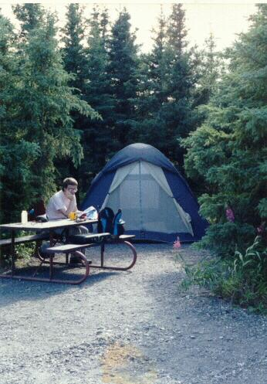
Our tentsite at Sanctuary Campground.
We had no planned activities and actually little concept of what to do now that we were here. That didn't bother us since we were quite tired and an unstructured day seemed quite luxurious. We set up the tent, stored our food, and decided to take a hike.

Hiking on the Tundra
We started out on a small trail which paralleled the river. We had our camera and our fishing gear. The trail was littered with "scat", probably moose, and the trail itself was obviously an animal trail used occasionally by the Sanctuary campers. As we moved away from the campsite, the trees became more sparse and we were soon walking on open ground with a pretty good view of the nearby hills (mountains). It was really quite serene, very alone, and with little (if any) signs of humanity other than ourselves. Tory took some panoramic photographs. Even the bugs were respectful of us and posed no problem that the Deet couldn't handle. The day was warm with little breeze. This was the closest that we had come, thus far, to Arctic wilderness.
We stopped at a few little streams that, unlike the main river, were clear, but found no interest in our lures. After half an hour, and perhaps one mile, the trail petered out. Since we had no experience in off-trail hiking, and we had gotten a feeling of the spirit of the place, we turned around and returned to the campsite stopping off for some more unprofitable fishing in the main river.

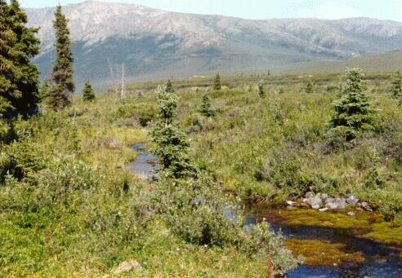
A little stream winding through the tundra.

Lounging at Sanctuary
We made our usual lunch sandwiches and found a shady secluded river side nook and ate lunch and soaked in the beauty, serenity, and our good fortunes. After lunch Tory spent quite a lot of time with her water colors capturing the feelings of our riverside location.
I can't remember now (six months later) the details of how we spent all our time in Sanctuary, probably reading, napping, writing in our diaries, drawing. But there was not a moment of boredom. It was pure contentment.

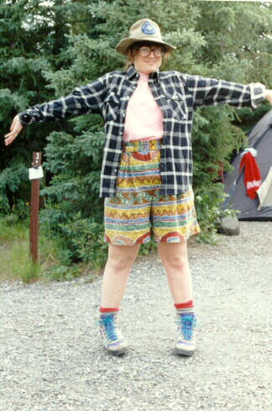
Tory had a particular way with colors and patterns. This outfit was designed to repel grisly bears.
In the late afternoon, our solitude was interrupted by loud voices speaking in German. We talked to the origin, a family of Swiss hikers. We noticed that a big percentage of the visitors in Denali (perhaps 20 percent) and a majority of the hikers were Europeans and mostly Swiss.
As the evening progressed, the campsite filled up (but it obviously never got very busy with only 12 campsites). We made dinner and retired early. For some reason, Tory and I had little real contact with other people during our trip. For the most part we found sufficient stimulation in each other there wasn't a major need to seek conversation with others. Actually, on this trip, there was not that much opportunity to meet other travelers. I was surprised, actually, that in mid July there was so little aircraft camping activity. Although Denali was full of Winnebagos, there wasn't that much tourist activity in the few other places we visited, e.g. Fairbanks' Alaska Land was quite deserted, and the airplane camping grounds had little more than one or two planes in residence.
Another reason why we may not have much conversation with others was that we didn't fit a standard category, e.g. married couple, or family with children. It worried me somewhat, not without reason as Dawson would suggest, that people would take me for an old lecher taking advantage of an impressionable young girl. I always went to great pains to explain that "she's my daughter". Sure, sure.....

Saturday, July 20. (Day 8)
On Saturday morning we had set our travel alarm clock for an early wake up call. We made breakfast and did our morning toilet. There were little pockets of activity at the other campsites but it was subdued and in keeping with the spirit of the wilderness. We dismantled our campsite and made up our nine bundles and hiked out to the road.

Camping Bus to Wonder Lake
The camping bus was right on time at 9:20. We produced our magic reservations and were allowed entry. The bus was full as it had been the previous day and loaded with camping gear in the rear. There was an especially large group of "serious" back packers with their food safes and ski poles. Most of them appeared to be European and very healthy looking.
It took 4 1/2 hours to go about the sixty miles to our destination, Wonder Lake campsite, the farthest away from the entrance in the park. However there were many stops and lots of sight seeing. The "tour" was much better as the PA system worked today.
The dirt road was in good condition but it was not wide. The trip was mostly a series of climbs and descents from one river valley to the next. As we proceeded west, the smoke got thicker.
We made several stops, the longest of which was at the Eielson Visitor's center which was about 60 miles from the entrance or about two thirds of the way from Sanctuary to Wonder Lake. We got there around noon. The Visitor's Center was a small museum, look out, rest stop, and ranger's station rolled into one. There was supposed to be a panoramic view of Mt. McKinley, Muldrow Glacier, and the Alaska range but is was totally obscured in the smoke.
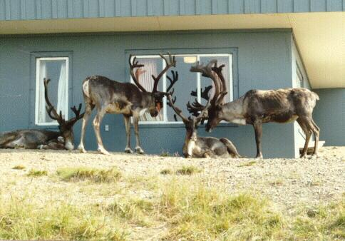
Carabou at the Eleison Visators Center. They tolerated the people in cxchange for protection from the grisly bears.
On one side of the Visitors Center, we found a small herd of four caribou. We were told that they were totally wild but sought out the Visitors Center since it afforded protection from grizzly bears who avoided the Center and human contact. The caribou tolerated the gawking human visitors and the incessant picture taking since they were relatively safe from their principal predator. There were signs warning the visitors to keep clear.
As we progressed we saw lots of wildlife, most notably moose, beaver, birds, and a few Grizzly bears (all in the distance). The binoculars were indispensable for seeing everything. A telephoto lens on the camera would have been fantastic for capturing closeups of the wildlife and scenery. The close in scenery was also very beautiful: low brush, wild flowers, and tundra. Trees were almost totally absent. It was all very green except for the bottom of the valleys which were more like river beds than tundra. These were rocky and grey-brown. Braided river beds, very wide, were in every valley floor. The visibility was no more than five (or at most ten) miles.

Wonder Lake Campgrounds
We arrived at Wonder Lake Campground at about two o'clock in the afternoon. We were bussed out and hungry. Wonder Lake campsite was much bigger than Sanctuary, perhaps as many as one hundred tent sites. These were all laid out in the tundra about 30-40 feet from each other with a little path to each tent site. Each tent site was like a little island in a sea of tundra. Although you could see all of the other tent sites, it was not possible to get from one to another except across the tundra and walking on the fragile tundra was discouraged.
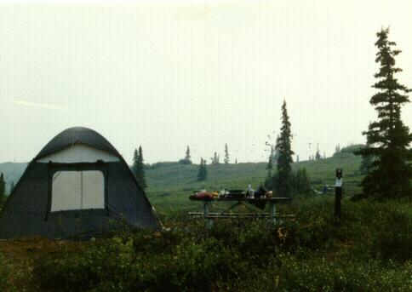
Our tentsite at Wonder Lake Campground. Each tentsite was like a little island on a tundra sea.
We got to examine the tundra close up. It is like thick moss, and very spongy. It was perhaps four inches thick and made up of intertwined plant life of all types. Of course there were small bushes too, but the principal vegetation was this low stuff.
We selected a tent site close enough to the latrine and food shed to be convenient but not so close that there was a lot of bothersome traffic. Our little "island" was about twenty feet on a side of built-up earth and stone with a picnic table and the ubiquitous sign post for the reservation slip. We set up the tent and made lunch. We settled in for an afternoon siesta (hey, its hard work riding on the bus).
Around four we arose and decided to go on a fishing expedition. We gathered together our rod and lures and hiked the half mile or so to the lake. The lake itself is quite large, perhaps two miles long and half a mile wide. It had a real lonely look from the shore. It is undeveloped for recreation (boating and housing) and the only sign of humanity was a few hundred yards of path in the tundra at the south end of the lake. The lake was rippled by the moderate breeze that seemed to be a feature of this place. A few hundred yards off shore was a family of ducks, two adults and three or four ducklings. We also saw some crane type birds hiding in the rushes to our right.
The weather was neither cold or hot, perhaps 68 degrees. The sky was gloomy with the smoke. One got the feeling that this place was having its short concession to summer but that in two months winter would be threatening and by October it would be brutal, wind, ice, snow, and little to eat.
We passed a young man who looked somewhat shaken who said he had encountered a Grizzly bear, at that very spot, a few minutes earlier. We took note of this fact, but for some reason probably ignorance, it made little impression on either of us.
We commenced "fishing". The lake was very shallow. In fact we were told that the entire lake was quite shallow which is a feature of lakes formed by glacier action. Sure enough, within a few casts the lure was stuck on a rock. Like Captain Hook, I made Tory walk the plank and wade out and release the hook. Actually, she was quite willing for the adventure but after the third time, she told me to do it myself. The water was surprisingly warm and ten feet from shore it still only came to my knees. Tory tried her luck, but we were not destined to have fish for dinner. In the process we lost two lures on the rocks.
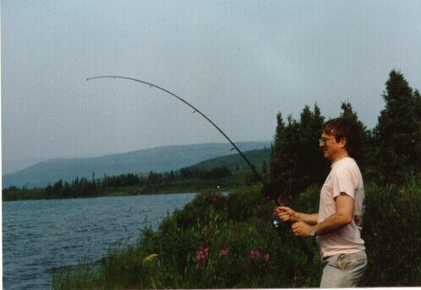
Wonder Lake. Jonathan duals with a big one (a big rock, that is).
We had enjoyed our outing. We returned to our campsite and lounged around till dinner time at about 8:00. It may seem to the reader that we did little while in Denali. That is true, in a sense, especially if you ignore getting around. The bus segments were major sensory input, very interesting, stimulating, and quite tiring. The rest of the time, we were just taking in the sights, just being there, feeling, watching, listening, thinking. Denali and Alaska are so different from normal everyday life, that just being in the middle of it will keep your mind occupied. It may seem that we were doing little, but we were fully occupied doing it.

Solar Eclipse
At around nine o'clock, after dinner, we noticed that it seemed particularly gloomy. I commented on it and Tory, who looked up at the sun exclaimed that there was an eclipse in progress. Sure enough, about two thirds of the disk was covered. Since the sun was already somewhat obscured by the smoke layer, it was possible to give the sun a momentary glance. We got a pretty good look. The eclipse lasted about half an hour. After the excitement we turned in, mindful of another early day tomorrow.

Sunday, July 21 (Day 9)
Up at 6:30, coffee, breakfast, break camp, and walk to the bus staging area. We had a reservation on the first camping bus (8:00 am) all the way back to the Park entrance and Riley Campground. Was it really only two days ago that we first came to Denali?
The bus trip back was very interesting. The driver was a young man, very funny, a little flaky, and very knowledgeable about the region. We saw lots of animals: grizzly bears, elk, moose, wolf, etc. I think that is a function of the sharp eyes and knowledge of the driver. Sitting in front of us was the wife of the park pilot. We talked a little about flying in Alaska. It turned ut that she was the supervisor of all the bus drivers and our driver was nervous throughout the trip (6 hours) trying to do a good job and not screw up. He shared that with us after he dropped the lady off at the park headquarters.
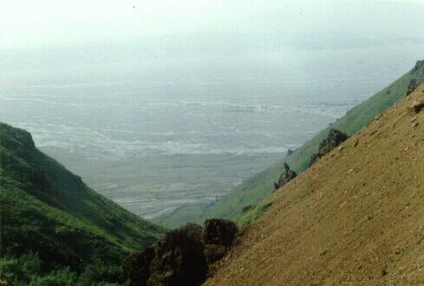
Looking down on the tundra plain from one of the many mountain passes while coming back from Wonder Lake.
We arrived back at our Rent-a-Wreck. The car was untouched. I had left my wallet in the car with all our money and credit cards. What good would they have been in the park, right? Wrong. An obviously unattended rental car would be a very attractive target, I would think. And as soon as we had gotten on the bus two days earlier, I had nagging worries and wished I had had my wallet on my person.
We had been alerted that the Mercantile Exchange (convenience store) across from the park airport offered showers. So we went over there and had luxuriously unlimited showers and put on clean clothes.

Fairbanks Airport
The drive back to Fairbanks with the heater now off was a delight. We soon were back at the airport reclaiming our airplane, which incidently, I had left unlocked for the last two and one half days. I taxied down to the camping area while Tory followed up with the car. Within a few minutes we were set up snug as a bug in a rug.
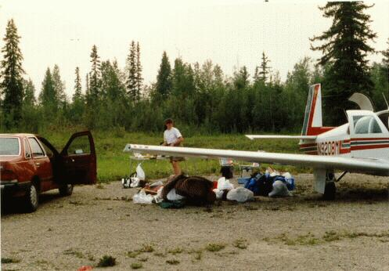
Back at Fairbanks Airport unloading our gear from our Rent-a-Wreck.
We saw across the campsite, the red Cessna 170 with the two old codgers we had met in Ft. St. John, BC. It shows that slow and steady works too.
We spent the evening at the laundry and doing shopping for our second week. We were back at the campsite by 10 pm at which point we had an abbreviated dinner and went to sleep.

Point Barrow Plans
I shared with Tory a fantasy I had been cooking up: to fly to Point Barrow the most northern point in Alaska and the northernmost city in North America. Much to my delight, she thought it would be a good adventure. So we made plans to leave in the morning, weather permitting.

Monday, July 22. (Day 10)
As soon as coffee and breakfast were over, we drove down to the flight service station to check on the weather at Barrow. The plan was that we could fly to Barrow and return the next day to Arctic Circle Hot Springs, a resort with a famous hot spring and baths just south of the Arctic circle. However, it was not to be (today at least). We were disappointed to learn that the weather at Barrow was zero-zero (or nearly so) and the trip was not recommended. We consulted our list or places we wanted to go and considered our options.
It was decided that we would fly to Fort Yukon which is on the Yukon River just 12 miles north of the Arctic Circle. This would permit us to brag that we had landed above that arbitrary line. The guide books, incidently, in no way recommended Ft. Yukon as a tourist center. Then we would fly back to Arctic Circle Hot Springs and spend the night, in a hotel room if possible! The weather to Ft. Yukon looked satisfactory with reports of smoke in the area.

Fairbanks to Ft Yukon. (1.3 hours)
So Tory returned the car to Rent-a-Wreck while I disassembled the campsite and packed the plane. She was back at the campsite within an hour. We were ready to takeoff by about 9 am. Conditions at Fairbanks were good enough for a VFR takeoff, but just barely. We climbed up to 9,500 feet in order to get above the smoke and also to clear the 4,000 foot mountain range that lies to the north of Fairbanks.
We were pretty much in the clear at 8,500 feet but could hardly see the ground. As we flew north the higher terrain was just barely visible straight down. It was (like lots of terrain in Alaska) not very hospitable looking. The total distance to Ft, Yukon was 128 nautical miles or 147 statute miles. With climb, that ends up being about an hour in the air takeoff to touchdown.
Navigation was easy since both Fairbanks and Ft. Yukon have VORTAC stations that show bearing and distance to the station. About thirty miles from Ft. Yukon we began our letdown and reentered the smoke layers. Although it was technically VFR, it was solid instruments since there was no horizon and no ground contact until we were within 3,000 feet of the ground. I called up Ft. Yukon Unicom and announced my position and intentions to land.
There was no doubt that seeing the airport would be difficult. So I decided to follow the normal procedure for the VOR DME approach for runway 3, that is landing to the north east. So I kept my eyes riveted on the instruments and occasionally peeked outside to see if anything was visible. We descended to 1200 feet (about 800 feet above the ground) five miles out and preceded inbound on the specified heading. Soon we were over the Yukon River which is over two miles wide still looking for the airport on the opposite bank.
There was another factor affecting our approach. I had never landed Mike (the airplane) on an unpaved field. If fact, I rarely have ever used unpaved airports. We were, therefore, looking for an airport that had a very different appearance from what we were used to. Most hard surface runways stand out like a sore thumb. An unpaved airport is just another field. So as we descended lower we still didn't have the airport identified. The discussion with Tory about what we were seeing (or not seeing) became more terse as neither of us was able to confirm that there was an airport out there. Finally, it was indisputable that this big field off to the right was definitely suitable for a landing and if it wasn't the airport, tough. We touched down, thumpa thumpa, and crunched to a halt about halfway down the 5800 foot gravel runway.

Fort Yukon
We taxied back to the ramshackle hut that appeared to be the terminal building and stopped our engine. The sun was a brown disc in the smoky sky but it was still putting out lots of rays. In fact, it was quite hot. It did seem that the further north we went, the hotter it got, probably since there was no night to let things cool down. We stepped out into the spacious ramp, completely empty, and surveyed the array of low buildings and equipment. At the other end of the field there appeared to be some activity at a fire bomber staging area
.
The three of us at Fort Yukon Airport,
north of the Arctic Circle.
Photo taken by Ruth Post, a member of a wildlife management team.
We walked into the "terminal" lobby which was about twenty feet square and were greeted by an attractive female airline ticket agent who was totally disinterested in us or Ft. Yukon and didn't seem to know anything or care. She worked for some commuter airline (name forgotten) and was scheduled to be airlifted back to Fairbanks on the afternoon flight which, she said, wouldn't be soon enough. She soon went back to her nails and we stepped out again into the hot sun.

The Wildlife Management Team
At that point, a Bell Jet Ranger helicopter came into sight (and sound) and came in for a landing on the ramp about fifty feet behind Mike. Out hopped a pilot (khaki flight suit) and two scruffy personages who proceeded to start unloading a monumental pile of equipment and duffel bags. These two soon resolved themselves into a young man and woman, the man quite tall, and the woman of medium height, thin but attractive.
The man hobbled over first. He said he had terrible blisters on his feet. It turned out the two were seasonal employees for the U.S. Fish and Game Commission and they had been out in the "bush" for a month counting ducks. They were given a two mile square area (4 square miles) and told to count every duck in every puddle in the area. Since this area is fifty percent puddle, the job was very difficult. The purpose of the procedure is to estimate the duck population which determines how many duck hunting licenses will be issued in the US and Canada.
Tory struck up a conversation with the woman who told her the details of her job. Tory's eyes were getting bigger and bigger as the woman, whose name was Ruth Post, talked. It appeared that some occupational options were occurring to Tory.
Tory later wrote a letter to Ruth asking for more details and, in due course, got an informative and friendly reply. I have attached a copy of both letters to this diary since I think they ought to be part of the record. Ft. Yukon, Alaska-Fairbanks, Alaska (via Circle Hot Springs) (1.4 hours)
Having arrived, all that remained to do was to depart. We said our goodbys to the duck counters and started up Mike, and took off into the smoke. We set course for Arctic Circle Hot Springs another dirt strip 68 nm to the south east of Ft. Yukon. Expecting poor visibility, I had planned carefully our approach into Circle. I drew up an informal instrument approach based on the local NDB beacon. Since there were hills in the area, I did not need to be blundering around without knowing where we were. We climbed to 5,500 feet.

Impenetrable Smoke at Circle Hot Springs
The visibility was definitely not improving in the smoke. We went through some areas of thick smoke that stressed our peace of mind, but we pressed on nonetheless. But then, quite suddenly, we were plunged into near total blackness. There was no doubt that these conditions were unacceptable and that the way ahead was blocked. Not only that, the smoke could not be doing the engine any good. I started a slow measured 180 degree turn to the left (blessing the HSI that makes it so easy to do an about face). Soon we were back to the normal marginal conditions and we took stock. We could fly to Dawson but that was in Canada and we were not on a flight plan requesting customs. The only other choice was a return to Fairbanks. Since we had not really seen Fairbanks, we decided that this was a good plan. We set course to Fairbanks and climbed to 8,500 feet.

Doing Fairbanks
We arrived back at Fairbanks International at about 1 pm. Conditions at Fairbanks had deteriorated below VFR conditions in our absence so we had to get a special VFR clearance into the control zone. After a quick lunch, we called a taxi and with guide book in hand, we set out to see the sights of Fairbanks.

Fairbanks University
The taxi took us to Fairbanks University which is on a high bluff overlooking the city. There is a well known museum at the university specializing in the natural history of the region. The high point of the museum is the once frozen mummy of an extinct Arctic Ox. There were many interesting displays on the flora and fauna, geology, native population and culture, gold rush and local history, and the Aurora Borealis. We both liked that sort of stuff and we found it interesting.
We stopped off at the student center for a soda. It was like any other college student center: bulletin boards, cafeteria, entertainment facilities, cafes for meeting and relaxing. The University did not arrear to be in session (it was July, after all) but there was still a lot of activity. By far the biggest beehive was a children's ballet class taking place in one of the big meeting rooms. The thirty or so boys and girls ages five through 15 were practicing what appeared to be a show in the latest stages of preparation. It was a bit of a surprise to see this activity in a "frontier town". It was very comforting that such activity exists in Alaska. The ballet itself, which appeared quite accomplished, brought tears to my eyes.

Alaska Land
We consulted our guide book. The next big attraction in Fairbanks was Alaska Land. It sounded terrible to me but the brochure said that there was a Pioneer Air Museum with vintage airplanes from the early days of Alaska exploration. I will go anywhere to see an antique airplane.
The city bus stopped right in front of the student center and would take us right to Alaska Land. In fact, the bus was already there waiting since this was the beginning of the line. It left in a few minutes and the fifteen minute bus ride gave us a varied look at Fairbanks: modest business and residential areas, middle class, no big emphasis on growing things, sturdy rather than flashy, weather worn with a touch of poor.
Our first impression of Alaska Land was a disaster. The Pioneer Air Museum had, we were told, failed to get funding and would therefore not exist until next year, at the earliest. The drydocked river boat on display was a mass of peeling paint and advanced decrepitude. The place was practically deserted (it was by now nearly six pm) and it gave the impression of a down and out carnival. We were ready to depart and were glad that admission was, thus far, free. We decided to look around a little farther and maybe get a bite to eat.
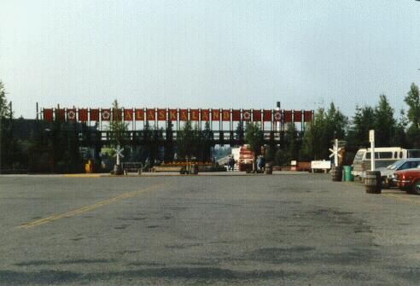
The extrance to Alaska Land, Fairbanks.
Tucked away in a corner of the site, were about thirty early Fairbanks houses (cabins really) that had been moved to Alaska Land and restored. These buildings formed a "main street" not unlike, I would imagine, the Fairbanks of 1900. Each house was either fixed up as a museum or as a retail establishment selling crafts, food, and the like. The furnished houses were particularly interesting and each one had a story. Most surprising was their small size, the largest was maybe fifteen feet by twenty feet with two stories. The whole effect of this area was one of quality, civic pride, and care. Very different from our initial impressions of a tacky theme park.
We took a few minutes off to listen to the obligatory recitation of the "Cremation of Sam McGee" by an apparent relic of the Gold Rush. We appreciated the telling and tipped accordingly.
We continued to wander around and came to the "Palace Theater" which was advertising a musical review at 8:30. The guide book said this was worthwhile so we made a reservation. We were told we would have two seats at the bar which was all that was left.
We took the opportunity to find some dinner and settled on a little restaurant that was serving Greek food. In Alaska? We ordered two gyros sandwiches and some stuffed grape leaves. The meal was, regretfully, quite forgettable.
We showed up at the Palace at the appointed time to find it nearly full of a mostly geriatric crowd, possibly from a bus tour. We were shown to our seats at the bar which in spite of being at the very back of the hall, offered an excellent view since we were two feet higher than anyone in front. Most of the other 150 or so patrons were seated at tables of from four to eight people. We witnessed one semi-elderly man having a hissy- fit because he was not seated at a table that suited his requirements. The usher patiently tried to reason with him, but he would not be consoled and demanded a refund (which was, I imagine, gladly given). There were a two young women serving drinks to the seated patrons as the crowd settled into readiness.
The show was a musical skit (lasting about an hour) with a cast of five, two men, two women, and the piano player/conductor who also sang. The cast, it turned out, were the usher, waitresses, and bartender. The program noted that the piano player was the composer of the show which contained all original music. These "Perils of Penelope" type shows can be pretty mundane musically, but this was Good! The music was bright, original, and kept the show moving. The story predictably followed the history of Fairbanks through the Gold Rush and was complimented by a multi-media projection of old photographs of pioneer Fairbanks on the back wall of the stage. I don't remember the details of the story but it included the boy-meets-girl-wins-girl-survives-adversity theme one would expect. It was delightful.
The review let out at about ten. We didn't feel like going through the hassle (and expense) of a taxi so we decided to walk back to the airport, a distance of about four miles. We marched off into the midnight sun down the main drag for two miles, then a left turn up the airport access road for another two miles.
This walk was the one point in our trip where we stretched to the limit the effectiveness of our mosquito repellent. Two sweaty bodies in the moderate temperatures of the late evening were too much for the bugs to resist. We found if we kept the speed up we were OK, but when we slowed up, they dive bombed us.
Our campsite was at the end of the airport closest to the town. There was an airport gate near our plane. We had noticed that a sign said that the gate closed at 10 pm. If that were the case, we had an additional two miles to hike. We hoped upon hope that the gate would be open as we were quite ready for bed. It was still open when we arrived. As we entered the gate at eleven thirty, the last bit of sun settled below the horizon. In a flash we had the tent up and beds made and were in the rack, instantly asleep.
It had been a busy day

Tuesday July 23. (Day 11). Fort Yukon Dawson
After our late night out, we slept late and rose at about eight for coffee and then breakfast. We talked for awhile with the occupants of the only other plane in the campground, two men who work for Beech Aircraft. They had a magnificently equipped Bonanza which belonged to the employee's flying club. They rented it for $20 per hour or something like that. Envy.
It was still our hope to fly to Barrow. My general plan was to fly to Bettles about an hour's flight north of Fairbanks and refuel. Then we would cross the Brooks Range and fly direct to Barrow (about two hours, 287 nm), if Barrow, which is on the coast, was socked in, we could fly back to Umiat (45 minutes south of Barrow) or we could make it back to Bettles to refuel.
The appeal of flying to Barrow was of uncertain origin and was certainly not justified for the rewards awaiting us in Barrow as tourists. But Tory was enthusiastic too, so it was probably just the desire to go as far north as we could and see the most unusual things we could.
Since we didn't have a car anymore, we packed the plane and taxied down to the flight service station (about a mile away from the campground). One check of the weather told us all we needed to know. Barrow was still zero-zero in fog. It had been so for three days and was likely to remain so. So our trip to Barrow was not practical. We had a little caucus to consider our options. We had just about exhausted Fairbanks (in one day). Arctic Circle Hot Springs was inaccessible due to the smoke. Perhaps it was time to turn around and head south, that is home.

Fairbanks, Alaska- Dawson, Y.T. (2.6 hours)
So we decided to head for Dawson City in the Yukon Territory, the site of the 1897-1899 gold rush. It was supposedly an interesting well preserved town and was on our list all along. We filed an instrument flight plan to Dawson City. We took off at 9:43 am and were shortly climbing out in the smoke. We leveled off at 9,000 feet mostly in the clear.
Our route took us south east over Tok Junction to Northway, and then over rugged mountains to Dawson. The first part of the flight was uneventful. We were in the clouds perhaps a third of the time. Around Tok we were in the clear long enough to see several widespread fire areas. We looked for fire tanker operations but could see none.
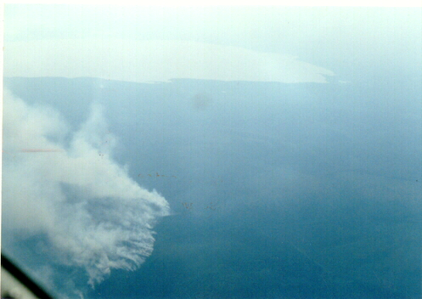
Forest fires near Tok Junction on our way to Dawson City, Yukon Terratory.

Back in Canada
After Northway (11:20 am) we left the security of the Alaska highway and the relatively flat lands around it and headed due east over some rugged looking mountains. We were also back to the primitive ADF navigation. The distance to Dawson was 100 nm and before we had totally lost Northway VOR we were getting a good signal from Dawson NDB which is on the field. The weather had deteriorated and we were continuously in the clouds and it looked like we would be doing an NDB approach into Dawson. As we descended we began to break out and, as it turned out, we arrived over the field with pretty good visibility straight down although there were rain showers in all quadrants. We dodged another plane that was leaving. After the usual "Check gear down" greeting we descended in several steep spirals to land to the east on a 5,000 foot gravel runway (sorry again Mike). Actually, it was in good shape. We arrived in Dawson at 1:05 having lost an hour as we crossed into Canada. We were now back on Pacific Standard Time, almost home.
The airport at Dawson is on the Klondike River about 15 miles up river from where the Klondike merges with the Yukon. As we descended to the airport we could see that the ground on both sides of the river was all churned up. It looked like hundreds of enormous intertwined earthworms with the worm's bodies being fifty feet or so across. This feature of the earth extended inland perhaps half a mile from the river's edge until the way was blocked by the steep hills on either side of the valley. We learned that these were the result of dredges that floated around in canals chewing up the gold laden earth from which was extracted the gold. The detritus was spit out the back of the dredge and formed the earth worms we saw from the air.
We taxied to the main ramp and went through Canadian customs conducted by a pleasant roly poly youngish woman. It turned out the gas attendant had to come in from town 15 miles away and that would take half an hour. We asked about camping at the airport. That caused several deep frowns and general cluck clucks of disapproval. Someone suggested that we cross the highway, and walk a few hundred yards to the Klondike River which, we were told, was very pleasant. This did not please us but we taxied down to the gas pumps and had lunch while we waited for the gas attendant to arrive.
In due course a lady arrived and gassed us up. We asked if she could give us a lift into town. We were surprised by a half negative answer but after some discussion, she finally agreed and we piled into the cab of her pickup truck. As we talked, she warmed up and was actually quite nice and helpful. In retrospect, I think her reluctance was due to not wanting to interfere with the taxi cab concession. We learned later that transportation in the Dawson area is big business.

Dawson City
Dawson is on the bank of the Yukon River as is Whitehorse, four hundred miles up river to the south. The two towns were linked by river boat until a road was pushed through in the thirties. The town is dominated by a big mountain to the north with a characteristic scar of bare rock. All the buildings have a turn-of-the-century gold town look and are in a remarkably good state of preservation. The town really spreads out quite a bit (during the gold rush, it had a population of over 30,000 people. Today I would estimate that there are three hundred buildings standing. Its year-round population is under a thousand people.
The streets are unpaved. In general, the town didn't look that busy. We did not see dozens of tour busses (or even one) in spite of the fact that the principle industry is tourism. Apparently there are still active mining interests in the Yukon Territory.
We noticed signs advertising a combination salmon barbecue dinner and river boat tour that sounded interesting. It turned out they were all booked up so we couldn't do that.

Dawson City Tour
So we checked in at the main tourist center/museum to see what was the best way to see the sights. They recommended a free walking tour that was just getting ready to leave. So we latched onto the tour which was led by a pleasant young man in period costume with a bowler hat. He started out in quite a long winded way that I feared would be frightfully dull and short on facts. But he soon got into his stride and the tour was actually quite interesting.
We started off at the water front where the guide described river boats and how the miners arrived in Dawson after a 1,000 mile trip from Skagway, over Chilkoot Pass, and down the Yukon from Lake Bennett. We walked around several streets looking at period buildings including the main commercial bank, the post office, and the red light district. Here we heard an anecdote about a benevolent madame who was finally closed down in 1950.
There was an odd side story here. One member of the tour was a nice looking young man probably about Tory's age traveling alone. When the story about the Madame began, he grumbled to us about how disgraceful it was that we had to listen to this garbage which "glorified the exploitation of women". We looked at him as if to say we thought his comment was a little strange (which we did) so he went off to complain to some other more receptive listener. He probably did no better with any one else since he soon walked off outraged. Tory and I discussed it and found his behavior inappropriate since prostitution in Dawson (and in all mostly-male communities) was a fact of life and a part of the history of the town. We were not here because we this was a normal small town. We were here because this town has an unusual and interesting history, and we wanted to hear about it. In fact, the anecdotes were very mild, non sexual, and generally presented with humor. Oh well, it take all kinds of people to make up the world.
We realized that we had forgotten the camera and could not record our impressions of Dawson.
Dawson, more than any other place we visited, was a tourist attraction. And in spite of an obvious commercialism, it was most enjoyable, Both the tour and the museum were free and everybody was eager to help.

Camping on the Klondike
At about this time, Tory announced that she wasn't feeling too well. It sounded like she had a touch of flu or just a cold creeping up due to exhaustion and lack of sleep. We decided to forego dinner in town or any further activities and to return to the plane and set up our campsite.
Had Tory been feeling well, we probably would have hitchhiked the 15 miles back to the airport. Instead, we inquired about a taxi and got hooked into the $24 dollars ride back to the airport. The taxi really was a tour van and the taxi driver was dressed up to look like a 1900's vintage snake oil salesman. We were miffed about the fare but kept our irritation to ourselves.
We arrived back at the airport and unpacked our critical gear. We then carried it in 3 trips about two hundred yards across the highway to the banks of the Klondike River. The scene was really quite idyllic, on a little rise above the banks of the river. We were far enough off the highway, known as the Dempster Highway (I keep remembering "Dumpster"), that the occasional 18-wheeler was hardly heard. The only problem was that we were on what seemed to be a heavily traveled dirt road which looked like an excellent teenage "parking" place. We were wondering if somebody might accidentally drive over our tent in the night (forgetting that there really was no night).
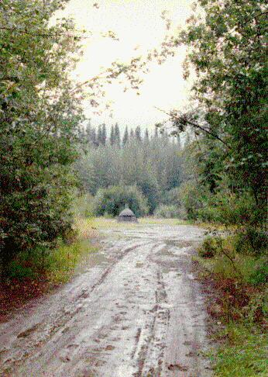
Our campsite on the banks of the Klondike River near Dawson City.

We set up camp. I then set out to catch dinner. The Klondike river was perhaps 100 yards wide and divided into two main channels. The smaller of the two ran in front of our tent. This was easily crossed. The bigger channel was on the other side of a fifty yard wide gravel bar was quite wide (75 feet), swiftly flowing, and deep. The water had that familiar brown grey look and was very cold. I fished for some time to no avail. Then Tory came by and took over with no better success. Not even a nibble. We assumed that our remaining lures were not appetizing to the local fish. Tory, incidently, managed to lose a lure in a tree branch so we really were down to the last bits of fishing tackle.
By this time it was perhaps seven o'clock and the skies were looking very very threatening. The occasional drop from the heavens encouraged us to return to our tent and to button up. We got there just as a nasty thunderstorm hit. It was thrashing the tent all over the place and the tent stakes were pulled out of the ground. In fact, one tent stake strap in the front, completely ripped off and the tent started flapping around quite noisily. This required a solution, fast. So I went to the river bank and carried up eight big smooth rocks (about 5-8 pounds each) and put them in all four corners and the mid points of each side of the tent. This kept the tent attached to the ground but as the rains started, the rocks, which were touching the sides of the tent, acted as wicks drawing the water through the tent walls into the tent. As the night progressed we found ourselves awash within our own tent.
We didn't know it at the time, but this was the beginning of fourteen hours of continuous rain. It didn't stop till mid morning of the next day. And it rained hard with occasional bouts of wind and thunder and lightning. We were in the tent (except for damp calls of nature) for the duration.
We cooked dinner in the tent forgetting all the cardinal rules designed to discourage bear attacks. We ate in the tent, and then placed our dirty dishes out in front of the tent. (These are absolute no-no's in bear country. We were not thinking !!). But it's raining out there, we kept telling ourselves.

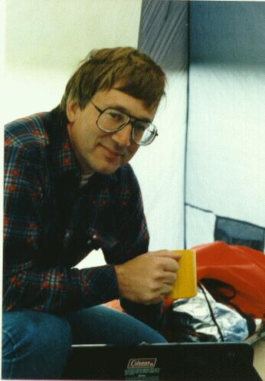
The hot chocolate ritual to ward off the evil storm raging outside our tent.
After bedtime hot chocolate, we turned in and I, for one, tried to ignore that the lower half of my sleeping bag was soaking wet. The trick was for avoiding the water was to huddle up in the middle of the tent as far away from the walls as one could get. Anything that touched the wall caused a steady stream of water to come in and usually got soaked itself (if it was soakable). The problem was that all our gear, milk crates, table, stove, chairs occupied the middle of the tent. So we had a night where people and things were competing for a small patch of dry ground in the middle of the tent.
I had a cold, wet wretched night's sleep that was far more miserable than my cold night at Watson lake. I had three demons haunting me. First was the cold and wet. Second was the imagined bear population lurking just outside the tent. And third was anxiety about the weather and flying the next day. I imagined ourselves being in Dawson for a week as the rain and thunderstorms kept us out of the air. I did not fancy flying in the weather that surrounded us now. I had not expected it from the forecasts and did not know how long it would last.

Wednesday, July 24. (Day 12)
The morning finally arrived and it continued to pour. We took this opportunity to turn over, check the rain, look for a dry spot, and catch another half hours sleep. By our standards, we really "slept in". It was after nine o'clock before we roused ourselves. And wonder of wonders, the rain was letting up.
We had a leisurely breakfast and plotted our plan of action. The first step was a walk over to the flight service station. It was surprising that a dirt strip like Dawson had a very good FSS. Air Transport Canada is really quite remarkable in that respect. Very unlike the US where the FSSs are being closed as fast as they can be.
The FSS staff was tearing their hair out with the weather forecast. It appeared that the weather guessers in Ottawa had no idea why it was raining in Dawson when the weather was fine in all directions. The problem was getting out of Dawson.
I filed an IFR flight to Watson Lake. Our route of flight was Dawson direct Whitehorse, Telsin, Watson lake. The first leg was 226 NM (260 miles) with no navaids or habitation. We would be out of range of any usable navaid for nearly an hour. It really was a case of point the airplane and go.
As we were getting packed, a young pilot in a Cherokee 140 (a small two seat trainer type airplane) came by. He was getting ready to depart to Whitehorse. I asked him if he was going IFR. He smiled and said he was going to follow the Yukon River and would be flying at 200 to 300 feet above the river. This route was over four hundred miles long (as opposed to the straight line distance of 260 miles). He seemed to have no anxiety about four hours at 200 feet in very rough country. My guess was he thought that IFR away from the known (and traveled) river route just as crazy. Well, each to his own methods. We wished each other well and he took off. Even though he left half an hour before us, I figured we overflew Whitehorse two hours before he got there.

Dawson, Y.T.- Watson Lake, Y.T. (3.3 hours)
As we were striking the campsite, the rains obligingly stopped. We rolled up our damp possessions and packed the plane (which must have been 30 pounds heavier as a result of the accumulated moisture). We started up and took off to the west, climbed out of the Klondike River valley, and swung south to pick up our course tracking outbound from Dawson NDB, dah-dit-dit dah-dah-dit-dah.
This flight was one of the most interesting and challenging of the trip. It was over totally uninhabited country, without navaids (for the first leg), and in instrument conditions. We flew at 9,000 and were in the clouds 75 percent of the time for the first hour and then the weather improved as we approached Whitehorse. After Whitehorse, we were in totally clear weather.
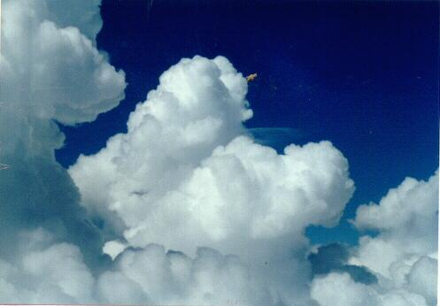
In and Out of the clouds at 9,000 feet IFR from Dawson to Whitehorse.
We did not have a road or navaid for 300 miles.
Between clouds, we could look down and see some rugged mountains. Several times the Yukon crossed our route below us. The river valley looked narrow, steeply guarded on all sides, and dark. I was glad we were not down there.
Tory, with apologies and reference to the flu, succumbed to aeronautical narcolepsy and snoozed away. It was her first and only airborne nap of the trip. My feeling at that moment over the Northern Yukon Territories was one of considerable loneliness.
After about 20 minutes of flight we lost the signal from the Dawson NDB and our only job was to maintain the heading of 120 degrees until we came into range of Whitehorse NDB or VOR. We actually were quite close to course when we acquired Whitehorse. I could imagine Charles Lindbergh flying across the arctic on his flight to the Orient.
About 75 miles out of Whitehorse, I could see Lake Lebarge about twenty miles to our left The lake was very long. I had visions of Sam McGee being incinerated on the shores of the lake as the temperature stood at 40 degrees below zero. Another vision was of the miners rowing their boats down the lake on their way to their fortunes in the Klondike which we had left less than an hour earlier. The miners would have had several months of danger and toil before they would have arrived.
Forty miles from Whitehorse, I made a position report to Edmonton Center. I am not used to making proper position reports since they are not required in a radar environment such as is found in the US. So I had to look up in my Airman's Information Manual to find the proper protocol. "Edmonton Center, Mooney niner two zero eight Mike, forty miles northwest Whitehorse on Bravo Romeo two niner, niner thousand feet, estimating Whitehorse twenty eight, next Telsin".
Approaching Whitehorse I was overcome by my several cups of morning coffee and had to utilize the emergency bottle, "Eyes right, Victoria". Why do women never go to the bathroom.
The flight from Whitehorse to Watson's lake was clear and beautiful. The wind was picking up a bit so there was some chop and our ground speed was helped a bit by the south west winds. We had been over this route on our way north and felt (somewhat) like we were in familiar territory.
Upon landing at beautiful Watson Lake, it seemed that we were practically home. Tory commented on my get-home-itis. And it's true. Once headed for the barn, I was ready to get home. And that does not reflect on the quality of our vacation.

Fire Bombers
While we were getting gas, we visited with the crews of some of the fire bomber planes which were temporarily flying out of Watson Lake. We talked with the pilot of one of the spotter planes, a Piper Aerostar which is a high powered plane in any body's book. The spotter plane helps guide the DC-6's which carry the fire retardant. The spotter pilot, even though he calls the shots, is the junior member of the team. The senior jobs are with the four engine bombers. It sounds like they do some pretty impressive flying. They had been having a busy summer. Impressive! We saw several missions come and go as we sat in our campsite. It was like a war.

Back at Watson Lake
We spent the afternoon just taking it easy. Someone had, in the week since our last visit, made major improvements to the campsite. There was a second outhouse, proper picnic tables, and general cleanup activities had occurred. This was without doubt, the best campsite of the trip.
In the evening (8:30 pm) two VFR Cessna Skyhawks (172's) arrived after a 12 hour flight from the midwest US somewhere. The occupants were nice people, two older couples on their way to Alaska, VFR. They had a heck of a time getting their tent and gear setup as this was their first night camping and they didn't know how things worked. It was fortunate that it wasn't raining. They were up before we arose and were off to Fairbanks.
We walked over to the (always) deserted terminal building and called Robin Flannery in Vancouver. She sounded really eager to have us visit. So I said we'd be there the next night and would call when we arrived.
I spent half an hour wrapped up in my maps on a picnic table as the sun got lower in the sky preparing for the next day's flight through the "Trench".
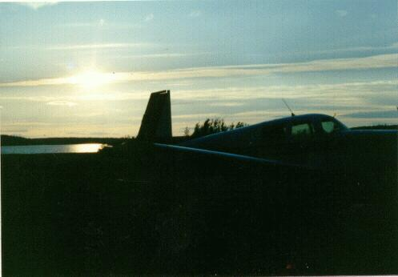
Back at Watson Lake with the setting sun over "Mike".
We did not try our hand at fishing for dinner. We had, it seemed, plenty of food and no more lures.

Thursday, July 25 (Day 13)
The day dawned beautiful with a few scattered middle clouds. Actually, it is improper to say the day dawned since it was dawn since about 1:00 am, but when we arose, the day was beautiful. It was very different from our first visit to Watson Lake when we were greeted by low fog and drizzle as we arose. Unlike the first visit, the night was mild with no all-night shivers due to my inadequate sleeping bag. A post breakfast trip to the flight service station confirmed good weather to the south and light winds. We filed our flight plan to Prince George via the "trench".
It was our intention to fly to Vancouver and spend the night with Robin. Actually, our flying destination for the night was Blaine airport just across the border in the US and the closest airport to Robin's house in White Rock, BC. Since Blaine doesn't have US customs, we would have to clear customs in Bellingham, Washington and then make the 10 minute hop back to Blaine. Such was our program for the day.

The "Trench"
The trench is a legend among private plane travelers to Alaska. Geologically, it is a major fault line that travels the length of British Columbia. The Fraiser River Canyon over which we flew northbound forms the southern end of the fault. It provides a straight low level route through the Canadian Rocky Mountains. It bypasses the somewhat tortuous Alaska Highway route that twice crossed the backbone of the Rockies. The trench itself runs from Mckenzie at the southern tip of Williston Lake to just south of Watson's lake. Throughout its length of over 300 nautical miles (360 statute miles), it has high mountains on both sides. It consists of a long valley that forms a tunnel when the clouds are low. Experienced trench pilots say that it is protected from low clouds and is often open when low ceilings prevail elsewhere. The maximum altitude of the ground through the trench is about 3200 feet, so it would be possible to fly from the US to Watson's Lake as low as 3,500 feet if necessary.
I had learned of the trench with some trepidations from the Downie book and from conversations with John Kaminsky. The trench, according to Downie, is unpopulated and without roads or navaids for its entire length. It seemed the height of adventure to do the trench and we therefore avoided it on our northbound trip. After flying around the Yukon and Alaska without incident, the trench didn't seem so intimidating so we decided to give it a try, especially since the weather was excellent and it would cut 108 nm and one hour off of our trip to our destination, Bellingham.

Watson Lake, Y.T.- Prince George, B.C. (3.2 hours)
We went through the break-camp-and-pack-the plane ritual without realizing the significance of this being the last such chore of this trip. We took off at 7:23 am and climbed out to the south east to join up with the northern opening of the trench. Navigation would be simple. "Just head 115 degrees and don't hit the mountains on either side" was the advice they offered in flight service. We had a good strong VOR/DME signal which directed us right to the trench opening. The first 40 miles of the flight was over the flat Laird River valley that surrounds Watson Lake. It is largely unpopulated with a few lakes, streams, and little domes of hills to break up the monotony.
The mountains to the south are the Rockies and they rose up to embrace us as we got closer. I decided to fly at 5,500 feet which was a proper VFR cruising altitude. It would keep us well clear of the ground but was not too low in case an emergency landing was necessary. On the other hand, it was well below the surrounding terrain of the trench which made navigation easy (just don't hit the mountains). We were cautioned that the only possible ambiguity for navigation was a fork in the river at about 110 miles (from Watson Lake) and if we took the left fork by accident, we would soon come to a dead end (bad choice of words).
We entered the trench following a river that got smaller and smaller as little tributaries branched off it from either side. There were numerous lakes nestled in the mountains, each looking like a perfect place to have a cabin and a float plane. It was quite green and wooded below. We successfully took the right fork as the ground gradually rose toward us but we were never less than 2,000 feet above the ground. At about 160 miles from Watson Lake we reached the high point of the trench. All the water behind us (to the north) flowed north to join the Laird River while the water below us would flow into Williston Lake and into the Peace River. Curiously, both watersheds ultimately joined after a thousand miles of separate wandering at the Mckenzie River to empty into the Arctic Ocean.
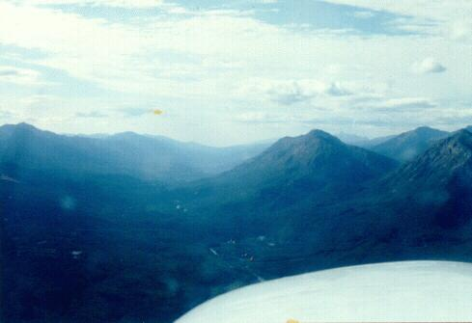
In the "Trench" southbound coming up on the divide.
As we passed over the divide in the pass, we spotted a column of smoke from about fifty miles off. As we approached it, a plane to the south was talking to Prince George Radio through the RCO (remote communication outlet) at Ingenika. He reported a possible forest fire to his north. When we got to the fire area we could see no actual flames but the smoke was much more than a cooking fire. We too, called up Prince George and reported the exact position of the fire. Talking to Prince George broke the feeling of isolation. We never really felt like we were over "sparsely settled" areas again.

Thursday, July 25 (Day 13), The Trench and Home

Williston Lake
After 200 nm and 1:20 minutes from Watson Lake, we were at the northern end of Williston Lake. This lake is man made and is formed by the damming of the Peace River The dam formed a massive lake in the form of a "T" lying on its side. We were traversing the top of the "T" from north to south while the dam was at the base of the "T" at the eastern end of the lake near Fort St John. The length of the lake is 150 nautical miles or 170 statute miles. Apparently, when they flooded the valleys they didn't cut down any trees so the lake is useless for fishing since all fishing lines get tangled in the tree trunks below. Boating, too, is nearly impossible since they are always hitting submerged logs.
The most significant impression of Williston Lake is of logging operations. Vast tracts of land surrounding the lake are clear cut. It really was quite ugly and served to remind us of the realities of modern life and our impending return to civilization. The lake itself serves as the shipping route for the logs. We saw one vast raft of logs being towed south by a boat. Apparently Mackensie is the mill town for Williston Lake.
We motored down the western edge of Williston Lake trying not to think of a forced landing in the lake. I had all sorts of visions of getting tangled up in submerged pine trees long since drowned in the murky waters and looking for revenge on the human race.
As we reached Mackensie, the enormous pulp plant and the highway welcomed us back into the modern world. It was here, ten days earlier that we had made the decision to fly IFR over the Rockies to Fort St. John In retrospect, it would have been far safer to have flown up the trench to Watson lake. We followed the highway for another 35 minutes and landed at Prince George at about 10:30. On our trip north, Prince George had been shrouded in a violent thunderstorm and we had skirted it by ten miles to the west. As we pulled up to the gas pumps, we were greeted by two post adolescent line boys who rolled out a red carpet at our feet. Commercialism was back in full force.
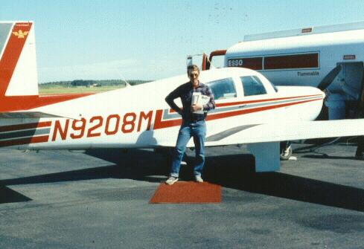
Red Carpet treatment at Prince George, British Columbia, with the Trench safely behind us.
We had lunch in the shade of the gas shack. God bless Swiss Army knives. We went over to flight service to get a briefing for the rest of our trip. The weather in the Vancouver basin was poor: a low stratus overcast. So we filed an IFR flight plan requesting customs in Bellingham.

Prince George, B.C.- Bellingham, Washington (2.7 hours)
We took off a little after noon. The weather after takeoff continued beautiful with a few distant CBs (building future thunderstorms). We retraced our route of ten days earlier but there were major differences. The land which had seemed so foreboding, isolated, and hostile on the way north seemed as friendly and familiar as the Salinas Valley. In contrast to the Yukon and Alaska, it was. Unlike our earlier transit when we trembled to venture three miles from the umbilical of the highway, we boldly flew the airways from one navigational fix to the next.
The entire trip was 330 NM and was scheduled to take 2:35 minutes. We were right on flight plan. We initially flew at 9,000 feet and at the northern end of the Fraiser River Canyon we were given a climb to 11,000 feet. As we climbed to 11,000 feet, the stratus clouds filled in below us and totally obscured the rugged features of the canyon.

A Moment of Introspection
It looked benign, but I knew the horrible mountains that lurked below the fluffy stratus. This would be the worst place to have a total engine failure, since there would be little way to avoid the mountains in the clouds. Bad thoughts, so I put them out of my mind.
But it does make me think, why do I fly airplanes where there is the possibility, however slim, of death or injury? Why risk oblivion for myself and the same for innocent passengers? These are heavy thoughts. But the answer is clear and consistent. For the present, flying gives me more satisfaction and sense of accomplishment than any other thing that I do. For the long term, I don't want to be sitting in the old people's home thinking "Why didn't I experience more during my life". The memories that are associated with flying and flying trips are worth the risk. As for others at risk, I rationalize that flying is quite safe statistically.

Back in the USA
We followed the low frequency route B22 since we were below the MEA (minimum en route altitude) for the more commonly used Victor airways (which use the VHF VOR/DME stations). As we approached the US border at the Canadian town of Hope we were given vectors for the ILS approach to Bellingham. We descended into the clouds and transitioned to instrument flight. I felt a lot of confidence since I had more recent instrument flying than at any time since I owned Mike (the airplane). We broke out at 1,500 feet and made an uneventful landing at about 2:40 pm.
We taxied to the custom's area and parked outside in the designated areas. Remembering the regulations about not leaving the airplane until under the supervision of a customs agent, we just waited for one to show up. We waited and waited. We could see a person lounging at a desk just inside the building, but could not get his attention. Airplanes do not have horns, nor did I think they would have needed them, before this moment. After about ten minutes (which seemed much longer) he noticed us and came out to inspect us. Unlike the Northway man, he was pleasant, apologetic, and thoroughly professional. We were soon cleared and officially back on US soil.

Blaine
We found a pay phone and called Robin giving our ETA at Blaine. After a potty stop and refueling, we fired up Mike for the thirty mile trip to Blaine. We took off to the north and with the clouds having lowered to 1,000 feet, we maintained 500 feet and followed Interstate 5 north. From that altitude (as with Merril Field) you can't see much. Finding Blaine airport would have been a problem except for the fact that I had been there the previous year. Its approximate location was a mile south east of the border crossing on the interstate. So we swung around in a low pattern for the airport I couldn't yet see and flew a slow approach for a landing to the south. Like magic, the airport appeared on our nose about a mile off and we landed on the 2,000 foot runway without problem. It was, no doubt, the heaviest landing of the trip (and for that matter, the heaviest landing for Mike) since we had just loaded full fuel and were probably one hundred pounds or so over legal gross weight. Oh well, as they say, any landing that you walk away from is a good landing. It was now about 4:00 pm and we felt that we had had a long day.
We waited a few minutes for Robin to arrived with son David in tow. We loaded up a small subset of our gear. Robin felt comfortable enough to tell me that I needed a bath. This confirmed my own suspicions on the limitations of deodorant. We passed through the border crossing without any discussion of why we had been in Canada an hour earlier. The first order of business was a long luxurious shower for the two of us (separately, of course). Then we sat down with a glass of wine and talked.
We had a lovely visit with Robin. Steve was away on business. Robin was very attentive and hospitable and David and Jennifer were fun.

An Unexpected Retrospective
Robin asked us what parts of the trip we liked the best. This question caught us off guard since Tory and I hadn't discussed it among ourselves. Nor had either of us thought about it much. Our answers were tentative since neither of us knew very much what the other thought. In fact, since we were still on the trip, I was not sure just what the lasting value of the trip would turn out to be. No doubt, we had had an interesting time, but I did not yet have the perspective to know with conviction that the trip was worthwhile.
There is no doubt in my mind that the best part of the trip was spending over two weeks with Tory. We had a great time together in a new type of relationship: adult to adult. She is a very congenial interesting person and we had fun sharing the experiences of the trip and each other. She was, in every sense, an equal partner on this trip, a real friend.
The flying was, in itself, a major experience. We spent over fifty hours in the air and the airplane performed perfectly. It was a challenge to do this trip safely and without stress and we did that. Never, were we uncomfortable in the airplane (except maybe for a few minutes of unexpected IFR enroute to Ft. St. John). Tory wasn't as caught up in the techniques of flying as I was but she seemed to enjoy the uniqueness of the experience and our seven league boots.
The most interesting flying legs were.
- a) Whitehorse to Northway, low over the Alaska Highway.
- b) Anchorage to Fairbanks, passing by Mt McKinley
- c) The flight to Ft. Yukon, north of the arctic circle.
- d) Dawson to Whitehorse, IFR over the wilderness with no navaids for 300
- miles.
- e) Watson's Lake to Prince George via the "Trench".
In terms of the touristy things we saw and did, in my opinion the best were:
- a) Denali Park
- b) Watson Lake Campground
- c) The Klondike II river boat museum in Whitehorse.
- d) The musical review at Alaska Land in Fairbanks.
- e) Dawson City
In terms of complaints about the trip:
- a) Dawson City was too touristy
- b) Alaska Land was tacky
- c) We found the condition of the native population disturbing.
- d) We didn't have enough time. This trip should have been twice as long.
- e) We were sometimes constrained as to what we could do without a car (but
- this wasn't a big problem on this short trip, I think)
- f) The airplane is too small
- g) We didn't have a telephoto lens with us.
- h) There were major parts of Alaska that we missed, e.g. the coastal areas and
- Southeast Alaska

Friday, July 26 (Day 14)
Showered and fed, we had a wonderful night's sleep. We awoke the next morning to cloudy sky with the promise of broken sky conditions at our time of departure. We had a nice breakfast and at about 10:00 left for Blaine. It was a relief not to have to pack the plane for once.

Blaine, WA - Red Bluff, CA. (4.0 hours)
Vancouver was nearly socked in with low stratus, but I could see some breaks in the overcast. So we took off to the south. Blaine airport, at 2,000 feet in length, is none too long in our heavy takeoff condition. We had no problem but a small bank right to skirt the tall trees at the southern boundary of the airport was required. I looked up for an accommodating "hole" and saw a peek of blue sky above. We spiraled up through this small crack in the clouds. It took about ten tight spirals to get above the overcast which topped out at about 2,000 feet MSL. It was definitely not legal in terms of 2,000 feet horizontal separation from the clouds, but what the hell! Getting an instrument clearance from Vancouver Approach control (in Canada) for an ascent from Blaine (in the US) enroute to a US destination is awkward (having done it once).
We settled onto our southerly heading at 4,500 above a solid undercast. However, in all directions, magnificent volcanos poked up out of the clouds. We tried to contact the ever busy Seattle Center who ignored our calls. Thus we had to skirt the Seattle Terminal Control Area (TCA) to the west. That put us squarely on the flanks of Mt. Rainier which sits to the west of Seattle. We found ourselves momentarily squeezed between a segment of the TCA above us and the foothills rising to the mountain below. We snuck through without busting any airspace.
We headed south to Portland and climbed to 8,500. This route differed from our route northbound in that we were now on the western (rainy) side of the Cascades. After Portland, the undercast completely disappeared and it was a severe clear day, visibility at least 50 miles. Lots of logging was evident in Washington and Oregon. It's no wonder the spotted owl is having a rough time. The flight was smooth and uneventful but it seemed very long (3:38). By Medford we were really dragging. We crossed the Syskiyou Mountains into California and began a long descent into Red Bluff for fuel.

A Visit with George
Unlike in Vancouver it was HOT in Red Bluff. As we descending we could feel it getting hotter and hotter. On the ground, out thermometer read 95 degrees. It had been regularly going over 100 degrees all week in Red Bluff. We had a dilemma. We were hungry and in a hurry to get home. We were not sure we had enough time to visit with George and Juanita (Gayle's parents) who live just a block from the airport. We decided it would be best to eat first and then give them a courtesy call. So we put together another (our last) sandwich of the trip and ate quietly at the park bench next to the flight line.
I called my in-laws and George answered. He said Juanita was baking and couldn't come over, but that he would be right out. Sure enough, in three minutes, his white car showed up. I dug out Don's rifle and gave it to George to pass on (since they see Don and Shelly in Susanville every few weeks). George is a man of few words, so our greetings were short and the conversation brief.

Red Bluff, CA- Salinas, CA (1.8 hours)
We took off and began our slow hot climb to 8,500 feet. I chose the altitude more for the temperature (cooler) than for the ground clearance since 6,500 would have done just fine. The short flight seemed much longer since the route is very familiar (and boring) and the accumulated fatigue of our three day flight from Dawson was beginning to have an effect.
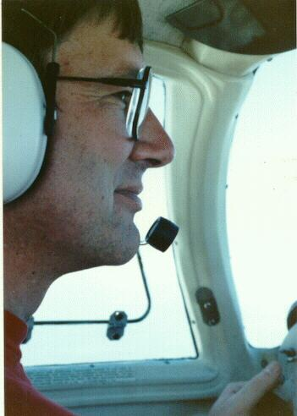
The intrepid pilot feeling very butt weary.
Salinas was overcast as the stratus had come in early. We skirted the fog to the west over the foothills and ducked under the overcast for a straight in landing to runway 26. We couldn't see the airport at all until we were about two miles out. The controllers were having some trouble sorting out the (mostly student) traffic blundering around in the haze. We landed without fanfare. I wanted to say "Hey, you guys, we've just arrived from Alaska", but resisted the urge.
The truck was snugly stored in the hanger where we had left it. We quickly unloaded all our gear into the bed of the truck. We drove home to Gayle who, we hoped, was waiting for our arrival. She was.
We were very tired. But of course we had to tell Gayle all our stories and she listened patiently.
We had spent 44 hours in the air since leaving Salinas 13 days earlier (an average of 3.4 hours per day). I estimated we had covered more than 6,000 miles over the ground.
The trip was over. Time and memory would prove it worthwhile. It has given me a great deal of pleasure thinking about it since and planning for the next one.

Glossary of Aeronautical Terms
- ADF - Automatic Directional Finder. A radio with an indicator which will point in the direction of a low or medium frequency navigation aid
- ATC - Air Traffic Control
- DME - Distance Measuring Equipment. An on board instrument that indicates the distance from a ground TACAN station.
- FAR - Federal Air Regulations
- FSS - Flight Service Station
- HSI - Horizontal Situation Indicator. An instrument that displays both aircraft heading and bearing to a navaid.
- IFR - Instrument Flight Rules
- ILS - Instrument landing System
- MEA - Minimum Enroute Altitude
- MSL - Altitude above Mean Sea Level
- Navaid - A ground navigational station
- NDB - Non Directional Beacon, a Low and Medium frequency Navaid
- RCO - Remote Communication Outlet
- SIGMET - Significant Weather Report
- TACAN - Tactical Air Navigation Station. A military navaid with a DME capability.
- TCA - Terminal Control Area. Restricted airspace around busy airports.
- Unicom - Communication frequency at smaller airports
- VFR - Visual Flight Rules
- VOR - Visual Omni Range. A very high frequency navaid
- VORTAC - a VOR with a TACAN (DME) capability

Copyright © 1991, Jonathan Paul

